Top tips
Put these measurements in order starting with the smallest.
100 grammes
85 grammes
75 grammes

Explain your thinking

Position the symbols
Place the correct symbol between the measurements > or <
36cm 63cm

130ml 103ml

Explain your thinking

Undoing
The film finishes two hours after it starts. It finishes at 4.30. What time did it start?
Draw the clock at the start and the finish of the film.
Start Finish
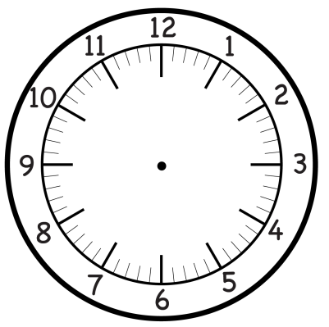

Explain thinking
The time is 3:15pm.
Kate says that in two hours she will be at her football game which starts at 4:15.
Is Kate right? Explain why.

Application
Draw two lines whose lengths differ by 4cm.

Possibilities
How many different ways can you make 63p using only 20p, 10p and 1p coins?

The answer is ….
3 hours
What is the question?

What do you notice?
What do you notice?
1 hour = 60 minutes
½ hour = 30 minutes
¼ hour = 15 minutes

Write down some more time facts like these

