**Tonal Shading**

**Cross-Hatching**

|  |  |  |  |  |  |  |  |
| --- | --- | --- | --- | --- | --- | --- | --- |
|  | | | | | | | |
| **1** | **2** | **3** | **4** | **5** | **6** | **7** | **8** |

**Blending**

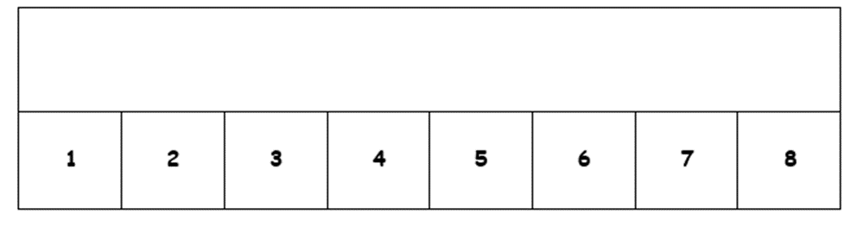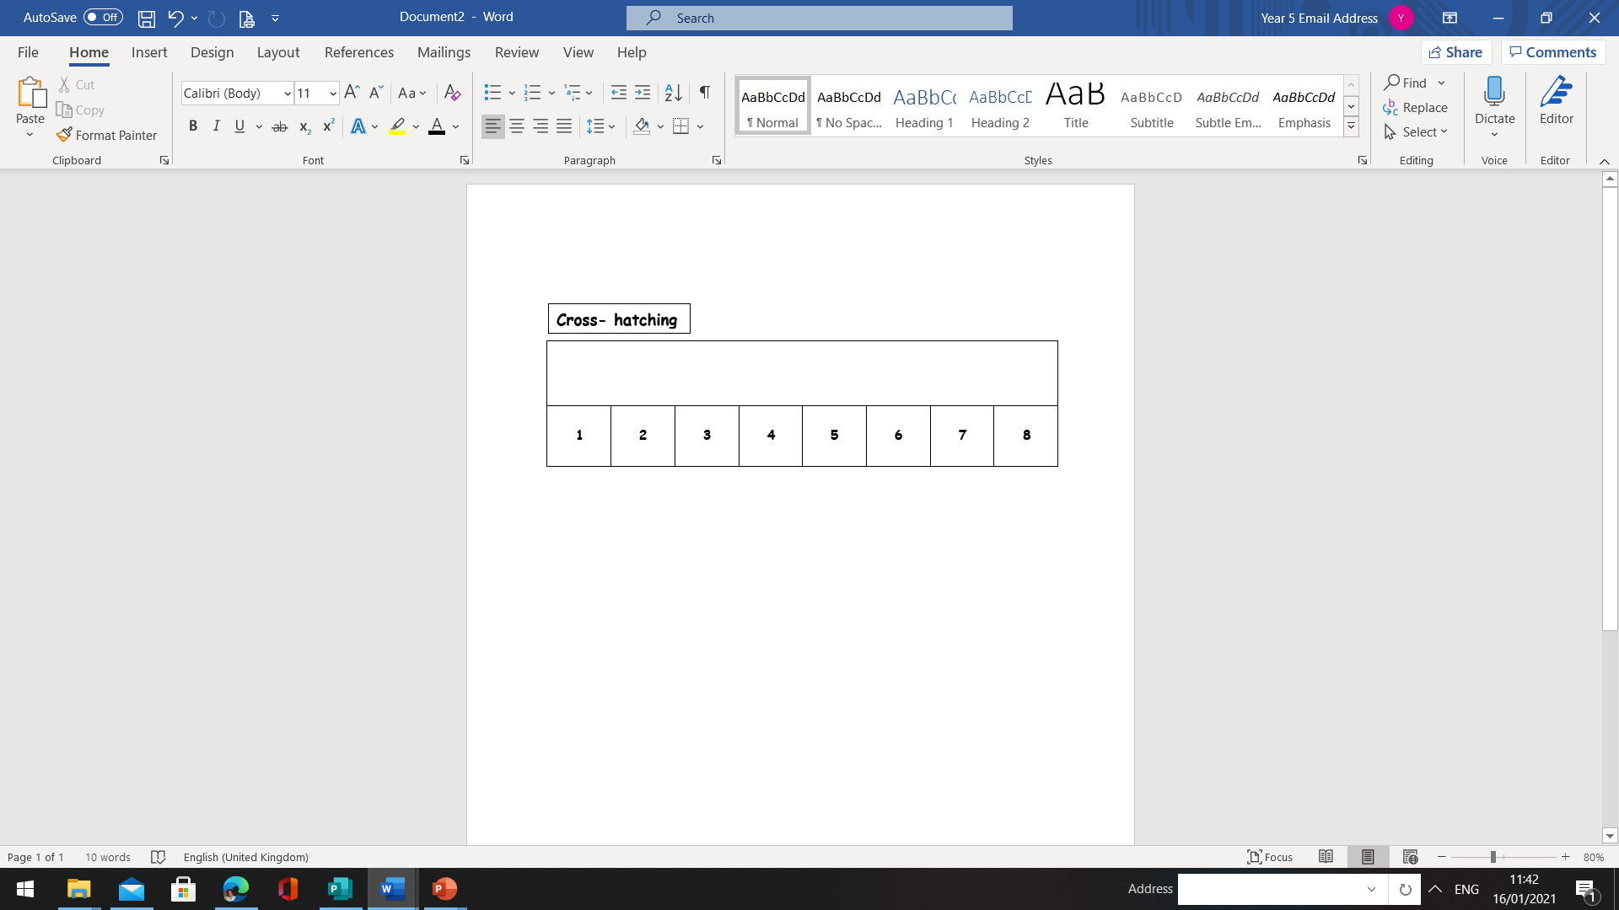

**Thinking about the success criteria below, write two positive comments about your work and one thing you could improve upon.**

**Success Criteria -** To experiment with cross-hatching, blending and stippling.

Two things I am proud of….

 ___________________________________________________________________

 ____________________________________________________________________

I could improve my work by…

_________________________________________________________________________

**Stippling**