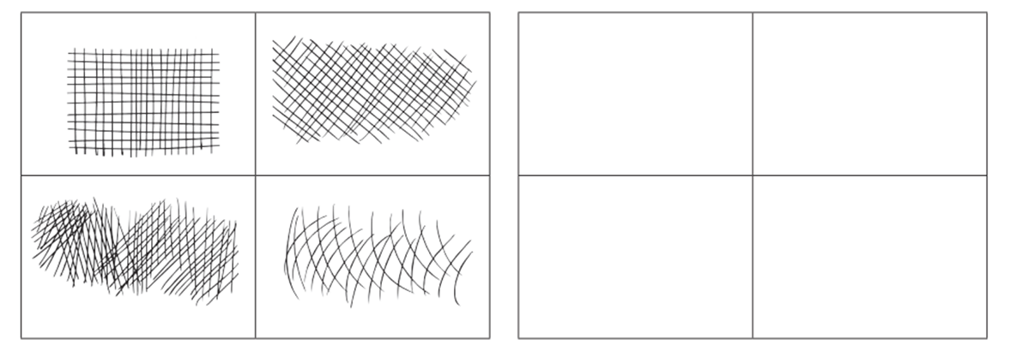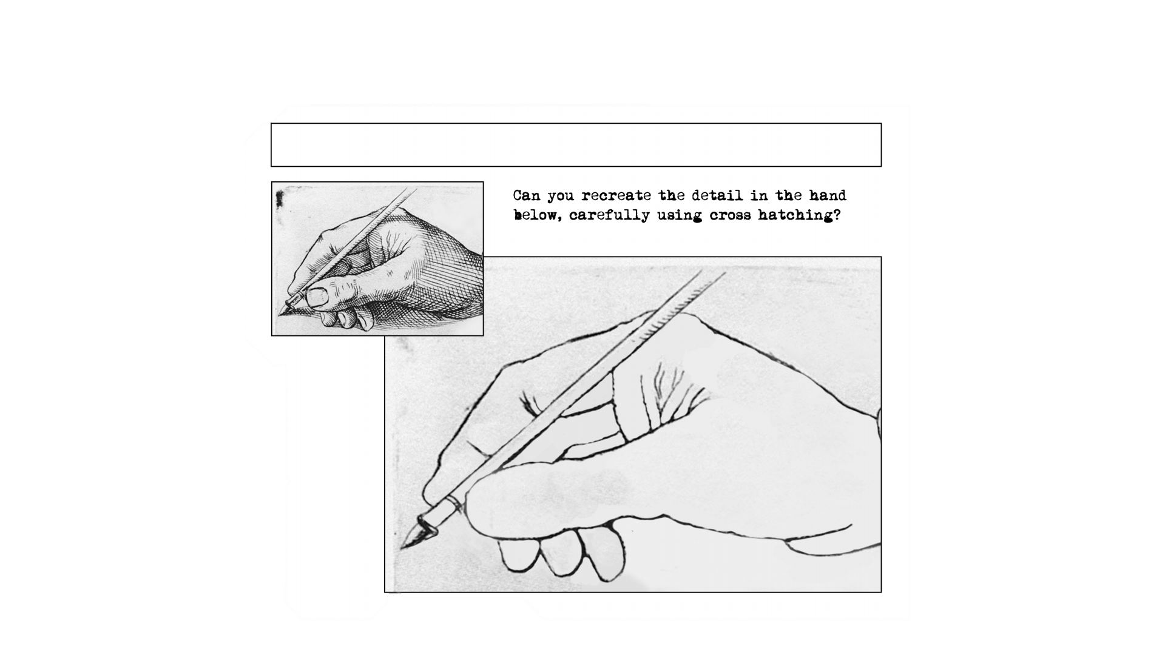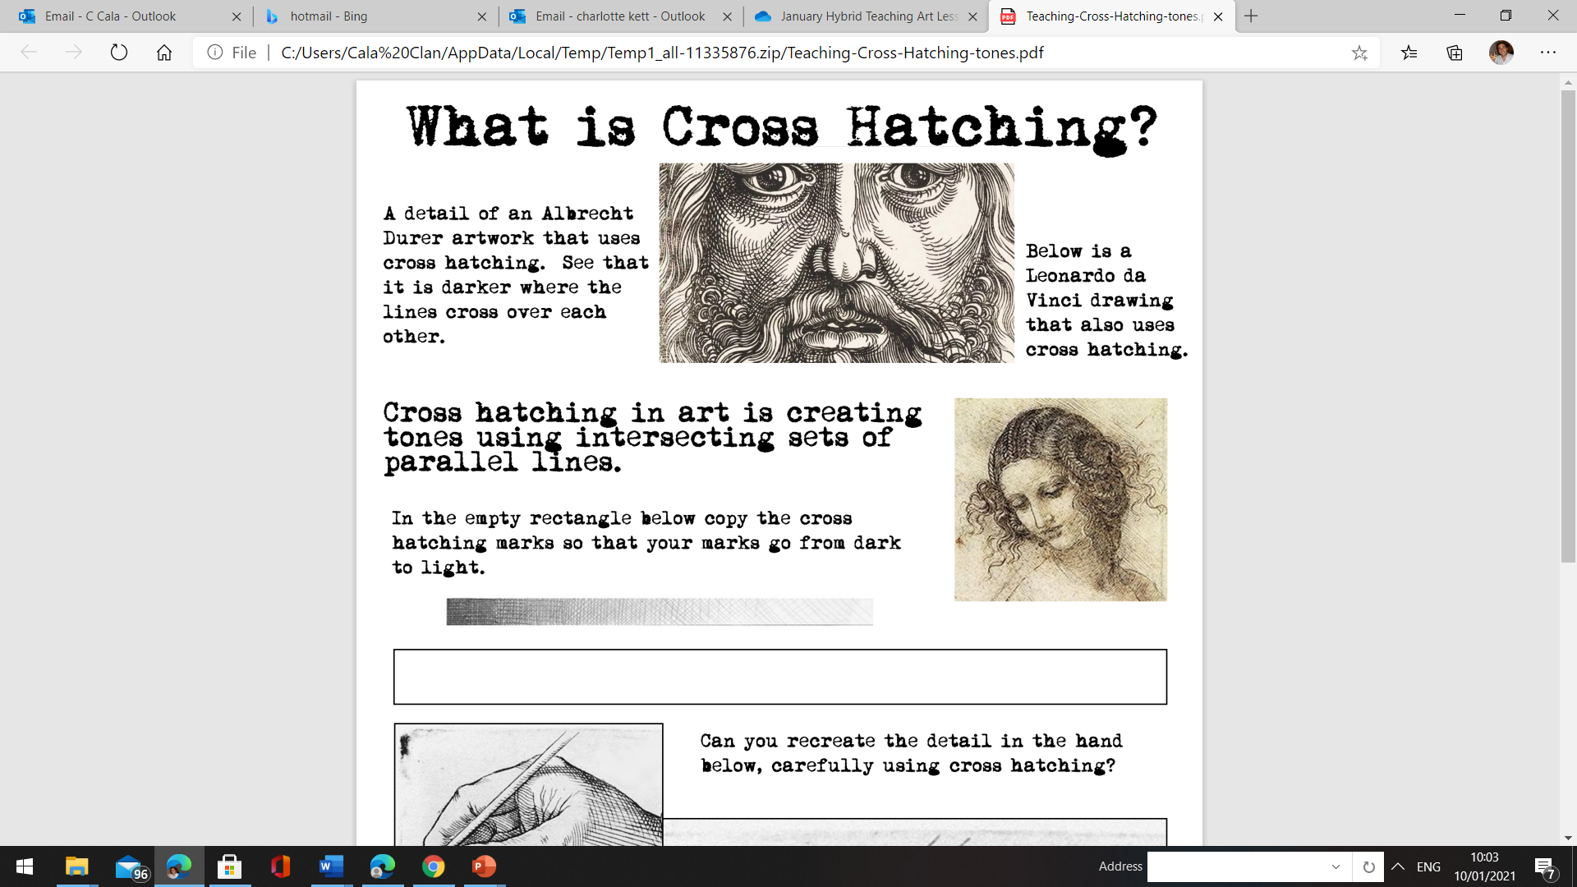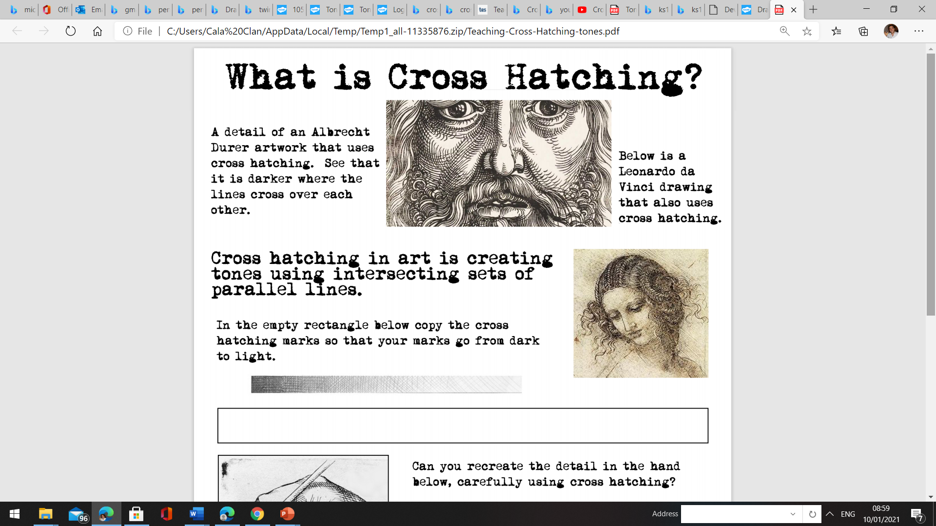

Can you recreate the detail in the hand

below, carefully using cross hatching.

Let’s try! Carefully, copy the direction of the lines in each box using a pencil.

Here is an example of Albrecht Durer’s artwork that uses cross hatching. Notice, that it is darker where the lines cross over each other.

Cross hatching in art is creating tones

using intersecting sets of parallel lines.

In the empty rectangle below copy the cross-hatching marks so that your marks go from dark to light.

**Tonal Shading** - Using Cross Hatching