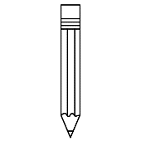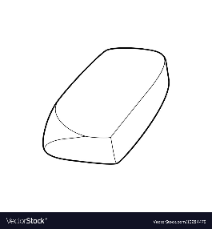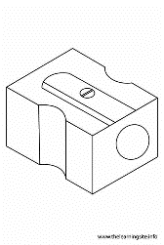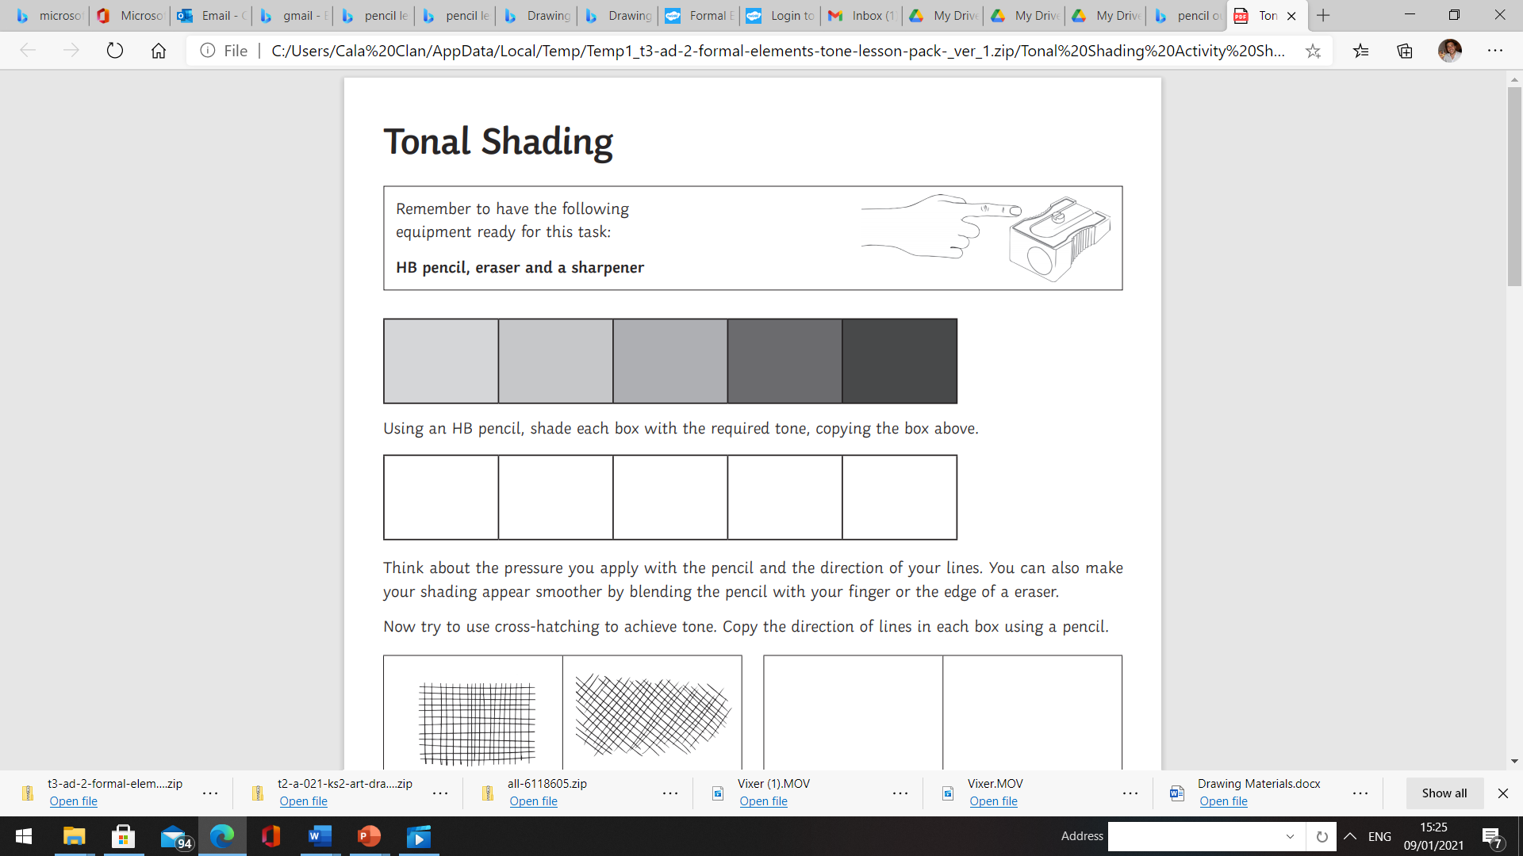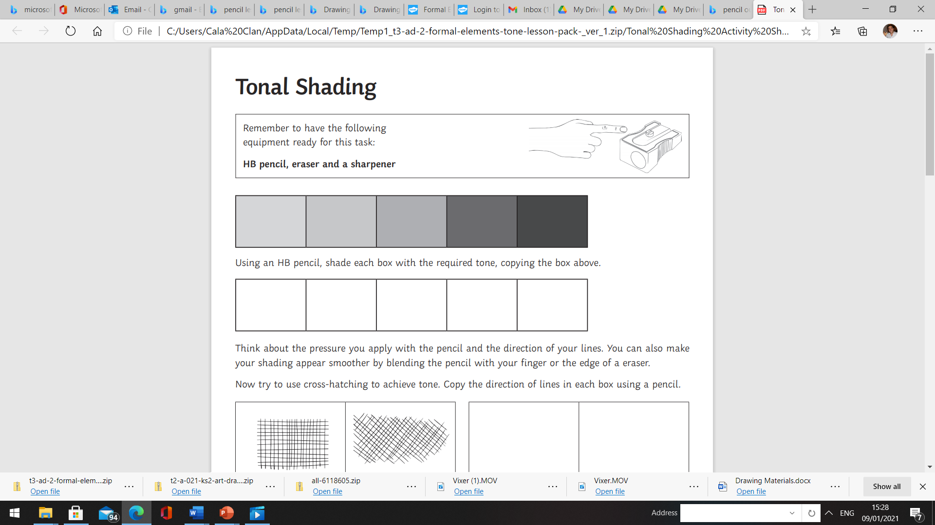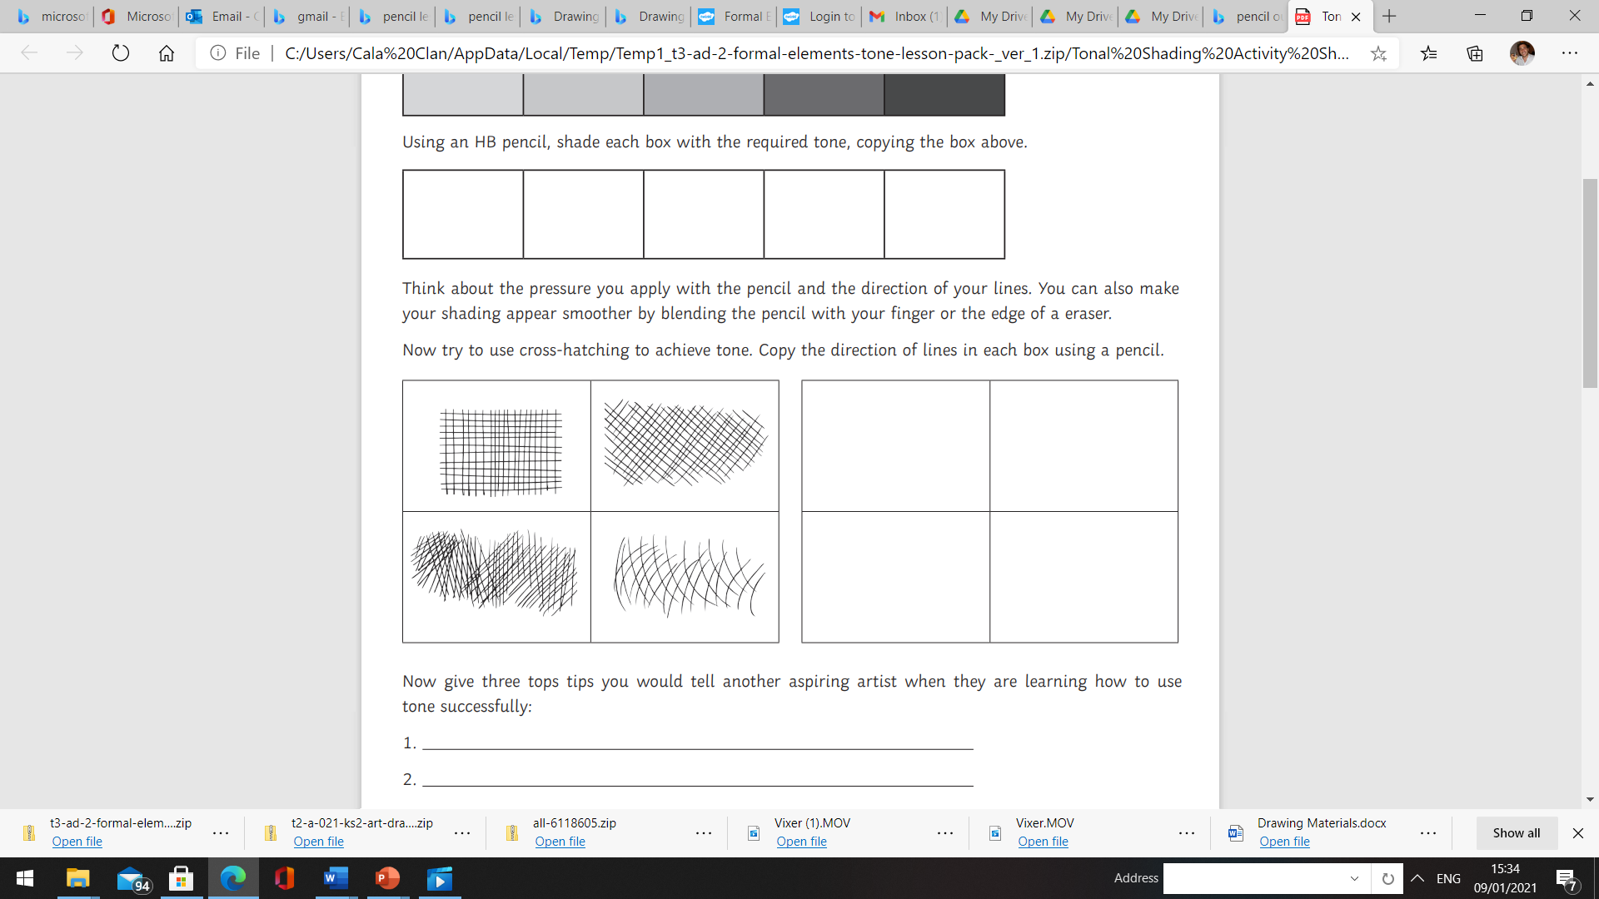

Remember to have the following equipment for this task:

**HB pencil, eraser, and a sharpener**

**Tonal Shading (Lower KS2)**

Using an HB pencil, shade each box with the required tone, copying the box above.

**Think about** the pressure you apply with the pencil and direction of your lines. You can also make your shading appear smoother by blending the pencil with the end of your finger or the edge of the eraser.

Now try to use cross-hatching to achieve tone. Carefully, copy the direction of the lines in each box using a pencil.

The more you practise cross hatching, the better you become.

**Be Reflective**

Write down one new thing you have

learnt today in the thought bubble.