

Dear Children,

Exploring famous artists, architects and designers is lots of fun and a great opportunity to learn about new art processes and techniques. Learning about art history can inspire you to create some exciting artist inspired art projects.

During the Spring Term we would like you to work through this ARTist Challenge book at home.

We hope you enjoy this ARTist Challenge and look forward to hearing about all the incredible new artist, architects and designers you have met along the way.

The Art and Design Team!



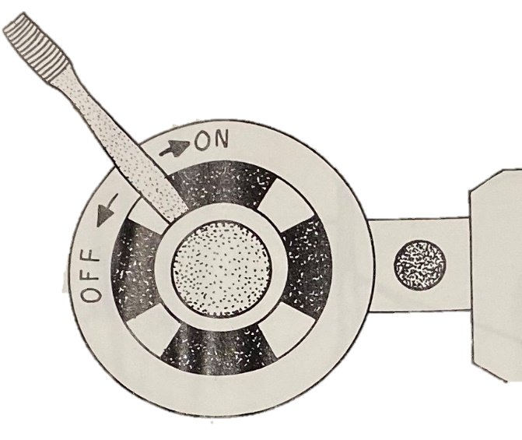

You have just invented a machine that will change the lives of everyone on earth. Only you understand the invention well enough to complete the picture.



**Artist Research**

You have just invented and designed your own machine. Can you research a famous artist who was also an inventor?

**Name of Artist**

**_____________________**

**Sketch one of the artists inventions.**

**Three interesting facts about the artist:**

**1)______________________________________________________________________________________________________________________________________________________________________________________________________**

**2)______________________________________________________________________________________________________________________________________________________________________________________________________**

**3)______________________________________________________________________________________________________________________________________________________________________________________________________**

**During which period of art was the artist most famous.**

**Describe one art work from this artist and share how it makes you feel.**

**_____________________________________________________________________________________________________________________________________________________________________________________________________________________________________________________________________________________________________________________________________________________________________________________________________________________________________________________________________________________**

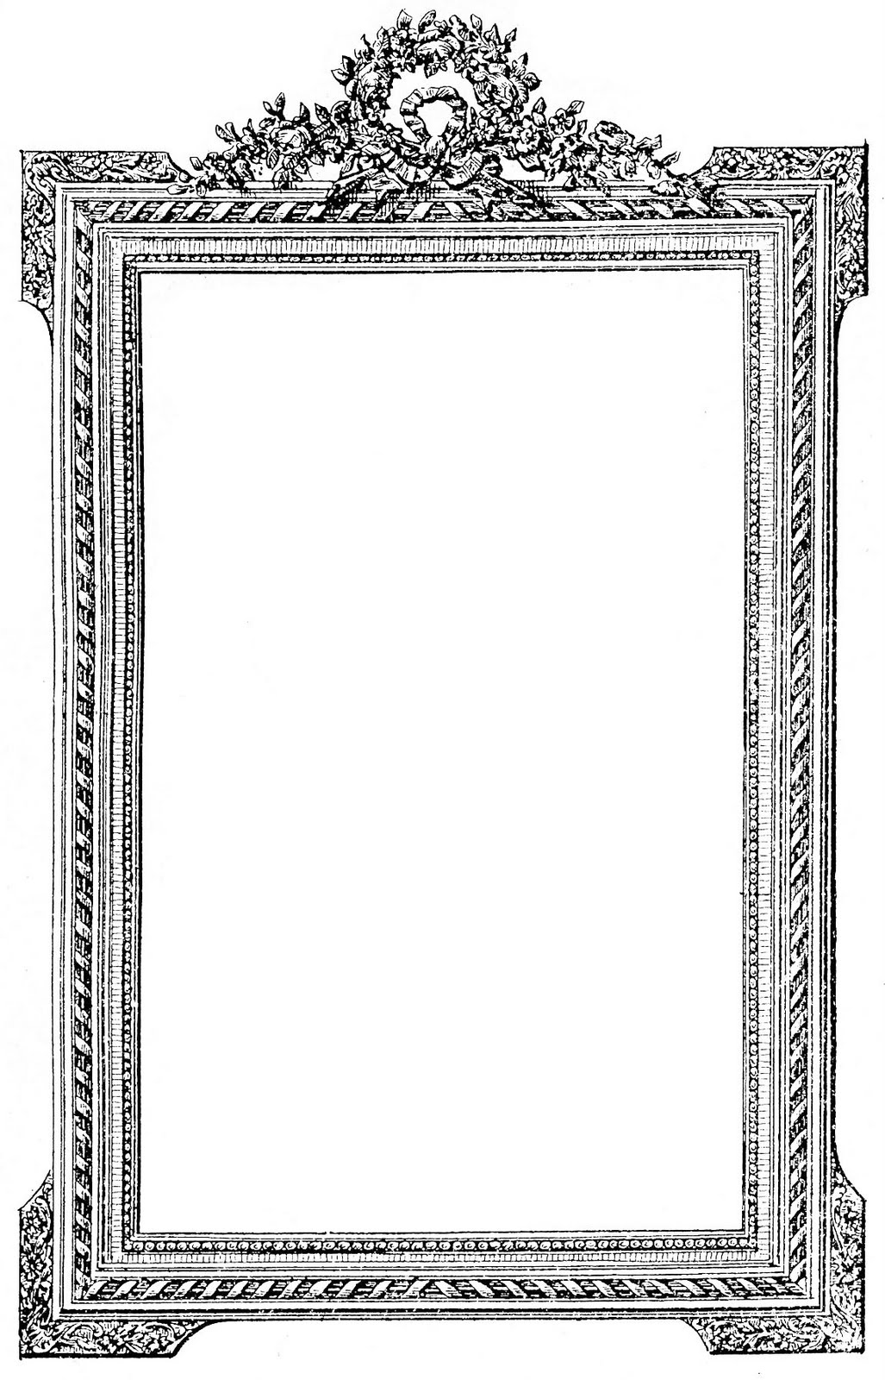

A famous artist needs your help. The artist started this picture but was stung on the thumb by a bee. Turn the picture any way you’d like and finish it.

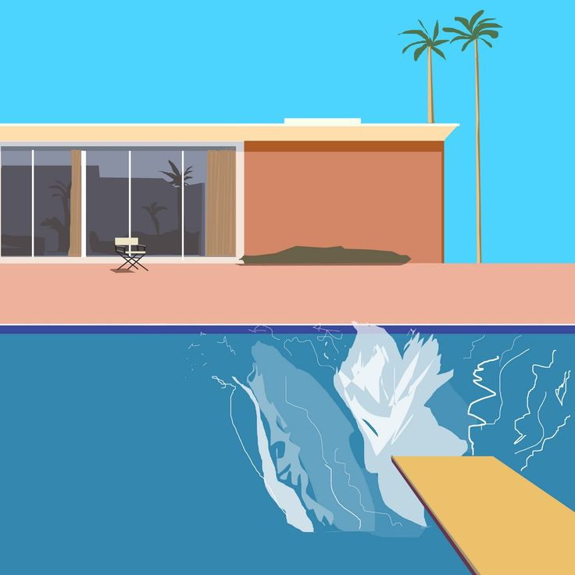

**A Bigger Splash!**

This famous painting is called ‘A Bigger Splash’.

**Challenge**

Who made this piece of artwork? What art movement was the artist part of? What country did the artist come from?

____________________________________________________________________________________________________________________________________________________________________________________________________________________________________________________________________________________

Who or what caused the ‘bigger splash’?

Add your own creativity to the artwork? Could you add swimmers? Inflatables? Extra palm trees?

**Artist Interview**

Imagine you are a famous artist of your choice. After finding out lots about them, try to answer the interview questions below as though you were them!

**What is your name? ­­­­­­­­­­­­­­­­­­­­­­­**

**_________________________________________________________________________**

**­When and where were you born? ___________________________________________________________________________________________________________________________________________________________________________**

**­­­­­­­­­­­­­­­­­­­­­­­­How did you get into art? ____________________________________________________________________________________________________________________________________________________________________________________________________________________________________**

**What defines your artistic style?**

**_____________________________________________________________________________________________________________________________________________________________________________________________________________________________________________________________________________________________**

**What is your favourite piece you have done and why?**

**____________________________________________________________________________________________________________________________________________________________________________________________________________________________________**

**What do you think you could improve on?**

**____________________________________________________________________________________________________________________________________________________________________________________________________________________________________________________________________________________________________**

**‘The Magpie’ by Claude Monet**

**Background Information**

This painting is called ‘The Magpie’ and was painted by French artist Claude Monet between 1868-1869. It was painted in Normandy, France during the winter months from a house in Etretat where Monet was staying with his family. This painting is one of around 140 winter landscapes painted by the artist. It is thought that this is due to the harsh winters recorded in France during the late 19th century.

The painting is one of the first examples of Monet experimenting with coloured shadows

The winter sun beaming down onto the crisp white snow makes blue shadows.

The original painting measures approximately 89cm x 130cm.

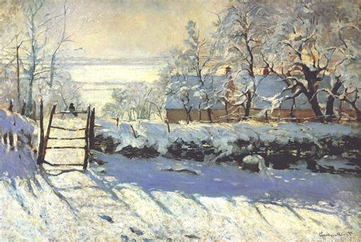

The painting features a single black magpie perched on the fence.

Monet used oil paint applied to canvas.

His new use of light and colour resulted in the painting being rejected by the famous Paris Salon art exhibition.

**Why do you think the artist enjoyed painting winter scenes?**

**Questions**

**________________________________________________________________________________________________________________________________________________________________________________________________________________________________________________________________________________________________________________________________________________________________________________________________________________________________________________________________**

**Do you like the use of blue shadows? Explain your answer.**

**________________________________________________________________________________________________________________________________________________________________________________________________________________________________________________________________________________________________________________________________________________________________________________________________**

**How do you think the painting would differ if traditional shadows created with black had been used?**

**________________________________________________________________________________________________________________________________________________________________________________________________________________________________________________________________________________________________________________________________________________________________________________________________**

**When you heard the title ‘The Magpie’, what did you expect of this painting?**

**________________________________________________________________________________________________________________________________________________________________________________________________________________________________________________________________________________________________________________________________________________________________________________________________­­­­­­­­­­­­­­­­­­­­**

What kinds of buildings will we have in the year 2080? Design them below.

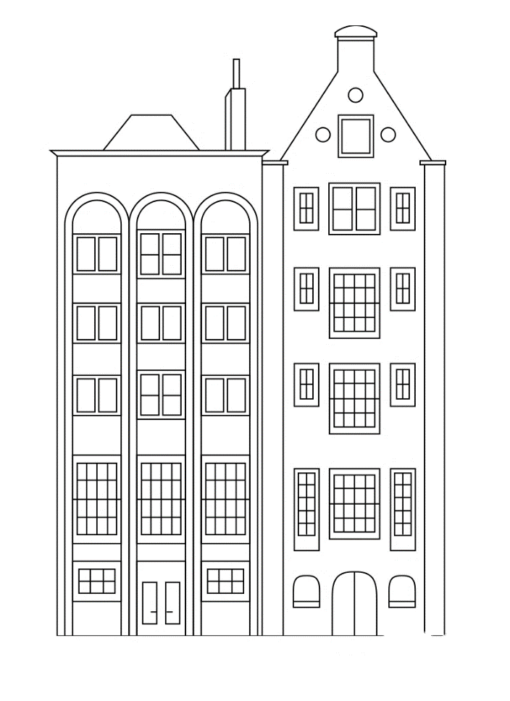

**Architecture** is an art and science of designing the built environment; including cities, buildings, interiors, landscape, furniture, objects, etc.

Can you research an architect-past or present?

**Architect Introduction** (What’s their name, where do they come from, what have they designed?)

**________________________________________________________________________________________________________________________________________________________________________________________________________________________________________________________________________________________________________________________________________________________________________________________________________________________________________________________________**

**Explain why you have chosen this architect?** (Is it their style, their subject matter?)

**________________________________________________________________________________________________________________________________________________________________________________________________________________________________________________________________________________________________________________________________________________**

**Analyse** (What do they focus their subject on? What does the viewer think first? Is there a hidden meaning? How does their work make you feel? Etc)

**_______________________________________________________________________________________________________________________________________________________________________________________________________________________________________________________________________________________________________________________________________________________________________________________________________________________________________________________________________________________________________________________________**

Experiment

**Create your own- Using the architect as inspiration create a design based on the work of the chosen architect.**

Evaluate

Evaluate your own work- How could you improve this? What do you really like about the piece? What could you do to develop it further?

**____________________________________________________________________________________________________________________________________________________________________________________________________________________________________________________________________________________________________________________________________________________________________________________________________________________________________________________________**

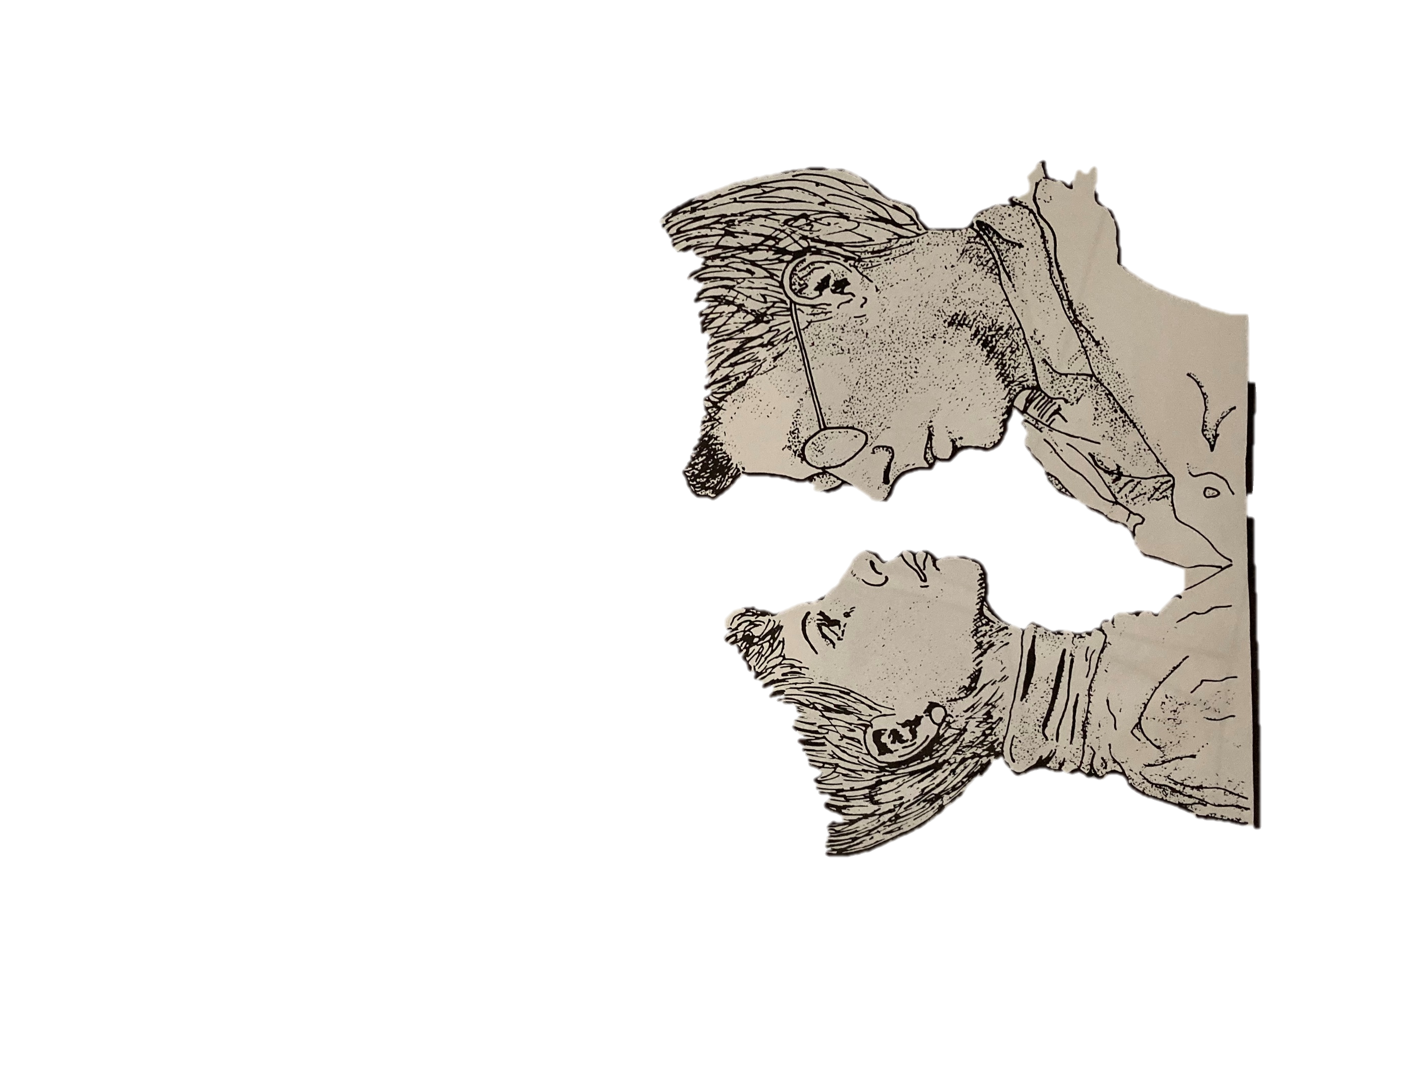

HAT SHOP

These people can’t decide which hats to buy. Can you help design them a hat?

**A designer** is a person who makes designs for objects. A fashion designer designs clothing, a web designer designs web pages and an automobile designer designs automobiles. **Compare and contrast two designers of your choice.**

**Second Designer’s name_________________________________**

Stick in a photograph of the designer

Stick in a photograph of the designer

**First Designer’s name_________________________________**

|  |  |
| --- | --- |
| **Similarities** | **Differences** |
|  |  |

**Which designer do you prefer and why?**

**____________________________________________________________________________________________________________________________________________________________________________________________________________________________________**



Opps! We spilled ink on the last page of this book. Can you turn it into a picture?