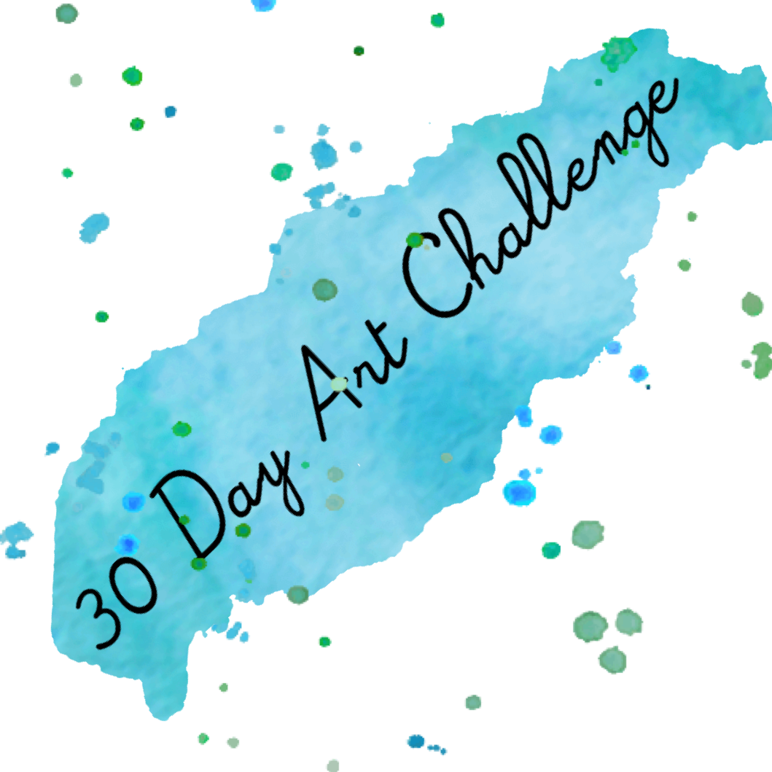

- Draw or paint something you see everyday form outside your window.
- Cover an entire sheet of paper with old magazine pictures- they must all be shades of yellow.
- Make something you can wear.
- Make a bed for an animal you might see outside your window.
- Create a drawing of all different types of lines. There should be no white paper left at the end.
- Draw something orange.
- Design a new type of shoe for the future.
- Draw the most beautiful day you can imagine and use only three colours.
- Draw life from a fly’s point of view.
- Draw something using only 3 lines.
- Make a continues line drawing by never taking the pencil or pen off the page. Draw slowly!
- Draw what you want to be in the future.
- Take a creative risk.
- Draw something you dislike.
- Make something inspired by your favourite song.
- Draw your favourite lollipop.
- Draw a city skyline.
- Draw your dream home.
- Draw yourself as an astronaut.
- Make a robot using 5 pieces of recycling.
- Draw something pink.
- Draw yourself surfing with a shark.
- Draw a quick scribble or shape, turn the scribble or shape into a monster.
- Draw yourself conquering your greatest fear.
- Draw yourself as a superhero.
- Draw your friend as a villain.
- Draw your favourite toy.
- Try a new art technique or style.
- Discover a new artist.
- Draw whatever you want.

