A complete spelling programme
Year 5

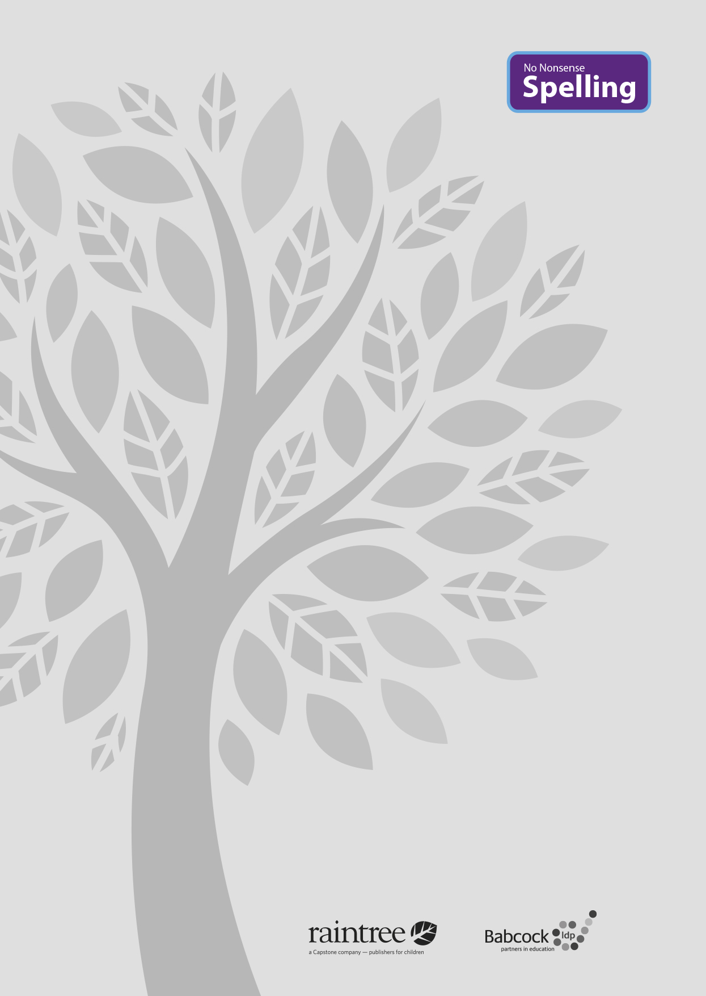

A complete spelling programme
Year 5

Raintree is an imprint of Capstone Global Library Limited, a company incorporated in England and Wales having its registered office at 7 Pilgrim Street, London, EC4V 6LB – Registered company number: 6695582

www.raintree.co.uk
myorders@raintree.co.uk

Text © Capstone Global Library Limited 2016
The moral rights of the proprietor have been asserted.

All rights reserved. No part of this publication may be reproduced in any form or by any means (including photocopying or storing it in any medium by electronic means and whether or not transiently or incidentally to some other use of this publication) without the written permission of the copyright owner, except in accordance with the provisions of the Copyright, Designs and Patents Act 1988 or under the terms of a licence issued by the Copyright Licensing Agency, Saffron House, 6–10 Kirby Street, London EC1N 8TS (www.cla.co.uk). Applications for the copyright owner’s written permission should be addressed to the publisher.

Devised and written by Rebecca Cosgrave, Jenny Core, Joy Simpson and Angela Sykes of the Babcock LDP Primary English Team.
Edited by Clare Lewis
Designed by Richard Parker and HL Studios Picture research by Eric Gohl
Production by Helen McCreath
Originated by Capstone Global Library Ltd Printed at Ashford Colour Press, Gosport, Hants

ISBN 978 1 4747 1001 5
19 18 17 16 15
10 9 8 7 6 5 4 3 2 1

British Library Cataloguing in Publication Data
A full catalogue record for this book is available from the British Library.

Acknowledgements
National Curriculum extract p. 11 © Crown copyright information licensed under the Open Government Licence v3.0.

Cover image provided by Shutterstock

Every effort has been made to contact copyright holders of material reproduced in this book. Any omissions will be rectified in subsequent printings if notice is given to the publisher.

All the Internet addresses (URLs) given in this book were valid at the time of going to press. However, due to the dynamic nature of the Internet, some addresses may have changed, or sites may have changed or ceased to exist since publication. While the author and publisher regret any inconvenience this may cause readers, no responsibility for any such changes can be accepted by either the author or the publisher.

Contents

Introduction 4
What is the No Nonsense Spelling Programme? 4
Assessment 6
Complementary Resources 7
Learning Spellings 9

Year 5 National Curriculum requirements 12

Year 5 Lesson plans 13
Year 5 Term 1 overview 13
Block 1 – autumn first half term 15
Block 5 – autumn second half term 22
Year 5 Term 2 overview 28
Block 3 – spring first half term 30
Block 4 – spring second half term 36
Year 5 Term 3 overview 41
Block 3 – summer first half term 43
Block 4 – summer second half term 48

Statutory word list for Years 5 and 6 52
Year 2 Supporting Resources 53

Introduction

What is the No Nonsense Spelling Programme?

The No Nonsense Spelling Programme was devised to offer teachers a comprehensive yet accessible progression in the teaching of spelling. Guidance, rather than prescription, is provided on how to teach the strategies, knowledge and skills pupils need to learn.

The focus of the programme is on the teaching of spelling, which embraces knowledge of spell- ing conventions – patterns and rules; but integral to the teaching is the opportunity to promote the learning of spellings, including statutory words, common exceptions and personal spellings.

The programme

delivers a manageable tool for meeting the requirements of the 2014 National Curriculum

has a clear progression through blocks of teaching units across the year

comprehensively explains how to teach spelling effectively.

How No Nonsense Spelling is organised

The programme consists of the following elements:

The requirements of the National Curriculum, which have been organised into strands and then broken down into termly overviews. The overall pathway can be found on the USB stick.

Termly overviews that have been mapped across weeks as half termly plans. These follow a

model of five spelling sessions across two weeks, except in Year 2 where sessions are daily.

Daily lesson plans for each session, with Supporting Resources, including word lists and guidance on conventions.

The lesson plans

The lessons themselves then follow the structure below:

Lesson | Reference to year group, block of lessons and lesson number in sequence
Lesson type | Revise/Teach/Learn/Practise/Apply/Assess
Lesson focus | The particular spelling focus for the day
Resources needed | A list of the resources that will be needed. These might be documents that are photocopied or printed in advance so that flashcards can be prepared, or presentations to display the task/activity on a whiteboard. The resources are featured at the end of each book for reference. Editable versions are available on the USB stick, which can be copied and pasted into your own documents and edited.
Teaching activity | Key teaching points, sometimes including extra notes and tips for the teacher

4

Each lesson is approximately 10 to15 minutes long, but lesson plans are flexible so that the teaching can reflect the extra time needed on a teaching point if required. The Supporting Re- sources at the back of each book can be used as appropriate to adjust the pace and focus of the lesson. Each lesson clearly signposts when additional resources from the Programme can be used.

Supporting Resources

The Supporting Resources include pictures and word lists, which can be photocopied and made into flashcards or used in classroom displays, and pictures. They also include games and quiz- zes. The Resources are featured at the end of each book for reference and as editable Word documents on the USB stick, which can be copied and pasted to be used on classroom white- boards and in other documents.

Teaching sequence

The programme has been written broadly following a teaching sequence for spelling, whereby each new concept is taught, practised and then applied and assessed. Frequently there is also a ‘Revise’ session before the teaching session. A typical teaching sequence is as follows:

Revise
Activate prior knowledge Revisit previous linked learning

Teach
Introduce the new concept Explain
Investigate Model

Practise Individual/group work
Extend/explore the concept independently Investigate
Generalise

Apply/Assess
Assess through independent application Explain and demonstrate understanding

Within the lessons, the particular focus is identified, followed by suggested teaching strategies. By integrating activities for handwriting, the benefit of making a spelling activity kinaesthetic is

secured. The pupil acquires the physical memory of the spelling pattern as well as the visual. Integral to the process is the scope to encourage pupils to learn spellings. The value of a school policy and possible approaches are explored further on page 9, ‘Learning spellings’.

You will find the following referred to in the lessons:

Modelling: An activity is described, and it is anticipated that the action expected of pupils is mod-

elled to them first.

Spelling partners: Pupils are asked to work in pairs, often to ‘test’ each other. They will be asked to work with their spelling partner from time to time.

5

Assessment

Pupils’ learning is assessed throughout the programme. The ‘Apply’ part of the sequence regu- larly includes assessment activities to identify if pupils have learnt the key concept taught. These activities include:

Testing – by teacher and peers

Dictation

Explaining

Independent application in writing

Frequent learning and testing of statutory and personal words.

Error Analysis

Error Analysis can be used to assess what strategies pupils are using in their day-to-day writing. It can also help identify where to put emphasis in the programme – for the whole class, groups or individuals. Error Analysis can also be repeated to assess progress over a longer period of time.

A template for a suggested grid for Error Analysis can be found in the Supporting Resources. How to complete an Error Analysis:

Choose one piece of independent writing from each pupil.

Identify all the spelling errors and record them on the grid. Decide what you think is the main source of the error and record the word in the corresponding column. It is a good idea to re- cord the word as the pupil has spelt it.

Identify any patterns. Quite quickly you will be able to see which aspect of spelling needs to be addressed.

The headings on the grid included are

Common exception words

GPCs (grapheme–phoneme correspondences) including rarer GPCs and vowel digraphs

Homophones

Prefixes and suffixes

Word endings

Other.

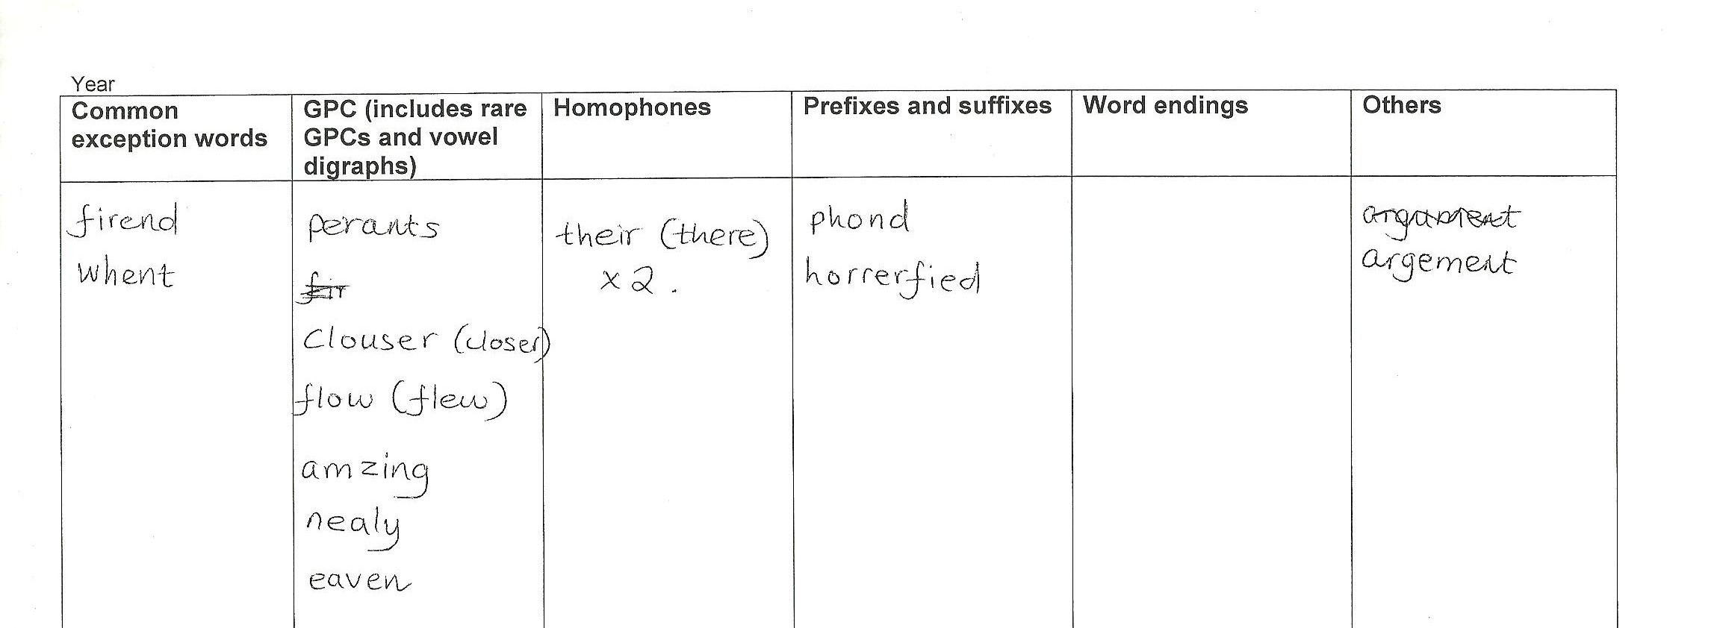These headings correspond to key strands within the National Curriculum. These could be changed or further areas added if needed.

6

Complementary resources

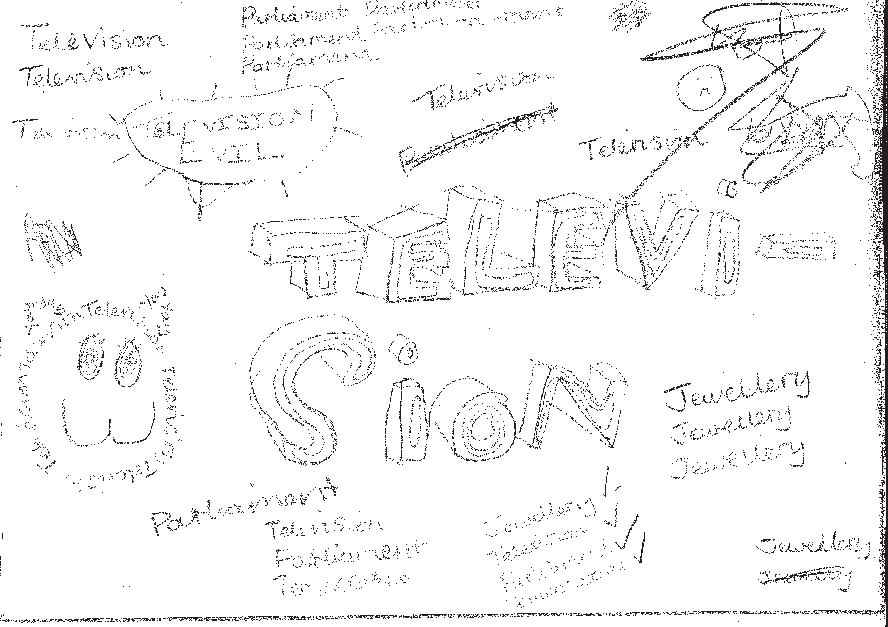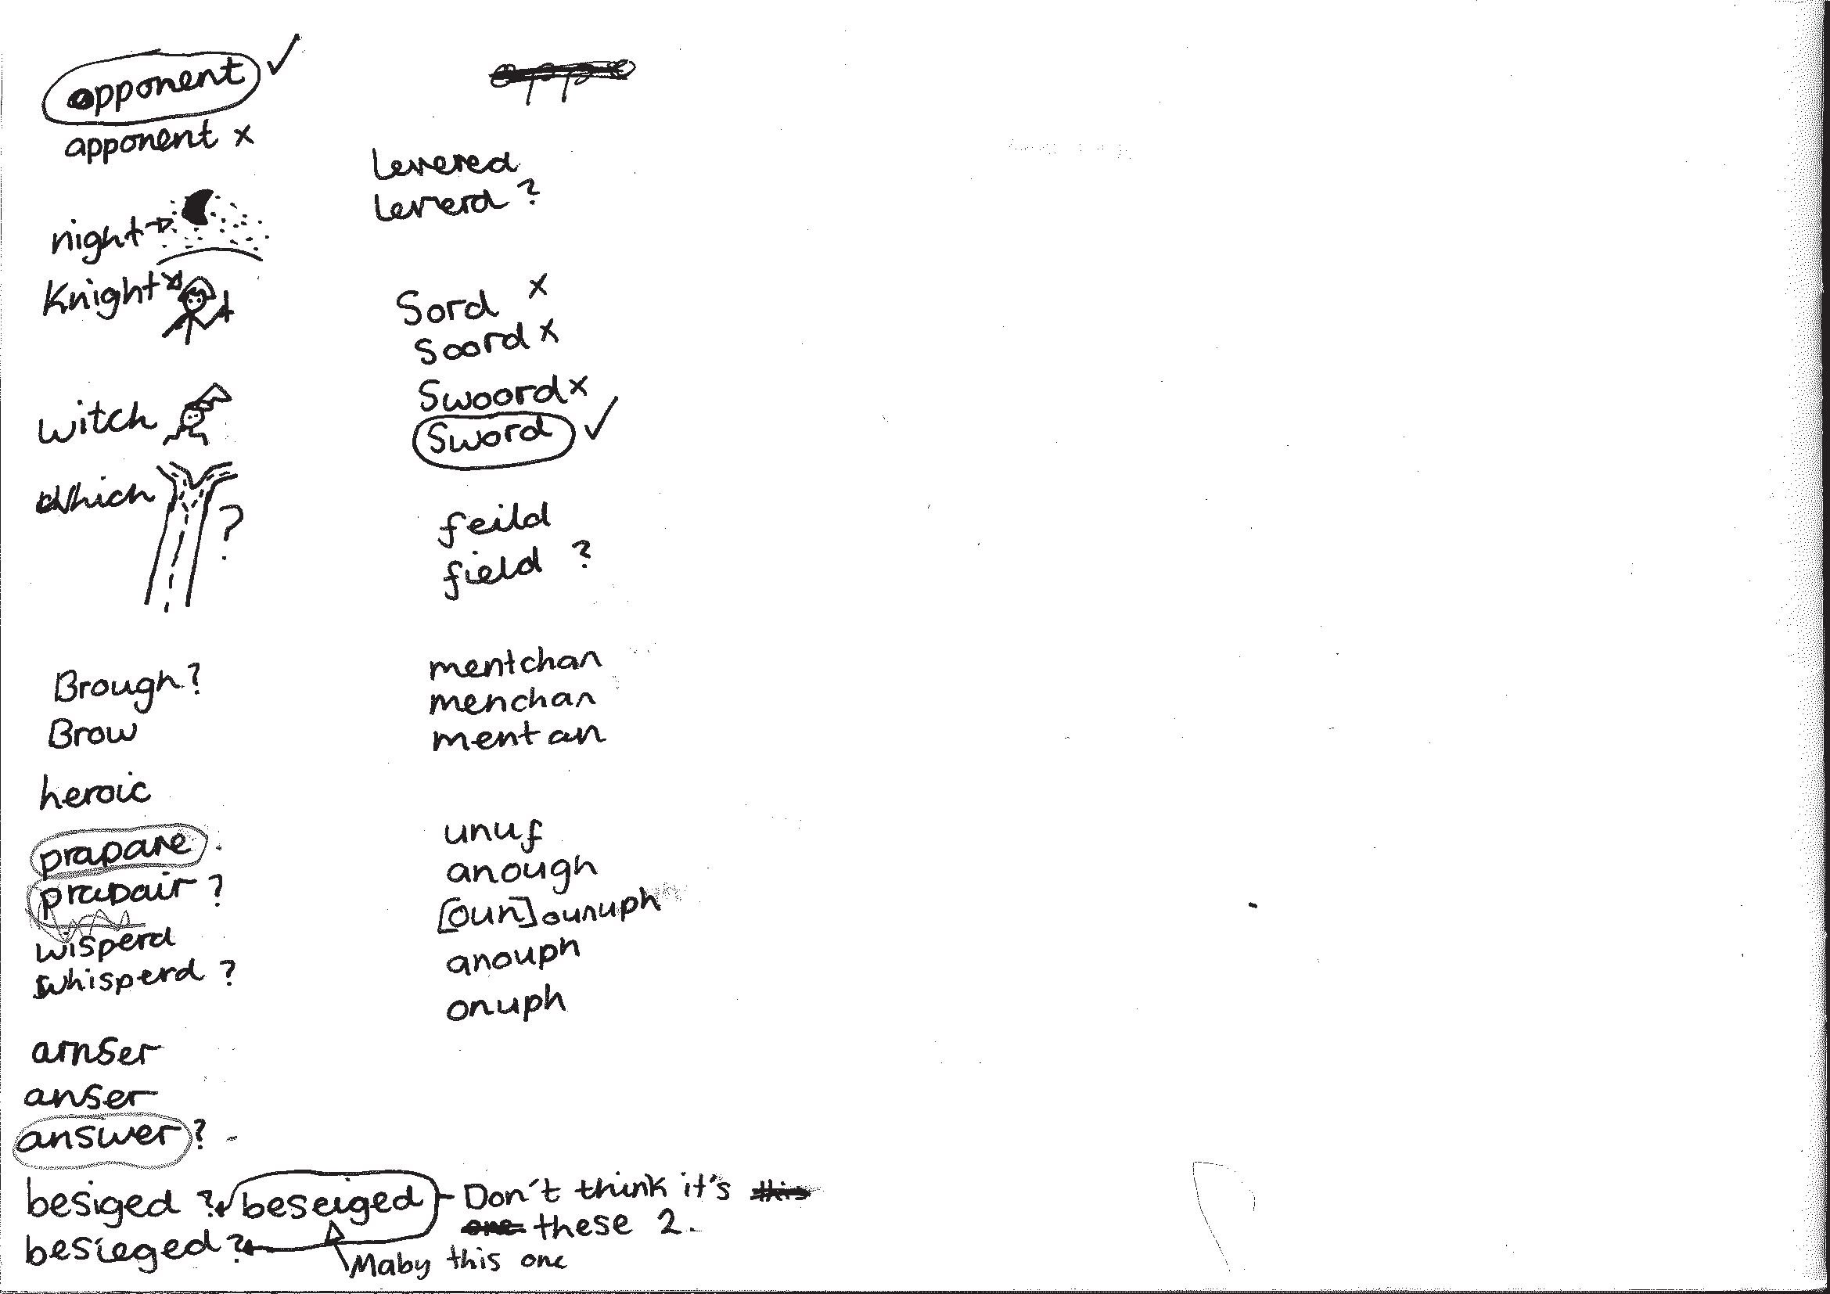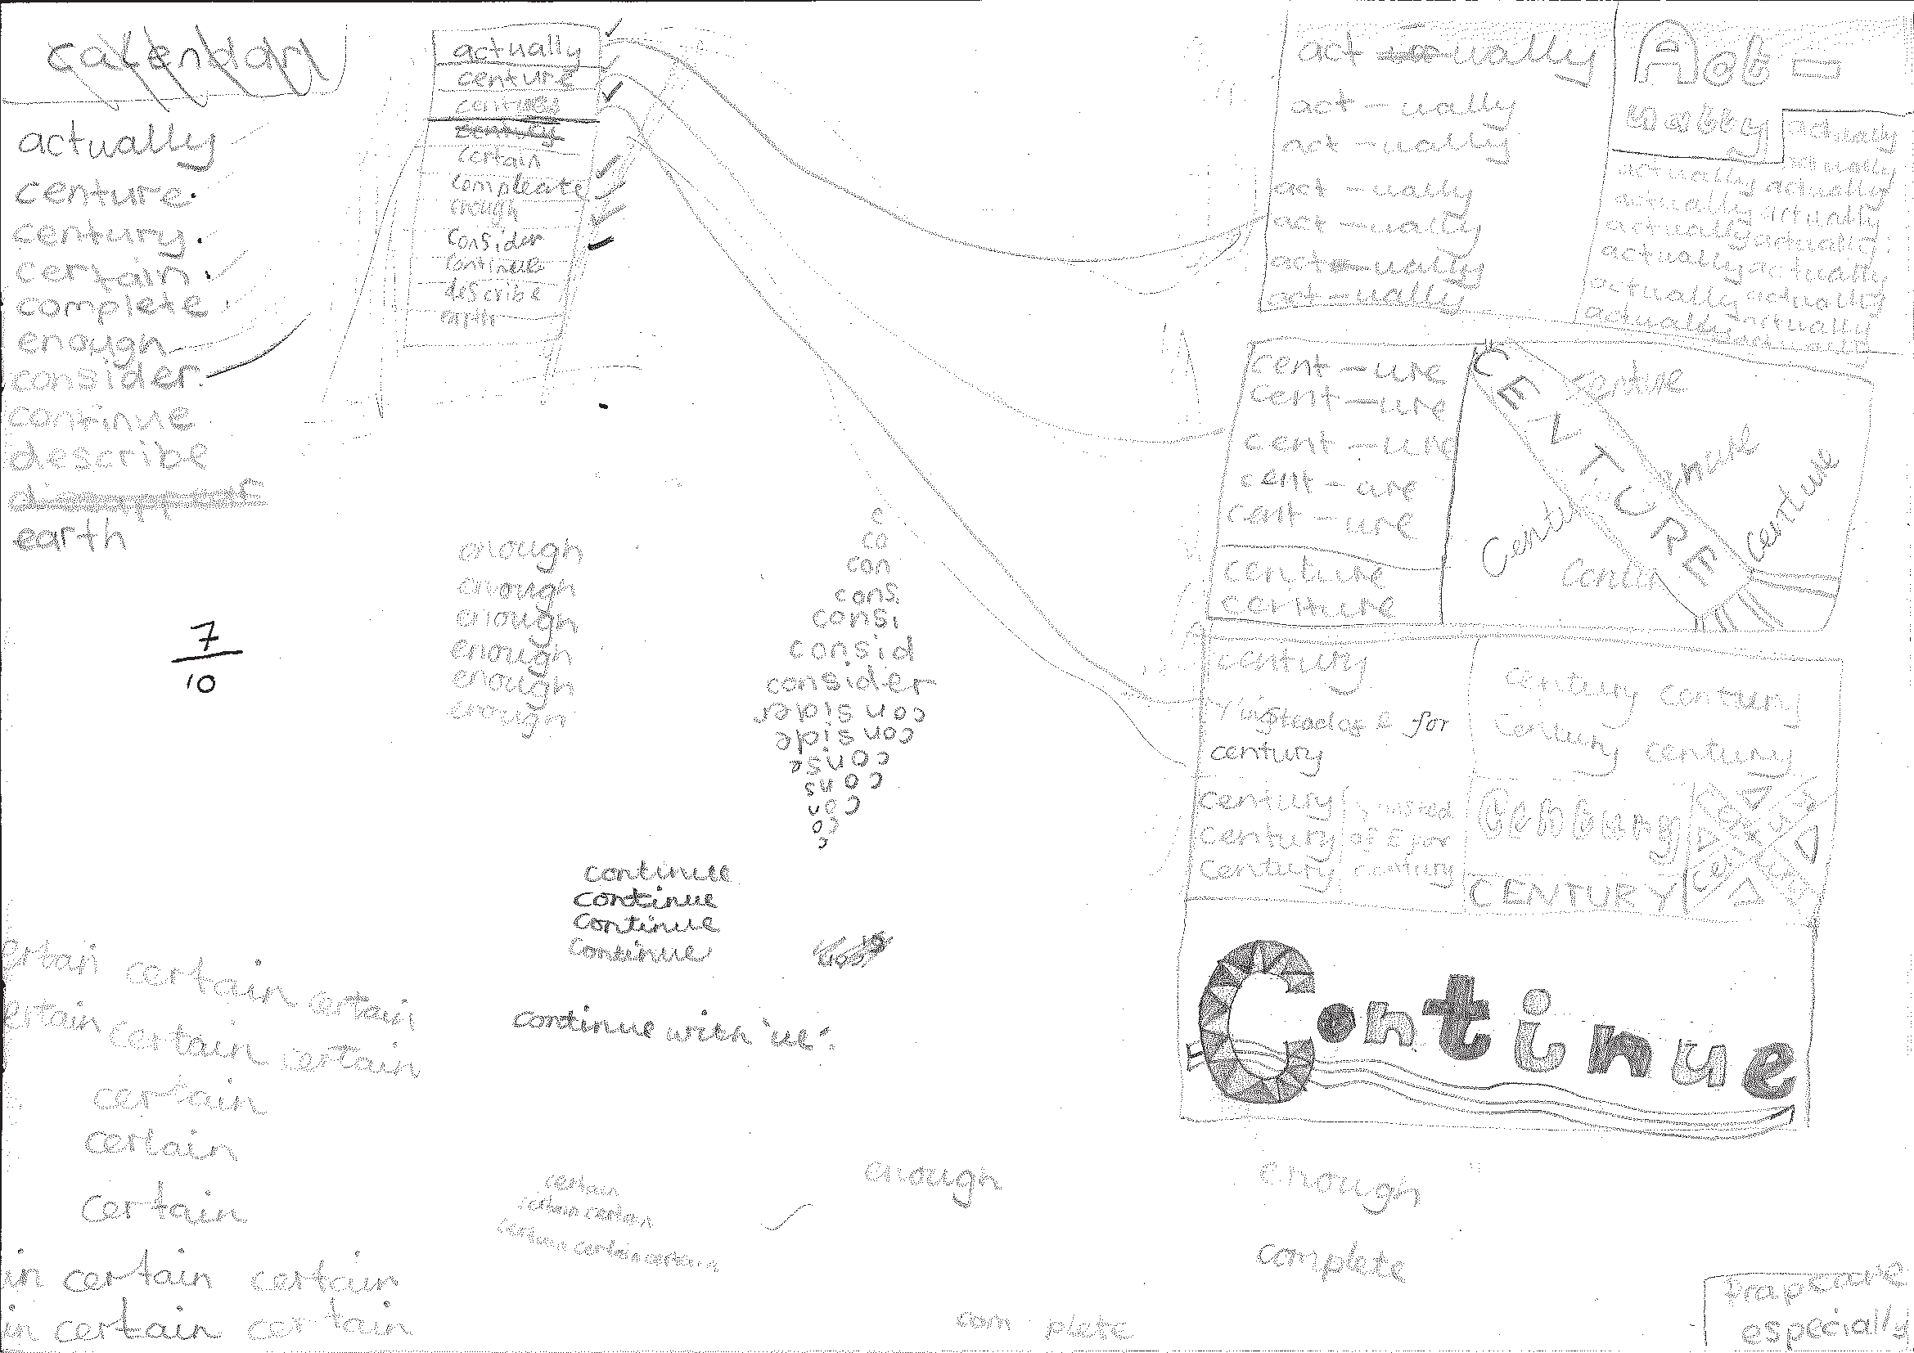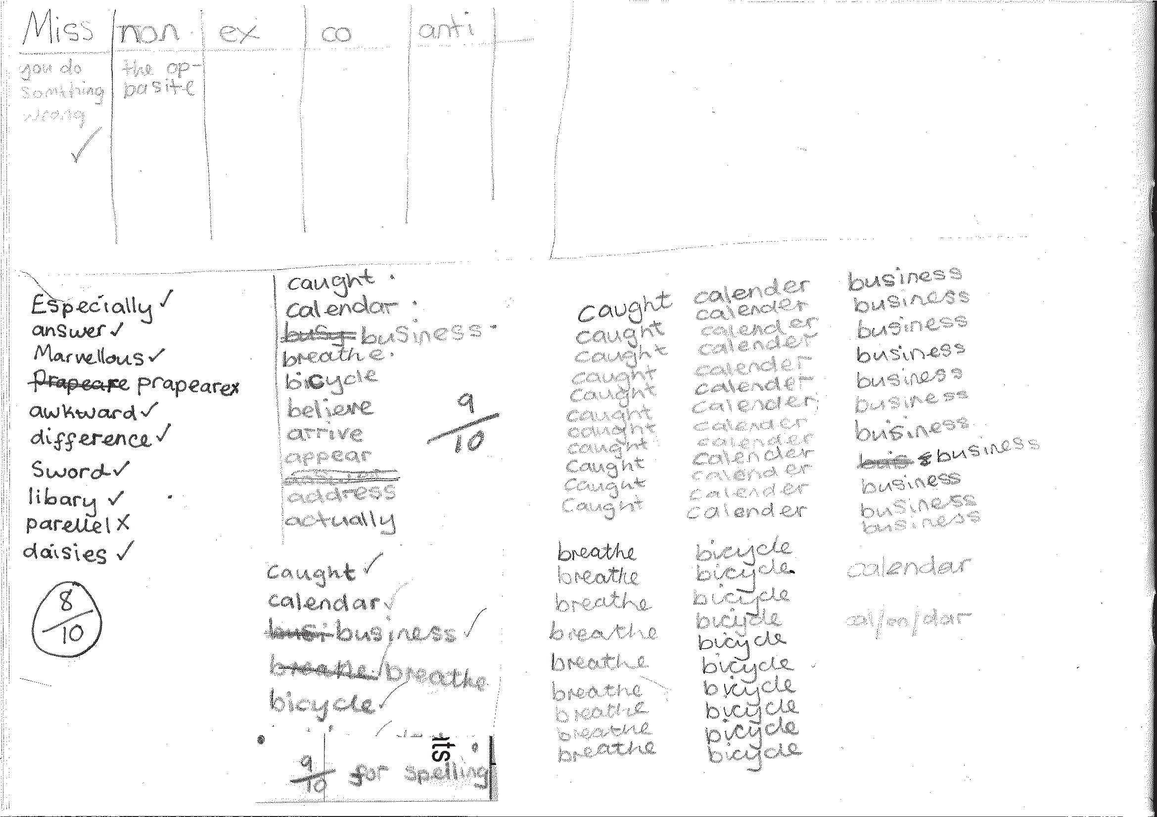To support the teaching, additional resources are recommended and referred to throughout the programme.

Developing the use of spelling journals can support both teachers and pupils in many ways. They enable

  - pupils to take responsibility for their spelling learning
  - pupils to refer back to previous learning
  - teachers to see how pupils are tackling tricky bits of spelling
  - teachers and pupils to discuss spelling with parents and carers

Spelling journals
Spelling journals can take many forms and are much more than just a word book. Spelling journals can be used for

- practising strategies
- learning words
- recording rules/conventions/generalisations as an aide-memoire
- word lists of really tricky words (spelling enemies)
- ‘Having a go’ at the point of writing
- ongoing record of statutory words learnt
- investigations
- recording spelling targets or goals
- spelling tests.

In the programme, there is flexibility for journals to be set up in a variety of ways. Below are a few recommendations:

- Make sure that the journal can be used flexibly. A blank exercise book gives much more scope for pupils to try out ideas
and organise their learning than a heavily structured format.
- Model different ways of using the journal.
A class spelling journal or examples from different pupils could be used to do this.
- Give time for pupils to use their journals and to review them.
- Do the majority of spelling work in the journal.

7

Have a go sheets | These are a key component of Strategies at the point of writing. They are introduced in the Year 2 programme and then revisited in Years 3, 4, 5 and  6. Schools need to decide how Have a go will form part of their spelling policy, together with the use of spelling journals and establishing routines for attempting unknown spellings. A Have a go sheet template is provided in the Supporting Resources.  Have a go sheets can take several different forms, for example:  - a large sheet of paper on a table that pupils write on when they need to.  - sheets stuck in all pupils’ books that fold out when pupils are writing  - a book placed on the table open at a clean sheet for pupils to use.  - a page in pupils’ spelling journals.  Note: it is important that teachers have an enlarged version of a Have a go sheet displayed for modelling when writing in any curriculum area and at any time in the school day.  Introducing Have a Go:  - Model writing a sentence and being unsure about how to spell a word. Talk about the tricky part in the word and some of the choices you might have for that part. You could refer to a GPC chart to find the choices if appropriate.  - Model writing the word with two or three choices on your own enlarged version of a Have a go sheet and then model choosing the one that you think looks right and using it in your sentence. It is important that pupils learn to ask themselves the question ‘Does it look right?’ or ‘Have I seen it like this in a book?’ to help them make their choices.  - If you are still unsure of the spelling, put a wiggly line under it in the sentence to signal that this needs checking by the teacher, or the pupil if appropriate, during proofreading time.  - Model continuing with writing and not checking the correct version of the spelling at this point. This is important so that the flow of writing is not unnecessarily slowed.  5. Make sure you model this process briefly in writing in all curriculum areas.  - Pupils use their own Have a Go sheet (or group sheet) whenever they write and refer to GPC charts and other classroom displays as support, as well as specific strategies that have been taught for using at the point of writing.  - Remind them never to make more than three attempts at a word.  Misspelt words will need to be corrected in line with your school’s spelling and marking policy. Some of these words may be included in pupils’ individual word lists for learning.  To see lessons where Have a go strategies are first introduced, please refer to  Year 2 Block 1 Lessons 11 and 17.
GPC (grapheme- phoneme correspondence) choices chart | The teaching of spelling complements very much the teaching of phonics. It is anticipated that the school will draw upon the GPC charts used in their phonics programme to work alongside the teaching of spelling.

Individual whiteboards | Individual whiteboards these can be used in a variety of ways to support lessons including checking spelling attempts, Quickwrite and Have a go.
Working wall | It is really useful to have a small area of display space in the classroom that can reflect current teaching focuses and provide support for pupils’ spelling as they write. GPC charts, reminders of common spelling patterns or conventions and tricky words to remember could be part of a working wall for spelling.

Learning spellings

A school policy can help inform

the strategies for learning spellings that are being taught

routines for learning spellings

links with home learning.

Learning needs to happen in school and at home. There is little evidence, though, that the tradi- tional practice of learning spellings (usually 10) at home and being tested on them (usually on a Friday) is effective. However, there is a high expectation within the new National Curriculum that pupils will learn many increasingly complex words. Within the programme, learning spellings is built into each six-week block. Within the sessions a range of strategies for learning spellings are introduced and practised. This enables pupils to choose the strategies they find most effective for learning different words.

Tips for learning spellings at home

Learning at home needs to be an extension of the practice in school. Consider

limiting the number of words to five or less a week to ensure success and enable deeper

learning

making sure pupils and parents have access to the range of learning strategies which have been taught in school, to use in home learning

assessing spellings in context, for example: learning spellings in a given sentence, generating sentences for each word, assessing through unseen dictated sentences

keeping an ongoing record of words learnt and setting very high expectations of correct application in writing once a word has been learned.

The learning strategies on the next two pages are introduced incrementally throughout the pro- gramme and can then be used to support learning spellings at home.

9

Look, say, cover, write, check | This is probably the most common strategy used to learn spellings.  Look: first look at the whole word carefully and if there is one part of the word that is difficult, look at that part in more detail.  Say: say the word as you look at it, using different ways of pronouncing it if that will make it more memorable.  Cover: cover the word.  Write: write the word from memory, saying the word as you do so.  Check: Have you got it right? If yes, try writing it again and again! If not, start again – look, say, cover, write, check.
Trace, copy and replicate  (and then check) | This is a similar learning process to ‘look, say, cover, write, check’ but is about developing automaticity and muscle memory.  Write the word out on a sheet of paper ensuring that it is spelt correctly and it is large enough to trace over. Trace over the word and say it at the same time. Move next to the word you have just written and write it out as you say it. Turn the page over and write the word as you say it, and then check that you have spelt it correctly.  If this is easy, do the same process for two different words at the same time. Once you have written all your words this way and feel confident, miss out the tracing and copying or the tracing alone and just write the words.
Segmentation strategy | The splitting of a word into its constituent phonemes in the correct order to support spelling.
Quickwrite | Writing the words linked to the teaching focus with speed and fluency. The aim  is to write as many words as possible within a time constraint.  Pupils can write words provided by the teacher or generate their own examples. For example, in two minutes write as many words as possible with the /iː/ phoneme.  This can be turned into a variety of competitive games including working in teams and developing relay race approaches.
Drawing around the word to show the shape | Draw around the words making a clear distinction in size where there are ascenders and descenders. Look carefully at the shape of the word and the letters in each box. Now try to write the word making sure that you get the same shape.

10

Drawing an image around the word | This strategy is all about making a word memorable. It links to meaning in order to try to make the spelling noticeable.  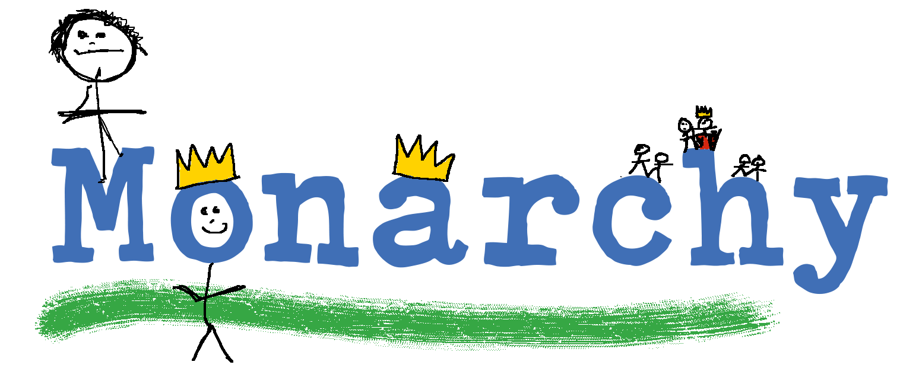  You can’t use this method as your main method of learning spellings, but it  might work on those that are just a little more difficult to remember.
Words without vowels | This strategy is useful where the vowel choices are the challenge in the words. Write the words without the vowels and pupils have to choose the correct grapheme to put in the space. For example, for the word field:
Pyramid words | This method of learning words forces you to think of each letter separately.  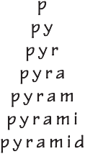  You can then reverse the process so that you end up with a diamond.
Other strategies | Other methods can include:  - Rainbow writing. Using coloured pencils in different ways can help to make parts of words memorable. You could highlight the tricky part s of the word or write the tricky part in a different colour. You could also write each letter in a different colour, or write the word in red, then overlay in orange, yellow and so on.  - Making up memorable ‘silly sentences’ containing the word  - Saying the word in a funny way – for example, pronouncing the ‘silent’ letters in a word  - Clapping and counting to identify the syllables in a word.

11

Year 5 National Curriculum requirements

Pupils should be taught to

develop a range of personal strategies for learning new and irregular words*

develop a range of personal strategies for spelling at the point of composition*

develop a range of strategies for checking and proof reading spellings after writing*

use further prefixes and suffixes and understand the guidance for adding them
  - spell some words with ‘silent’ letters (for example, knight, psalm, solemn)

continue to distinguish between homophones and other words which are often confused

use knowledge of morphology and etymology in spelling and understand that the spelling of

some words needs to be learnt specifically, as listed in English Appendix 1

use dictionaries to check the spelling and meaning of words

use the first three or four letters of a word to check spelling, meaning or both of these in a

dictionary

use a thesaurus

proofread for spelling errors.

* non-statutory

12

Year 5 lesson plans

Year 5 Term 1 overview

Block 1 – autumn first half term

Week 1 | Lesson 1 Revise  Strategies at the point of writing: Have a go | Lesson 2 Teach  Words with the letter string ‘ough’ | Lesson 3 Practise  Words with the letter string ‘ough
Week 2 | Lesson 4 Apply  Words with the letter string ‘ough’ | Lesson 5 Teach  Words with ‘silent’ letters
Week 3 | Lesson 6 Learn  Strategies for learning words: words with ‘silent’ letters from statutory and personal spelling lists | Lesson 7 Assess  Words with ‘silent’ letters: dictation | Lesson 8 Teach  Use of spelling journals for etymology
Week 4 | Lesson 9 Teach  Words ending in ‘-able’ and ‘-ible’ | Lesson 10 Practise  Words ending in ‘-able’ and ‘-ible’
Week 5 | Lesson 11 Assess  Words ending in ‘-able’ and ‘-ible’ | Lesson 12 Teach  Homophones (isle/aisle, aloud/allowed, affect/effect, herd/heard, past/passed) | Lesson 13 Practise  Homophones (isle/aisle, aloud/allowed, affect/effect, herd/heard, past/passed)
Week 6 | Lesson 14 Apply  Strategies for learning words: homophones (isle/ aisle, aloud/allowed, affect/ effect, herd/heard, past/ passed) | Lesson 15 Learn  Strategies for learning words: words from statutory and personal spelling lists

13

Block 2 – autumn second half term

Week 1 | Lesson 1 Revise  Selected spellings taught last half term and new spellings for this half term | Lesson 2 Revise  Selected spellings taught last half term and new spellings for this half term | Lesson 3 Revise/Teach  Selected spellings taught last half term and new spellings for this half term
Week 2 | Lesson 4 Revise/Teach  From previous years: plurals (adding ‘-s’, ‘-es’ and ‘-ies’ | Lesson 5 Revise  From previous years: apostrophe for contraction and possession
Week 3 | Lesson 6 Learn  Strategies for learning words: words from statutory and personal spelling lists | Lesson 7 Teach  Use of the hyphen | Lesson 8 Practise  Use of the hyphen
Week 4 | Lesson 9 Assess  Use of the hyphen | Lesson 10 Learn  Strategies for learning words: words from statutory and personal spelling lists.
Week 5 | Lesson 11 Teach  Proofreading, focusing on checking words from personal lists | Lesson 12 Practise  Proofreading, focusing on checking words from personal lists | Lesson 13 Teach  Using a dictionary to support learning word roots, derivations and spelling patterns
Week 6 | Lesson 14 Practise  Using dictionaries to create word webs | Lesson 15 Assess  Strategies at the point of writing: building new words from known morphemes

14

Block 1 – autumn first half term

Lesson | Year 5, block 1, lesson 1
Lesson type | Revise
Lesson focus | Strategies at the point of writing: Have a go
Resources needed | Supporting Resource 5.2 (Have a go sheet)
Teaching activity | Model writing using a Have a go sheet (see Introduction page 8) and remind pupils of the strategies you might use to spell the word you want.  Remind them that they don’t need to make more than three attempts at spelling before choosing the one they think looks right.  If they are not sure they have the correct spelling, they should draw a line under the word in their writing to alert you to this fact.  Words not spelt correctly can form part of the personal list of words to learn.

Lesson | Year 5, block 1, lesson 2
Lesson type | Teach
Lesson focus | Words with the letter string ‘ough’
Resources needed | Supporting Resources 5.4 (poem) and 5.5 (‘ough’ words)
Teaching activity | Introduce pupils to the poem.  In small groups see if they can read it so it makes sense. What makes this poem tricky?  Read as a shared read all together and underline the ‘ough’ words.  Ask pupils to identify how many different sounds the letter string ‘ough’ can make.  Make a table for the working wall with the ‘ough’ words from the poem at the top.

Lesson | Year 5, block 1, lesson 3
Lesson type | Practise
Lesson focus | Words with the letter string ‘ough’
Resources needed | Supporting Resource 5.5 (‘ough’ words), spelling journals
Teaching activity | Give pupils the set of words containing ‘ough’ and a copy of the table from the previous lesson to stick in their spelling journals.  In pairs pupils sort the words according to how the ‘ough’ grapheme is pronounced.  Pupils look up any words they don’t know in a dictionary to check meaning and pronunciation.  They identify any tricky words to add to their personal spelling lists.

15

Block 1 – autumn first half term

Lesson | Year 5, block 1, lesson 4
Lesson type | Apply
Lesson focus | Words with the letter string ‘ough’
Resources needed | Supporting Resource 5.4 (poem) and 5.5 (‘ough’ words)
Teaching activity | Pupils work in pairs to write their own ‘ough’ poem or sentences, using as many of the words with the ‘ough’ letter string as they can, whilst ensuring it makes sense.  Share the results!

Lesson | Year 5, block 1, lesson 5
Lesson type | Teach
Lesson focus | Words with ‘silent’ letters
Resources needed | Supporting Resource 5.6 (words with ‘silent’ letters), spelling journals or interactive whiteboards
Teaching activity | Explain to pupils that we already know that letters don’t make single sounds and that graphemes represent phonemes, for example, ‘sh’.  In some words there are some more unusual graphemes with letters that are sometimes called ‘silent’ letters.  Can they think of any words they have come across like that?  Give pupils a spelling test of silent letters. Read out the words from the list provided and in pairs pupils try to spell them on their whiteboards or in their spelling journals.  Compare spellings in small groups and then write them together on the board, drawing attention to the ‘silent’ letter. Discuss what the grapheme is and what sound it stands for, for example, in the word doubt ‘bt’ stands for a /t/ sound.  Can they think of any other words with these ‘silent’ letter graphemes? Record them.

16

Block 1 – autumn first half term

Lesson | Year 5, block 1, lesson 6
Lesson type | Learn
Lesson focus | Strategies for learning words: words with ‘silent’ letters from statutory and personal spelling lists
Resources needed | Statutory list for Years 5 and 6 (page 52), personal spelling lists
Teaching activity | Choose words from the statutory list for pupils to learn and pupils choose words from their personal lists. Revise the strategies below.  Pupils learn spellings using a strategy that suits them and each word best:  - Pyramid words  - Trace, copy and replicate  - Look, say, cover, write, check  - Drawing around the word to show the shape  - Drawing an image around the word  - Words without vowels

Lesson | Year 5, block 1, lesson 7
Lesson type | Assess
Lesson focus | Words with ‘silent’ letters: dictation
Resources needed | Spelling journals
Teaching activity | Dictate the following sentences to assess the use of silent letters in words:  There is no doubt that knights were very solemn.  If you don’t wear your knickers, people will whistle and you will go numb. Lambs like to munch on thistles in autumn.  Check, correct and discuss which words were tricky. Pupils add any tricky words to their personal word lists.

17

Block 1 – autumn first half term

Lesson | Year 5, block 1, lesson 8
Lesson type | Teach
Lesson focus | Use of spelling journals for etymology
Resources needed | Supporting Resource 5.7 (words from other languages), dictionaries, spelling journals
Teaching activity | Introduce the idea that many of the words in the English language have come from other languages, both ancient and modern. Sometimes knowing where words have come from helps us to remember and understand their spellings. Studying this is called the ‘etymology’ of language and words.  Look at a couple of words and discuss where they came from:  mobile: comes from the Latin word mobilis which means ‘moveable’. marathon: comes from the story of a Greek hero, Pheidippides, who ran the 26 miles to Athens from the Plains of Marathon to tell of the Greek victory over the Persian army.  Model how you can work out the etymology of the words and also how you can  find them in a dictionary. You will need to use good dictionaries for this activity.  Put pupils in pairs and give them the list of words provided. Ask them to see if they can find out the etymology of some of the words and record them in their spelling journals.  Pupils could set up a page in their journals where they collect other interesting derivations of words, or note tricky spellings where the derivation helps them.  Notes:  The derivations are listed below.  - adder: Old English naedre, meaning ‘snake’  - bungalow: Indian for a one-storey house  - genie: Latin genius, meaning ‘guardian spirit’  - limbo: Latin limbus, meaning the place where souls go that cannot enter heaven  - salary: Latin sal, meaning ‘salt’. Roman soldiers were paid with salt.  - vandal: Latin, meaning a member of a Germanic people that sacked Rome in 455 AD  - hamburger: German Hamburger steak, meaning meat from Hamburg  - magazine: French magasin, meaning ‘storehouse’  - ketchup: Chinese, meaning ‘fish sauce’  - monster: Latin monere, meaning ‘to warn’

18

Block 1 – autumn first half term

Lesson | Year 5, block 1, lesson 9
Lesson type | Teach
Lesson focus | Words ending in ‘-able’ and ‘-ible’
Resources needed | Supporting Resource 5.8 (words ending in ‘-able’ and ‘-ible’), spelling journals
Teaching activity | Explain that the suffixes ‘-able’ and ‘-ible’ can be tricky because they often sound  the same.  Tell pupils that, whilst there aren’t hard and fast rules, we are going to investigate to see if there are any conventions to help us to remember the spellings.  Model looking at an ‘-able’ word and an ‘-ible’ word.  Show pupils how to mark the suffix (and therefore look at the root word).  In pairs or small groups, pupils are given the list of ‘-able’/’-ible’ words and have five minutes to investigate the words and see if they can find any patterns. Come back together and share ideas.  Explain that they will continue to explore these ideas and any new ideas in the next session.  Notes:  - ‘-able’ is more common than ‘-ible’.  - The ‘-able’ ending is usually used (but not always) if a complete root word can be heard before it. In some cases the ending of the root word may change, for example. rely/reliable.  - The ‘-ible’ root is common if a complete root word cannot be heard before it (but not without exception, for example sensible).  - The ‘-able’ ending is used if there is a related word ending in ‘-ation’ for example, applicable/application.

Lesson | Year 5, block 1, lesson 10
Lesson type | Practise
Lesson focus | Words ending in ‘-able’ and ‘-ible’
Resources needed | Supporting Resource 5.8 (words ending in ‘-able’ and ‘-ible’), spelling journals
Teaching activity | Continue investigating the ‘-ible’ and ‘-able’ words.  For some groups introduce the idea of exploring if an ‘-ation’ word could also be made from the root word.  Pupils record ideas in their spelling journals. Share patterns discovered as a class and ensure that the key ideas listed in the notes in the last lesson are discovered.  Give a few minutes for pupils to record any ideas they didn’t discover in their spelling journals.

19

Block 1 – autumn first half term

Lesson | Year 5, block 1, lesson 11
Lesson type | Assess
Lesson focus | Words ending in ‘-able’ and ‘-ible’
Resources needed | Supporting Resource 5.8 (words ending in ‘-able’ and ‘-ible’), spelling journals
Teaching activity | Do a quick spelling test for the whole class, reading out a mixture of ‘-able’ and ‘-ible’ words.  Pupils see if they can apply the conventions and spell most of them correctly. Use some new words (see list provided).

Lesson | Year 5, block 1, lesson 12
Lesson type | Teach
Lesson focus | Homophones (isle/aisle, aloud/allowed, affect/effect, herd/heard, past/ passed)
Resources needed | Supporting Resource 5.9 (homophone cards), dictionaries
Teaching activity | Pupils work in pairs.  Give a pair of homophone cards to each pair of pupils.  Give them five minutes to work out what each word means and give an example  sentence to contextualise it.  Pupils can use dictionaries if needed.  Clarify the meaning of each word as a class.  Share the sentences and record homophones on the board, identifying the tricky bits of the word.

Lesson | Year 5, block 1, lesson 13
Lesson type | Practise
Lesson focus | Homophones (isle/aisle, aloud/allowed, affect/effect, herd/heard, past/ passed)
Resources needed | Supporting Resource 5.9 (homophone cards), spelling journals
Teaching activity | Revisit what the tricky bit of each homophone is in terms of spelling and discuss if there are any easy ways to remember them.  For example, affect is a verb and effect is a noun; past is a preposition and  passed is the past participle of the verb ‘to pass’.  Record all homophones in journals and note any easy tips for remembering them.

20

Block 1 – autumn first half term

Lesson | Year 5, block 1, lesson 14
Lesson type | Apply
Lesson focus | Strategies for learning words: homophones (isle/aisle, aloud/allowed, affect/effect, herd/heard, past/passed)
Resources needed | Supporting Resource 5.9 (homophone cards), spelling journals
Teaching activity | Practise handwriting all the homophones. Use some of the pupils’ example sentences.  Read them out and pupils write down the correct version of the homophone. Check spellings as a class.

Lesson | Year 5, block 1, lesson 15
Lesson type | Learn
Lesson focus | Strategies for learning words: words from statutory and personal spelling lists
Resources needed | Statutory list for Years 5 and 6 (page 52), personal spelling lists
Teaching activity | Pupils learn spellings using a strategy that suits them and each word best:  - Pyramid words  - Trace, copy and replicate  - Look, say, cover, write, check  - Drawing around the word to show the shape  - Drawing an image around the word  - Words without vowels  Pupils work with a partner to test spellings and identify words that still need to be learnt.  You may need to provide an extra session for pupils to learn these words.

21

Block 2 – autumn second half term

Lesson | Year 5, block 2, lessons 1 and 2
Lesson type | Revise
Lesson focus | Selected spellings taught last half term and new spellings for this half term
Resources needed | Selected words from statutory and personal lists, personal spelling lists for each pupil,
Teaching activity | Identify elements from the previous half term that need consolidation.  Revisit key activities identified in the previous lesson as requiring consolidation. Use your ongoing assessment to identify key concepts or activities to revisit from this half term’s work.  You may choose to repeat lessons or particular activities to ensure that learning is secure.

Lesson | Year 5, block 2, lesson 3
Lesson type | Revise/Teach
Lesson focus | Selected spellings taught last half term and new spellings for this half term
Resources needed | Selected words from statutory and personal lists, personal spelling lists for each pupil,
Teaching activity | Pupils work with a partner to test spellings and identify words that still need to be learnt.  Set up words from statutory lists to be learnt by each pupil across this half term.

22

Block 2 – autumn second half term

Lesson | Year 5, block 2, lesson 4
Lesson type | Revise/Teach
Lesson focus | From previous years (plurals, adding ‘–s’, ‘-es’ and ‘-ies’)
Resources needed | Supporting Resource 5.10 (word list for plurals), spelling journals
Teaching activity | Pupils work in pairs. They talk to each other and see if they can remember any ways to make a word plural.  Show the first three words below to prompt them to remember the conventions:  bus cup baby  Revise the conventions (see the notes below). Play a version of Quickwrite (see page 10) in pairs. Show a word at a time from the list provided.  Pupils write the plural of that word as quickly as possible on their whiteboards or in their spelling journals.  Pupils check their answers in pairs.  Then run through the whole list as a class and discuss any tricky ones.  Give pupils time to record any information they had forgotten in their spelling journals.  Notes:  - Most nouns add ‘-s’ in the plural.  - Nouns ending in a hissing/buzzing/shushing sound add ‘-es’ because it makes  it easier to say.  - Nouns ending in ‘-y’ change the ‘y’ to ‘i’ and add ‘-es’  - Several nouns ending in ‘o’ add ‘-es’ (potato), but newer words just add ‘-s’ (radio).

Lesson | Year 5, block 2, lesson 5
Lesson type | Revise
Lesson focus | From previous years: apostrophe for contraction and possession
Resources needed | Examples of real road signs with apostrophes in the wrong place or absent, spelling journals
Teaching activity | Revisit with the class what they have learnt previously about apostrophes for:  - contraction  - singular possession  - plural possession.  Play ‘Hunt the mistake’. In pairs, look at the images you have collected and see how many errors there are. In their spelling journals, pupils correct the error.  Collect all errors and revisions together at the end as a class and ensure that they all understand the errors.

23

Block 2 – autumn second half term

Lesson | Year 5, block 2, lesson 6
Lesson type | Learn
Lesson focus | Strategies for learning words: words from statutory and pupils’ personal spelling lists
Resources needed | Statutory list for Years 5 and 6 (page 52), personal spelling lists
Teaching activity | Pupils learn spellings using a strategy that suits them and each word best:  - Pyramid words  - Trace, copy and replicate  - Look, say, cover, write, check  - Drawing around the word to show the shape  - Drawing an image around the word  - Words without vowels

Lesson | Year 5, block 2, lesson 7
Lesson type | Teach
Lesson focus | Use of the hyphen
Resources needed | Supporting Resource 5.11 (root words, prefixes and hyphen cards)
Teaching activity | Model for pupils how to use a hyphen when a prefix is added which ends with the  same vowel as the start of the root word.  Use the root word cards, cards with prefixes ‘co-’ and ‘re-’ and a hyphen card.  Create words by adding the prefix to the root and discuss when to add a hyphen.  Discuss the meaning of words to ensure that they are real words.

Lesson | Year 5, block 2, lesson 8
Lesson type | Practise
Lesson focus | Use of the hyphen
Resources needed | Supporting Resource 5.11 (root words, prefixes and hyphen cards)
Teaching activity | Use the root words from the last session and give small groups of pupils sets of words to use.  Ask the group to pick a root word and a prefix and decide:  - Is it a real word?  - Does it need a hyphen?  The group writes a sentence for each real, hyphenated word that they make. Share the sentences as a class.  Check that the words make sense and the pupils have used the hyphen correctly.

24

Block 2 – autumn second half term

Lesson | Year 5, block 2, lesson 9
Lesson type | Assess
Lesson focus | Use of the hyphen
Resources needed | Spelling journals
Teaching activity | Dictate the following sentences:  What are the co-ordinates for the meeting place? Let’s do it together, so we don’t all reinvent the wheel. When we work in groups, it is important to co-operate.  Check, correct and discuss which words were tricky. Pupils add any tricky ones to their personal word lists.

Lesson | Year 5, block 2, lesson 10
Lesson type | Learn
Lesson focus | Strategies for learning words: words from statutory and personal spelling lists
Resources needed | Statutory list for Years 5 and 6 (page 52), pupils’ personal lists,
Teaching activity | Pupils learn spellings using a strategy that suits them and each word best:  - Pyramid words  - Trace, copy and replicate  - Look, say, cover, write, check  - Drawing around the word to show the shape  - Drawing an image around the word  - Words without vowels  Pupils work with a partner to test spellings and identify words which still need to be learnt.

25

Block 2 – autumn second half term

Lesson | Year 5, block 2, lesson 11
Lesson type | Teach
Lesson focus | Proofreading, focusing on checking words from personal lists
Resources needed | Examples of pupils’ writing
Teaching activity | Remind pupils that the purpose of proofreading is to ensure that writing is accurate and also to identify any spelling errors that need to be corrected.  The words they have been learning as personal spellings have come from their own writing.  Model with one pupil’s work:  - Write up the personal spellings that have been learnt this term.  - Check through a couple of pieces of writing (use a visualiser or scan them in) to check that those words have not been spelt incorrectly.  Where errors are found, correct them in a different coloured pen.

Lesson | Year 5, block 2, lesson 12
Lesson type | Practise
Lesson focus | Proofreading, focusing on checking words from personal lists
Resources needed | Examples of pupils’ writing
Teaching activity | Pupils repeat the activity modelled in the previous lesson with their own spelling lists and writing.  At the end of the session, share any common errors and discuss whether the pupils found the activity useful. Stress that they are expected to check for their spellings whenever they proofread.

Lesson | Year 5, block 2, lesson 13
Lesson type | Teach
Lesson focus | Using a dictionary to support learning word roots, derivations and spelling patterns
Resources needed | Supporting Resource 5.12 (telephone word web), dictionaries
Teaching activity | Model using a dictionary to create a word web. Show the example in the Supporting Resource.  Pupils then use the dictionaries to find other words and to check the meaning  and derivation of the words used.

26

Block 2 – autumn second half term

Lesson | Year 5, block 2, lesson 14
Lesson type | Practise
Lesson focus | Using dictionaries to create word webs
Resources needed | Supporting Resource 5.13 (word web list)
Teaching activity | In pairs or threes, pupils choose a starting word from the list provided and create their own word webs, using dictionaries to support word generation and to check meaning.  Tell the groups that you might ask for the meaning of any word that they put into their web at the end of the session.

Lesson | Year 5, block 2, lesson 15
Lesson type | Assess
Lesson focus | Strategies at the point of writing: building new words from known morphemes
Resources needed | Supporting Resource 5.13 (word web list), spelling journals, individual whiteboards
Teaching activity | Write the words used as base words for the word webs in the previous lesson on the board.  Give a spelling test of new words we could derive from these (examples are below). Pupils work them out in pairs and write them on their whiteboards or in their spelling journals:  defensive refine microscopic telescope quadruple asteroid

27

Year 5 term 2 overview

Block 3 – spring first half term

Week 1 | Lesson 1 Revise  Strategies at the point of writing: Have a go | Lesson 2 Revise  From Years 3 and 4: apostrophe for possession | Lesson 3  Strategies for learning words: words from personal spelling lists
Week 2 | Lesson 4 Assess  words from statutory and personal spelling lists | Lesson 5 Teach  Rare GPCs (bruise, guarantee, immediately, vehicle, yacht)
Week 3 | Lesson 6 Teach  Rare GPCs (bruise, guarantee, immediately, vehicle, yacht) | Lesson 7 Assess  Rare GPCs: dictation | Lesson 8 Revise/Teach  Using spelling journals for etymology
Week 4 | Lesson 9 Teach  Words ending in ‘-ably’ and ‘-ibly’ | Lesson 10 Practise  Words ending in ‘-ably’ and ‘-ibly’
Week 5 | Lesson 11 Assess  Words ending in ‘-ably’ and ‘-ibly’ | Lesson 12 Teach  Homophones (led/lead, steel/steal, alter/altar) | Lesson 13 Practise  Strategies for learning words: homophones
Week 6 | Lesson 14 Apply Homophones | Lesson 15 Learn/Assess Strategies for learning words: words from statutory and personal spelling lists

28

Block 4 – spring second half term

Week 1 | Lesson 1 Revise  Spellings taught in previous half term | Lesson 2 Revise  Spellings taught in previous half term | Lesson 3 Assess  words from statutory and personal spelling lists
Week 2 | Lesson 4 Teach  Proofreading: checking from another source after writing | Lesson 5 Practise Proofreading
Week 3 | Lesson 6 Learn  Strategies for learning words: words from statutory and personal spelling lists | Lesson 7 Revise  Building words from root words | Lesson 8 Practise  Building words from root words
Week 4 | Lesson 9 Assess  Building words from root words | Lesson 10 Revise Homophones
Week 5 | Lesson 11 Learn  Strategies for learning words: words from statutory and personal spelling lists | Lesson 12 Assess  Words from statutory and personal lists | Lesson 13 Teach  Words with the /i:/ sound spelt ‘ei’
Week 6 | Lesson 14 Teach  ‘ei’ and ‘ie’ words | Lesson 15 Assess  ‘ei’ and ‘ie’ words

29

Block 3 – spring first half term

Lesson | Year 5, block 3, lesson 1
Lesson type | Revise
Lesson focus | Strategies at the point of writing: Have a go
Resources needed | Supporting Resource 5.2 (Have a go sheet)
Teaching activity | Remind pupils how to use Have a go sheets.  Model writing using a Have a go sheet and remind pupils of the strategies they might use to spell the word they want.  Remind them that they don’t need to make more than three attempts at spelling before choosing the one they think looks right.  If they are not sure they have the correct spelling, they should draw a line under the word in their writing to alert you to this fact.  Words not spelt correctly can form part of the personal list of words to learn.

Lesson | Year 5, block 3, lesson 2
Lesson type | Revise
Lesson focus | From Years 3 and 4: apostrophe for possession
Resources needed | Supporting Resource 5.14 (Apostrophe Hangman game)
Teaching activity | Play Apostrophe Hangman. The idea of the game is to guess the word before the teacher draws the hangman.  - Teacher chooses a word (make it a long one) for pupils to try and guess. Write up the number of letters it has as dashes.  - Use the apostrophe sentence cards to be pulled out of a pot, or put them onto the whiteboard and reveal one at a time  - Pupils take it in turns to decide if the sentence uses the apostrophe correctly or not.  - If they guess correctly, they get to suggest a letter in the teacher’s word.  - If they guess incorrectly the teacher gets to draw part of the hangman.  - You could add the option of extra letters for pupils who can rewrite or explain how to correct errors. Pupils could play as small teams to increase the competitive nature of the game.  Notes  When singular proper nouns end in ‘s’, you can either:  - add apostrophe and then ‘s’ (Thomas’s)  - or add just an apostrophe (Thomas’).  The National Curriculum uses the first convention.

30

Block 3 – spring first half term

Lesson | Year 5, block 3, lesson 3
Lesson type | Learn
Lesson focus | Strategies for learning words: words from personal spelling lists
Resources needed | Spelling journals
Teaching activity | Pupils review their writing from the last term and spelling journal work, using their proofreading skills.  Each pupil identifies approximately 10 words that they need to learn and records  them in their spelling journal.  Pupils learn spellings using a strategy that suits them and each word best:  - Pyramid words  - Trace, copy and replicate  - Look, say, cover, write, check  - Drawing around the word to show the shape  - Drawing an image around the word  - Words without vowels  - Any other methods that work  Pupils can take the words home for further learning.

Lesson | Year 5, block 3, lesson 4
Lesson type | Assess
Lesson focus | Words from statutory and personal spelling lists
Resources needed | Statutory list for Years 5 and 6 (page 52), personal spelling lists
Teaching activity | Test the class on the statutory words.  Pupils work with a partner to test personal words.  Identify those words that need further learning and use them in the next session of learning spellings.

31

Block 3 – spring first half term

Lesson | Year 5, block 3, lessons 5 and 6
Lesson type | Teach
Lesson focus | Rare GPCs (bruise, guarantee,immediately, vehicle, yacht)
Resources needed | Supporting Resource 5.15 (rare GPC word list), spelling journals
Teaching activity | Explain that over the next two sessions pupils will be exploring words with very unusual GPCs, and deciding which strategies that they have already learnt will help them remember how to spell them.  Take two to three words in each session and follow this pattern:  - Orally segment the word.  - Write it down and identify which grapheme is tricky.  - Discuss ways of remembering this part. What strategy will they use to learn?  - Are there any other strategies they have used (such as a word webs or matrices) they could explore to help them to understand how the word works?  Pupils record the word in their spelling journal and practise using the strategy discussed.

Lesson | Year 5, block 3, lesson 7
Lesson type | Assess
Lesson focus | Rare GPCs: dictation
Resources needed | Spelling journals
Teaching activity | Dictate the following sentences to assess the rarer GPCs:  I fell off my yacht and the next day, I had a huge bruise.  We guarantee delivery immediately in our extra fast vehicle.  Check, correct and discuss which words were tricky. Pupils add any tricky ones to their personal word lists.

32

Block 3 – spring first half term

Lesson | Year 5, block 3, lesson 8
Lesson type | Revise/Teach
Lesson focus | Using spelling journals for etymology
Resources needed | Supporting Resource 5.16 (sign word web)
Teaching activity | Revise the idea that many of the words, or parts of words, in the English language have come from other languages, both ancient and modern.  Tell pupils that sometimes knowing where words have come from helps us to remember and understand their spelling. This study is called the ‘etymology’ of language and words.  Model using a different form of word web to show how words are interrelated and linked by learning: use the example of the word sign from the French signe and the Latin signum, meaning ‘sign’.  Pupils work in pairs and take the root word press (from Latin and Old French) to build a word web like the model.

Lesson | Year 5, block 3, lesson 9
Lesson type | Teach
Lesson focus | Words ending in ‘–ably’ and ‘–ibly’
Resources needed | Supporting Resource 5.17 (list of words ending ‘-ably’ and ‘-ibly’), spelling journals
Teaching activity | Revise ‘-able’ and ‘-ible’ from last term (see Block 1, lessons 9, 10, 11).  Notes:  - ‘-able’ is more common than ‘-ible’.  - The ‘-able’ ending is usually used (but not always) if a complete root word can be heard before it. In some cases the ending of the root word may change, for example, rely/reliable.  - The ‘-ible’ root is common if a complete root word cannot be heard before it (but not without exception, for example, sensible).  - The ‘-able’ ending is used if there is a related word ending in ‘-ation’, for example, applicable/application.  - Show how when you add ‘-ibly’ or ‘-ably’, the same conventions apply as above, but you drop the ‘e’ from the end of the word before adding ‘-ibly’/’- ably’:  horrible becomes horribly adorable becomes adorably  Model applying these rules to add ‘-ably’ or ‘-ibly’ by reading out the words provided.  Pupils decide which spelling choice to make.  Discuss the fact that when pupils add ‘-ibly’/’-ably’, they are turning the word into an adverb.

33

Block 3 – spring first half term

Lesson | Year 5, block 3, lesson 10
Lesson type | Practise
Lesson focus | Words ending in ‘-ably’ and ‘-ibly’
Resources needed | Supporting Resource 5.17 (list of words ending ‘-able’ and ‘-ible’), spelling journals
Teaching activity | Use the words provided for the pupils to explore which ‘-ible’/‘-able’ words can be turned into adverbs by changing to ‘-ibly’/‘-ably’ and which can’t.  Pupils list the ‘-ibly’/‘-ably’ words in their spelling journals and practise putting some of them into sentences.

Lesson | Year 5, block 3, lesson 11
Lesson type | Assess
Lesson focus | Words ending in ‘-ably’ and ‘-ibly’
Resources needed | Supporting Resource 5.17 (list of words ending ‘-ably’ and ‘-ibly’)
Teaching activity | Do a quick spelling test as a whole class, reading out a mixture of ‘-ably’/’-ibly’ words from the list provided.  Pupils see if they can apply the conventions and spell them correctly.

Lesson | Year 5, block 3, lesson 12
Lesson type | Teach
Lesson focus | Homophones (led/lead, steel/steal, alter/altar)
Resources needed | Supporting Resource 5.18 (homophone cards), 5.19 (cloze sentences),  dictionaries
Teaching activity | Use the homophone cards. Give a pair of homophone cards to each pair of pupils.  Give pupils five minutes to work out what each word means and think of an  example sentence to contextualise it. They can use dictionaries if needed.  Share the cloze sentences as a class and record the homophones on the board.  Identify the tricky part of each word for spelling.  Answers:  You are not allowed in there!  He walked past the window and glanced at his reflection.  The bride walked up the aisle towards the altar. It was a steep ascent, but Tom knew the way.  He heard the sound of hooves and saw the metal flash of the bridle.  The shoplifter learnt it was wrong to steal and that it can affect people’s lives. The herder of sheep lived on the Isle of Mull.

34

Block 3 – spring first half term

Lesson | Year 5, block 3, lesson 13
Lesson type | Practise
Lesson focus | Strategies for learning words: homophones
Resources needed | Supporting Resources 5.18 (homophone cards) and 5.19 (cloze sentences)
Teaching activity | Revise the tricky parts of each homophone in terms of spelling and discuss if there are any easy ways to remember them. For example, using a mnemonic like my lead was made out of lead or perhaps drawing a visual image of a church tower as part of the word altar.  Pupils record all the homophones in their spelling journals and note any tips for remembering them.

Lesson | Year 5, block 3, lesson 14
Lesson type | Apply
Lesson focus | Homophones
Resources needed | Supporting Resource 5.18 (homophone cards) and 5.19 (cloze sentences)
Teaching activity | Practise handwriting for all the homophones.  Use some of the pupils’ sentences. Read them out and pupils write down the correct version of the homophone.  Check spellings as a class.

Lesson | Year 5, block 3, lesson 15
Lesson type | Learn/Assess
Lesson focus | Strategies for learning words: words from statutory and personal spelling lists
Resources needed | Statutory list for Years 5 and 6 (page 52), personal spelling lists
Teaching activity | Pupils learn spellings using a strategy that suits them and each word best:  - Pyramid words  - Trace, copy and replicate  - Look, say, cover, write, check  - Drawing around the word to show the shape  - Drawing an image around the word  - Words without vowels  Test pupils on all the statutory words learnt so far. Identify those that need further learning.

35

Block 4 – spring second half term

Lesson | Year 5, block 4, lessons 1 and 2
Lesson type | Revise
Lesson focus | Spellings taught in previous half term
Resources needed | Statutory list for Years 5 and 6 (page 52)
Teaching activity | Identify elements from the previous half term that need consolidation.  Revise key areas needing consolidation identified in the previous lesson.  Use your ongoing assessment to identify key concepts or activities to revisit from this half term’s work.  You may choose to repeat lessons or particular activities to ensure that learning is secure.

Lesson | Year 5, block 4, lesson 3
Lesson type | Assess
Lesson focus | Selected words from statutory and personal spelling lists
Resources needed | Statutory list for Years 5 and 6 (page 52), personal spelling lists
Teaching activity | Pupils work with a partner to test words from statutory and personal spelling lists. Set up words from statutory lists to be learnt by each pupil across this half term.

Lesson | Year 5, block 4, lesson 4
Lesson type | Teach
Lesson focus | Proofreading: checking from another source after writing
Resources needed | Examples of spelling errors from pupils’ own work
Teaching activity | Revisit with pupils all the ways they know to check a spelling they think may not be correct, for example, spell check (if on screen), spelling log, environmental print, spelling partner  Choose a few examples from the pupils’ work before the session. Discuss these examples with the class in terms of what would be the best strategy to use to put a word right.  Stress that we would only use a dictionary if the word was unfamiliar and we couldn’t work it out.  Model how the Have a go strategy used together with a spelling partner and spelling journals can often be the best way to correct a word.

36

Block 4 – spring second half term

Lesson | Year 5, block 4, lesson 5
Lesson type | Practise
Lesson focus | Proofreading
Resources needed | Dictionaries
Teaching activity | Get pupils to work with a spelling partner and do the following:  - Proofread a piece of work and identify up to five words to correct.  - For each word, decide on the best strategy and apply it.  - Check in a dictionary if you are still unsure of a word.  At the end of the session, encourage pupils to discuss which strategies they used and which were most effective and why.

Lesson | Year 5, block 4, lesson 6
Lesson type | Learn
Lesson focus | Strategies for learning words: words from statutory and personal spelling lists
Resources needed | Sutatutory list for Years 5 and 6 (page 52), personal spelling lists
Teaching activity | Pupils learn spellings using a strategy that suits them and each word best.  - Pyramid words  - Trace, copy and replicate  - Look, say, cover, write, check  - Drawing around the word to show the shape  - Drawing an image around the word  - Words without vowels  - Any other method that works

Lesson | Year 5, block 4, lesson 7
Lesson type | Revise
Lesson focus | Building words from root words
Resources needed | Supporting Resource 5.20 (example word matrices)
Teaching activity | Revise word matrices from Year 4.  Use the example matrices provided to discuss how they work and how they help both to spell a word and to understand its meaning. Use the term ‘morphemes’ to discuss the way that the parts of the word can be built up and how they affect the meaning.

37

Block 4 – spring second half term

Lesson | Year 5, block 4, lesson 8
Lesson type | Practise
Lesson focus | Building words from root words
Resources needed | Supporting Resource 5.21 (example word matrices), sheet of A3 paper per group, dictionaries
Teaching activity | Pupils work in small groups.  On a large sheet of paper they create a word matrix like the example in the previous lesson for one of the following root words: velop, cept, struct, quad, digit.  Encourage pupils to use dictionaries to research new words and to ensure that they know what the words mean.  Share their word matrices at the end of the lesson and display them on the working wall.

Lesson | Year 5, block 4, lesson 9
Lesson type | Assess
Lesson focus | Building words from root words
Resources needed | Spelling journals
Teaching activity | Test pupils on their ability to spell very complex multi-morpheme words using what they have learnt. Do a spelling test for them to answer in pairs with the following words:  constructively re-enveloping exception prestidigitation quadrisect  Check the spellings as a class and discuss how pupils built up the words from the morphemes. Discuss the meaning of each word.

Lesson | Year 5, block 4, lesson 10
Lesson type | Revise
Lesson focus | Homophones
Resources needed | Supporting Resource 5.22 (homophones list)
Teaching activity | Revisit all the homophones taught so far in Year 5 (see list provided) and check that pupils can spell and use them in the correct context.

38

Block 4 – spring second half term

Lesson | Year 5, block 4, lesson 11
Lesson type | Learn
Lesson focus | Strategies for learning words: words from statutory and personal spelling lists
Resources needed | Statutory list for Years 5 and 6 (page 52), personal spelling lists
Teaching activity | Pupils learn spellings using a strategy that suits them and each word best:  - Pyramid words  - Trace, copy and replicate  - Look, say, cover, write, check  - Drawing around the word to show the shape  - Drawing an image around the word  - Words without vowels

Lesson | Year 5, block 4, lesson 12
Lesson type | Assess
Lesson focus | Selected words from statutory and personal spelling lists
Resources needed | Statutory list for Years 5 and 6 (page 52), personal spelling lists
Teaching activity | Pupils work with partners to test words learnt.  They identify those that need further learning and work on these over the next few days.

Lesson | Year 5, block 4, lesson 13
Lesson type | Teach
Lesson focus | Words with the /i:/sound spelt ‘ei’ (usually after ‘c’ – for example, ceiling)
Resources needed | Supporting Resource 5.23 (list of ‘ei’ and ‘ie’ words)
Teaching activity | Stress that the grapheme ‘ei’ can represent lots of different phonemes.  It can also be very hard to know whether to use ‘ei’ or ‘ie’. Sometimes people use the rule ‘i’ before ‘e’ except after ‘c’, but this isn’t sufficient.  Use the lists of words on the resource provided, read them and sort them according to whether they include ‘ie’ or ‘ei’.  Now focus on the words with ‘ei’. What do pupils notice about the sound that the ‘ei’ is representing?  Pupils should sort these words into groups. You should end up with two main sounds (‘ei’ as in ceiling, and ‘ei’ as in vein). What is the same about all the words in the ceiling group?  Try to help pupils draw out some generalisations:  - ‘C’ is usually followed by ‘ei’ making the long /i:/ sound (ceiling).  - The other most common sound is the long /eɪ/ sound (vein).

39

Block 4 – spring second half term

Lesson | Year 5, block 4, lesson 14
Lesson type | Teach
Lesson focus | ‘ei’ and ‘ie’ words
Resources needed | Supporting Resource 5.23 (list of ‘ei’ and ‘ie’ words)
Teaching activity | Focus for this session on the words with ‘ie’ and ‘ei’ and see if further generalisations can be drawn.  Return to the lists of words from the last session and ask pupils to investigate them, using the following questions as prompts:  - Which spelling is more common: ‘ie’ or ‘ei’?  - Are there any sounds which are only represented by one of these graphemes?  - Which words are tricky exceptions?  - Is there anything about where in a word the grapheme occurs which helps us?  Notes:  - Most words use ‘ie’.  - ‘ie’ is the only grapheme used as a word ending.  - ‘ei’ is the only grapheme used as a word beginning.  - ‘c’ is usually followed by ‘ei’ (with a few exceptions: science, glacier, ancient).  - The long /eɪ/ sound is usually represented by ‘ei’.

Lesson | Year 5, block 4, lesson 15
Lesson type | Assess
Lesson focus | ‘ei’ and ‘ie’ words
Resources needed | Supporting Resource 5.23 (list of ‘ei’ and ‘ie’ words), spelling journals
Teaching activity | Do a spelling test with a selection of ‘ei’ and ‘ie’ words. Focus on the ones that conform to the conventions discussed, plus a few exception words.  Pupils need to note any that they are still finding tricky in their spelling journals.

40

Year 5 Term 3 overview

Block 5 – summer first half term

Week 1 | Lesson 1 Revise  Strategies at the point of writing: Have a go | Lesson 2 Revise  Strategies for learning words: using a range of strategies | Lesson 3 Revise  Strategies for learning words: using a range of strategies
Week 2 | Lesson 4 Assess  Words from statutory and personal spelling lists | Lesson 5 Teach  Strategies at the point of writing: using etymological/ morphological strategies for spelling | Lesson 6 Practise  Strategies at the point of writing: using etymological/ morphological strategies for spelling
Week 3 | Lesson 7 Learn  Strategies for learning words: words from statutory and personal spelling lists | Lesson 8 Assess  Words from statutory and personal spelling lists | Lesson 9 Teach  Using spelling journals for etymology
Week 4 | Lesson 10 Teach  Proofreading for words on statutory list | Lesson 11 Practise  Proofreading for words on statutory list
Week 5 | Lesson 12 Apply  Proofreading for words on statutory list | Lesson 13 Teach  Homophones (cereal/serial, father/farther, guessed/ guest, morning/mourning, who’s/whose) | Lesson 14 Practise Homophones
Week 6 | Lesson 15 Apply/Assess Homophones | Lesson 16 Learn  Strategies for learning words: words from statutory and personal spelling lists

41

Block 6 – summer second half term

Week 1 | Lesson 1 Revise  Spellings taught in the last half term | Lesson 2 Revise  Spellings taught in the last half term | Lesson 3 Revise/Assess  Spellings taught in the last half term: pair testing
Week 2 | Lesson 4 Teach  Proofreading: use of dictionary to check words referring to first three or four letters | Lesson 5 Practise  Proofreading: use of dictionary to check words
Week 3 | Lesson 6 Learn Strategies for  learning words: words from statutory and personal spelling lists | Lesson 7 Revise  Strategies for learning words: problem suffixes | Lesson 8 Practise  Strategies for learning words: problem  suffixes
Week 4 | Lesson 9 Assess  Problem suffixes | Lesson 10 Revise/Practise Homophones
Week 5 | Lesson 11 Revise/Practise Homophones | Lesson 12 Learn  Strategies for learning words: words from statutory and personal spelling lists | Lesson 13 Assess  Words from statutory and personal spelling lists: pair testing
Week 6 | Lesson 14 Revise  Spelling aspects from Year 5 that are not secure | Lesson 15 Revise  Spelling aspects from Year 5 that are not secure

42

Block 5 – summer first half term

Lesson | Year 5, block 5, lesson 1
Lesson type | Revise
Lesson focus | Strategies at the point of writing: Have a go
Resources needed | Supporting Resource 5.2 (Have a go template)
Teaching activity | Remind pupils how to use the Have a go sheets to aid spelling.  Model writing using a Have a go sheet and remind pupils of the strategies you might use to spell the word you want.  Remind them that they don’t need to make more than three attempts at spelling before choosing the one they think looks right.  If they are not sure they have the correct spelling, they should draw a line under the word in their writing to alert you to this fact.  Words not spelt correctly can form part of the personal list of words to learn.

Lesson | Year 5, block 5, lessons 2 and 3
Lesson type | Revise
Lesson focus | Strategies for learning words: using a range of strategies
Resources needed | Statutory list for Years 5 and 6 (page 52), personal spelling lists
Teaching activity | Pupils choose the method that works best for them and learn words from the statutory list and personal lists:  - Pyramid words  - Trace, copy and replicate  - Look, say, cover, write, check  - Drawing around the word to show the shape  - Drawing an image around the word  - Words without vowels  - Any other methods that work

Lesson | Year 5, block 5, lesson 4
Lesson type | Assess
Lesson focus | Selected words from statutory and personal lists
Resources needed | Statutory list for Years 5 and 6 (page 52), personal spelling lists
Teaching activity | Pupils work with a partner to test words learnt.  They identify those for further learning and take them home to learn.

43

Block 5 – summer first half term

Lesson | Year 5, block 5, lesson 5
Lesson type | Teach
Lesson focus | Strategies at the point of writing: etymological/morphological strategies for spelling
Resources needed | Supporting Resource 5.24 (spelling options for a made-up word)
Teaching activity | Remind pupils what is meant by ‘morphological’ (root words and prefixes/ suffixes) and ‘etymological’ (where words have come from and links with meaning) strategies.  Remind them that in previous terms you have explored word webs and word matrices, both of which can help us to look at how words are made up.  This knowledge can be used to help with the spelling of unknown words as we write.  Use a made-up word (such as phydorturglope) for pupils to have a go at spelling.  - Pupils spell the word on their own in their spelling journal.  - With a partner, pupils discuss any spelling differences.  - As a class discuss how pupils went about breaking this word up and attempting to spell it.  - Draw attention to possible root word and prefixes/suffixes.  - Draw attention to possible etymological roots, particularly for the ‘phy’ prefix.

Lesson | Year 5, block 5, lesson 6
Lesson type | Assess
Lesson focus | Strategies at the point of writing: etymological/morphological strategies for spelling
Resources needed | Spelling journals
Teaching activity | Pupils apply the approaches used for ‘chunking up’ the nonsense word to some real words as a spelling test. Use the following words:  uncovering enjoyable imagination befriender  Discuss the strategies pupils used to spell these words. Pupils record any tricky ones in their spelling journals.

44

Block 5 – summer first half term

Lesson | Year 5, block 5, lesson 7
Lesson type | Learn
Lesson focus | Strategies for learning words: words from statutory and personal spelling lists
Resources needed | Statutory list for Years 5 and 6 (page 52), personal spelling lists
Teaching activity | Pupils choose the strategy that works best for them and learn their words:  - Pyramid words  - Trace, copy and replicate  - Look, say, cover, write, check  - Drawing around the word to show the shape  - Drawing an image around the word  - Words without vowels  - Any other methods that work

Lesson | Year 5, block 5, lesson 8
Lesson type | Assess
Lesson focus | Words from statutory and personal spelling lists
Resources needed | Statutory list for Years 5 and 6 (page 52), personal spelling lists
Teaching activity | Test the class on all statutory words learnt so far.  Pupils work with a partner to test personal words. They identify those words needing further learning.

Lesson | Year 5, block 5, lesson 9
Lesson type | Teach
Lesson focus | Using spelling journals for etymology
Resources needed | Statutory list for Years 5 and 6 (page 52), Supporting Resource 5.16 (word web)
Teaching activity | Revise the idea that many of the words, or parts of words, in the English language have come from other languages, both ancient and modern. Sometimes knowing where words have come from helps us to remember and understand the spelling. This study is called the ‘etymology’ of language and words.  Often it is the root word in English that is linked by meaning and where there is a tricky spelling element.  Explore some of the words from the statutory word list where there is a clear etymological root.  Ask pupils to build a word web similar to Supporting Resource 5.16 (for sign) for one of the following sets of words:  rhyme/rhythm  develop/determine/definite  exaggerate/excellent/existence/explanation

45

Block 5 – summer first half term

Lesson | Year 5, block 5, lesson 10
Lesson type | Teach
Lesson focus | Proofreading for words on statutory list
Resources needed | Statutory list for Years 5 and 6 (page 52), Supporting Resource 5.25 (passage with errors)
Teaching activity | Model proofreading for the words on the statutory word list.  Using the passage in the resource, model and work together with pupils to identify a few of the statutory words that they think may be spelt wrongly. Attempt to correct them.

Lesson | Year 5, block 5, lesson 11
Lesson type | Practise
Lesson focus | Proofreading for words on statutory list
Resources needed | Statutory list for Years 5 and 6 (page 52), Supporting Resource 5.25 (passage with errors)
Teaching activity | Pupils work in pairs to complete the proofreading on the text started in the previous session.  Pupils correct all the spellings they can and add any which are still tricky to their personal spelling lists to learn.

Lesson | Year 5, block 5, lesson 12
Lesson type | Apply
Lesson focus | Proofreading for words on statutory list
Resources needed | Supporting Resource 5.25 (passage with errors)
Teaching activity | Return to the words used in the last session. Show just the incorrect words one at a time.  Pupils write the correct spellings in their spelling journals.

Lesson | Year 5, block 5, lesson 13
Lesson type | Teach
Lesson focus | Homophones: cereal/serial, father/farther, guessed/guest, morning/ mourning, who’s/whose
Resources needed | Supporting Resource 5.26 (homophone cards), dictionaries
Teaching activity | Use the homophone cards.  Put pupils in groups of four to five to play Pairs.  Place the cards face down on the table and ask children to turn two cards over to  try to find a pair.  They can only keep the pair if they can explain to the group what each word means or give an example using the correct context.  The group can use dictionaries to check.  One person in each group records the sentences used to show meaning.

46

Block 5 – summer first half term

Lesson | Year 5, block 5, lesson 14
Lesson type | Practise
Lesson focus | Homophones
Resources needed | Supporting Resource 5.26 (homophone cards), spelling journals
Teaching activity | Revisit what is the tricky part of each homophone in terms of spelling and discuss if there are any easy ways to remember them.  Pupils record all the homophones in their spelling journals and note any tips for remembering them.

Lesson | Year 5, block 5, lesson 15
Lesson type | Apply/Assess
Lesson focus | Homophones
Resources needed | Supporting Resource 5.26 (homophone cards)
Teaching activity | Practise handwriting of all the homophones.  Dictate sentences including the homophones (you could use the pupils’ sentences from the first session, lesson 13) to check that pupils can spell them correctly.

Lesson | Year 5, block 5, lesson 16
Lesson type | Learn
Lesson focus | Strategies for learning words: words from statutory and personal spelling lists
Resources needed | Statutory list for Years 5 and 6 (page 52), personal spelling list
Teaching activity | Pupils choose the strategy that works best for them and learn their words:  - Pyramid words  - Trace, copy and replicate  - Look, say, cover, write, check  - Drawing around the word to show the shape  - Drawing an image around the word  - Words without vowels  - Any other methods that work

47

Block 6 – summer second half term

Lesson | Year 5, block 6, lessons 1 and 2
Lesson type | Revise
Lesson focus | Spellings taught last half term
Resources needed | Statutory list for Years 5 and 6 (page 52)
Teaching activity | Identify elements from the previous half term that need consolidation. Revise key activities needing consolidation.  Use your ongoing assessment to identify key concepts or activities to revisit from this half term’s work.  You may choose to repeat lessons or particular activities to ensure that learning is secure.

Lesson | Year 5, block 6, lesson 3
Lesson type | Assess/Revise
Lesson focus | Spellings taught last half term: pair testing
Resources needed | Statutory list for Years 5 and 6 (page 52), personal spelling lists
Teaching activity | Pupils work with a partner to test words learnt from statutory word list and personal spellings lists.  Set up words from statutory lists to be learnt by each pupil across this half term.

Lesson | Year 5, block 6, lesson 4
Lesson type | Teach
Lesson focus | Proofreading: use of dictionary to check words referring to first three or  four letters
Resources needed | Supporting Resource 5.27 (words starting with same letters), dictionaries
Teaching activity | Revise how to use a dictionary with the whole class.  Focus on words where the first three or four letters need to be looked up (see list  provided).  Model by looking up a range of words with similar starting groups of letters.  - Read each word out and the children in pairs attempt to spell it.  - Pupils decide what order the words will come in the dictionary.  - Pupils look them up and check spellings and meanings.  Were any words particularly hard? If so, why?

48

Block 6 – summer second half term

Lesson | Year 5, block 6, lesson 5
Lesson type | Practise
Lesson focus | Proofreading: use of dictionary to check words
Resources needed | Supporting Resource 5.27 (words starting with same letters), dictionaries, spelling journals
Teaching activity | Pupils work with a spelling partner.  They repeat the activity from the last session with another set of words.  Ask pupils to number the words in the order they will appear in the dictionary before looking them up and checking spellings and meanings.  At the end of the session, ask pupils to note any useful strategies they have learnt in their spelling journals.

Lesson | Year 5, block 6, lesson 6
Lesson type | Learn
Lesson focus | Strategies for learning words: words from statutory and personal spelling lists
Resources needed | Statutory list for Years 5 and 6 (page 52), personal spelling lists
Teaching activity | Pupils choose the strategy that works best for them and learn their words using:  - Pyramid words  - Trace, copy and replicate  - Look, say, cover, write, check  - Drawing around the word to show the shape  - Drawing an image around the word  - Words without vowels  - Any other methods that work  Pupils work with a partner to test spellings and identify words not yet learnt. Send words home for parents/carers to test their child.

49
Lesson | Year 5, block 6, lessons 7 and 8
Lesson type | Revise/Practise
Lesson focus | Strategies for learning words: problem suffixes
Resources needed | Examples of pupils’ own writing, dictionary, spelling journals
Teaching activity | Use examples of pupils’ writing to identify some suffixes which are commonly  spelt incorrectly.  These could include ‘-ous’, ‘-ing’, ‘-ed’, ‘-es’ or ‘-ies’,  For the chosen suffix, ask pupils to generate as many words as they can which have that suffix. Ask them to practise writing the words and to check them in a dictionary.  Identify with pupils what it is that makes these particular suffixes tricky.  Pupils record notes in their spelling journals to ensure they spell them correctly in the future.

Block 6 – summer second half term

Lesson | Year 5, block 6, lesson 9
Lesson type | Assess
Lesson focus | Problem suffixes
Resources needed | List of problem suffixes from previous lessons
Teaching activity | Test pupils on a sample of the words they have generated containing tricky  suffixes.

Lesson | Year 5, block 6, lesson 10
Lesson type | Revise/Practise
Lesson focus | Homophones
Resources needed | Supporting Resource 5.28 (homophone list)
Teaching activity | Revise all the homophones taught so far in Year 5 (see resource list provided) and check that pupils can spell them and use in the correct context.

Lesson | Year 5, block 6, lesson 11
Lesson type | Revise/Practise
Lesson focus | Homophones
Resources needed | Supporting Resource 5.28 (homophone list)
Teaching activity | Set pupils a challenge to produce a short piece of writing including as many of the homophones covered as possible, used and spelt correctly.  You may need to specify some that must be used if they are not secure.  You may also need to add or substitute some from previous years if they are being used incorrectly in the pupils’ writing.  Share the writing by reading aloud or showing on screen if possible. Other pupils count the homophones used and check for meaning.

50

Block 6 – summer second half term

Lesson | Year 5, block 6, lesson 12
Lesson type | Learn
Lesson focus | Strategies for learning words: words from statutory and personal spelling lists
Resources needed | Statutory list for Years 5 and 6 (page 52), personal spelling lists, spelling journals
Teaching activity | Pupils choose the strategy that works best for them and learn their words using:  - Pyramid words  - Trace, copy and replicate  - Look, say, cover, write, check  - Drawing around the word to show the shape  - Drawing an image around the word  - Words without vowels  - Any other methods that work

Lesson | Year 5, block 6, lesson 13
Lesson type | Assess
Lesson focus | Words from statutory and personal lists: pair testing
Resources needed | Statutory list for Years 5 and 6 (page 52), personal spelling lists for each pupil, spelling journals
Teaching activity | Pupils work with a partner to test and identify words not learnt.  You may need to provide an extra session for pupils to learn these words.

Lesson | Year 5, block 6, lesson 14
Lesson type | Revise
Lesson focus | Spelling aspects from Year 5 that are not secure
Resources needed | Various
Teaching activity | Identify the aspects that need to be revisited based on analysis of pupils’ writing and on-going assessment for learning throughout spelling teaching sessions.

Lesson | Year 5, block 6, lesson 15
Lesson type | Revise
Lesson focus | Spelling aspects from Year 5 that are not secure
Resources needed | Spelling journals, various
Teaching activity | Revise key activities from the Year 5 programme as required.  Use pupils’ spelling journals to ensure that tricky areas of spelling are recorded and tips to support them noted.

51

Statutory word list for Years 5 and 6

 | accommodate | equip (-ped, -ment) | programme
 | accompany | especially | pronunciation
 | according | exaggerate | queue
 | achieve | excellent | recognise
 | aggressive | existence | recommend
 | amateur | explanation | restaurant
 | ancient | familiar | rhyme
 | apparent | foreign | rhythm
 | appreciate | forty | sacrifice
 | attached | frequently | secretary
 | available | government | shoulder
 | average | guarantee | signature
 | awkward | harass | sincere(ly)
 | bargain | hindrance | soldier
 | bruise | identity | stomach
 | category | immediately | sufficient
 | cemetery | interfere | suggest
 | committee | interrupt | symbol (h)
 | communicate | language | system
 | community | leisure | temperature
 | competition | lightning (h) | thorough
 | conscience | marvellous | twelfth
 | conscious | mischievous | variety
 | controversy | muscle (h) | vegetable
 | convenience | necessary | vehicle
 | correspond | neighbour | yacht
 | criticise (critic + ise) | nuisance
 | curiosity | occupy
 | definite | occur
 | desperate | opportunity
 | determined | parliament
 | develop | persuade
 | dictionary | physical
 | disastrous | prejudice
 | embarrass | privilege
52 | environment | profession

Year 5 Supporting Resources

Error Analysis template 5.1

Name

Class

Date

Common exception words | GPC (includes rare GPCs and vowel digraphs) | Homophones | Prefixes and suffixes | Word endings | Other
53

Have a go template 5.2

My column | Teacher’s column | My column | Teacher’s column

54

GPC chart 5.3

These charts show the phonemes of English represented by the International Phonetic Alphabet together with their common grapheme representations. All Phase 5 GPCs are included together with other less common grapheme choices needed in Year 2 and above. The correspondences in the table are based on Received Pronunciation and could be significantly different in other ac- cents. One example word is provided for each phoneme to support teachers unfamiliar with IPA. Other examples can be found in

Appendix 1 of the National Currciulum.

Consonant GPCs
/b/ bat | /d/ dog | /ð/  mother | /dʒ/ jug | /f/ fish | /ɡ/ goat | /h/ hand | /j/ yawn | /k/ cat | /l/ and /əl/ lamp, bottle | /m/ mouse | /n/ nail
b bb | d dd | th | j  g ge dge | f ff ph | g  gg  gu  gue | h | y | c k ck ch q  que | l  ll le el al  il | m mm mb | n nn kn gn pn mn

/ŋ/  wing | /θ/ thumb | /p/ pin | /r/ rain | /s/ sun | /ʃ/ ship | /t/ tap | /tʃ/  chick | /v/ van | /w/ watch | /z/ zip
ng n(k) | th | p | r rr wr | s ss se sc  c ce | sh ch ti ci  ss(ion, ure)  s (ion, ure | t tt | ch tch t | v ve | w wh u | z zz ze s se x
Note: The letter x in English frequently represents 2 adjacent consonant phonemes /k/ and /s/, for example in the word box.

Vowel GPCs
/ɑː/ arm | /ɒ/  hot | /æ/  cat | /aɪ/  pie | /aʊ/  cow | /ɛ/  hen | /eɪ/  day | /ɛə/  pair | /əʊ/  boat | /ɪ/  pin
ar a | o a | a | igh i-e ie i  y | ow ou | e ea | ai  ay  a-e  a  aigh  ei  eigh ey | air are ear | ow oa oe o-e o | i y e

/ɪə/  cheer | /iː/  bean | /ɔː/  fork | /ɔɪ/  boy | /ʊ/  book | /ʊə/  cure | /uː/  blue | /ʌ/  cup | /ɜː/  girl
ear eer | ea ee | or oor | oy oi | oo u | ure our | oo u-e | u o | er ir
ere | e-e | ore |  | oul |  | ue |  | ur
 | ie | aw |  |  |  | ew |  | or
 | y | au |  |  |  | ui |  | ear
 | ey | our |  |  |  | ou
 | e | a |  |  |  | ough
 | ei | al
 | eo | ar

Note: The symbol /ə/, known as “schwa” represents the unstressed phoneme in many English words. It can be spelt in many different ways, for example er as in farmer.
55

Year 5 – Block 1 – Lesson 2 5.4

I take it you already know
Of tough and bough and cough and dough?
Others may stumble, but not you, On hiccough, thorough, lough and through?
Well done! And now you wish, perhaps,
To learn of less familiar traps? Beware of heard, a dreadful word That looks like beard and sounds like bird,
And dead: it’s said like bed, not bead –
For goodness sake don’t call it deed!
Watch out for meat and great and threat
(They rhyme with suite and straight and debt).

A moth is not a moth in mother, Nor both in bother, broth in broth- er,
And here is not a match for there Nor dear and fear for bear and pear,
And then there’s dose and rose and lose –
Just look them up – and goose and choose,
And cork and work and card and ward,
And font and front and word and sword,
And do and go and thwart and cart –
Come, come, I’ve hardly made a start!
A dreadful language? Man alive!
I’d mastered it when I was five!

Quoted by Vivian Cook and Melvin Bragg 2004,
by Richard Krogh, in D Bolinger & D A Sears, Aspects of Language, 1981, and in Spelling Progress Bulletin March 1961, Brush up on your English.
Year 5 – Block 1 – Lessons 2–4 5.5

bough | cough | dough
enough | bought | plough
though | drought | sought
thought | tough | thorough
rough | although | brought

56

Year 5 – Block 1 – Lesson 5 5.6

doubt | island | lamb
solemn | thistle | knight
knickers | numb | autumn
whistle | debt | isle

Year 5 – Block 1 – Lesson 8 5.7

adder | hamburger
bungalow | magazine
genie | monster
salary | ketchup
vandal | limbo

Year 5 – Block 1 – Lessons 9–11 5.8

horrible | adorable | Additional words for lesson 11:
terrible | forgivable | incredible
possible | disposable | sensible
edible | enjoyable | reliable
reversible | valuable | respectable
invincible | breakable | agreeable
legible | identifiable | enviable
57

Year 5 – Block 1 – Lessons 12–14 5.9

isle | aisle
aloud | allowed
affect | effect
herd | heard
past | passed

Year 5 – Block 2 – Lesson 4 5.10

bus | cup | baby
balloon | box | fish
party | patch | word
worry | try | hiss
school | lunch | city
potato | meal | rope

Year 5 – Block 2 – Lessons 7-8 5.11

co | operate | exist
re | own | invent
– | enter | tell
 | emerge | ignite
 | ordinate

58

Year 5 – Block 2 – Lesson 13 5.12

grapheme graphics graph autograph

telegraph teleprinter telephoto telescope television telegram telepathy

automobile automatic automaton

TELEPHONE

microbe microwave microscope

phonetic phoneme xylophone microphone headphones

Year 5 – Block 2 – Lessons 14-15 5.13

definite | unhelpfulness | quadrilateral
disaster | signature | microscope

59

Year 5 – Block 3 – Lesson 2 5.14

A | B
There are three Mathews in my class. | There are three Mathew’s in my class.
We played in Fred’s garden. | We played in Freds garden.
The field was full of cows. | The field was full of cow’s.
Our neighbours are nice. | Our neighbour’s are nice.
I am going to sell some of my book’s. | I am going to sell some of my books.
The sandcastle’s were washed away by the sea. | The sandcastles were washed away by the sea.
The cat ate the dogs bone. | The cat ate the dog’s bone.
I had two egg’s for breakfast. | I had two eggs for breakfast.
My friends car is blue. | My friend’s car is blue.
Some of the book’s page’s were torn. | Some of the book’s pages were torn.

Year 5 – Block 3 – Lessons 5-6 5.15

bruise | yacht
guarantee | vehicle
immediately

60

Year 5 – Block 3 – Lesson 8 and Block 5 – Lesson 9 5.16

resign resignation resigning resigned

signature signatory

signal signalling

sign
consign consignment consigned

assign assignment reassign
design designer designing designation designate redesign

Year 5 – Block 3 – Lessons 9–11 5.17

horrible | adorable | Additional words
terrible | forgivable | incredibly
possible | disposable | sensibly
edible | enjoyable | reliably
reversible | valuable | respectably
invincible | breakable | agreeably
legible | identifiable | enviably
61

Year 5 – Block 3 – Lessons 12–14 5.18

steel | steal
alter | altar
led | lead
assent | ascent
bridal | bridle

Year 5 – Block 3 – Lessons 12–14 5.19

You are not
in there!

He walked
reflection.
the window and glanced at his

The bride walked up the
towards the .

It was a steep
, but Tom
the way.

He
the sound of hooves and saw the metal

flash of the .

The shoplifter learnt it was wrong to
and

that it can
people’s lives.

The
of sheep lived on the
of Mull.

62

Year 5 – Block 4 – Lessons 7 and 8 5.20

un de  in | fin | ish al ite | ing ed es ly ist ise ive
un re | at de | tach | ing ed es able ment

Year 5 – Block 4 – Lesson 8 5.21

photo
calli |  | y
para | graph | ic | al | ly
geo |  | er
tele |  | s
auto
63

Year 5 – Block 4 – Lesson 10 5.22

isle | aisle
aloud | allowed
affect | effect
herd | heard
past | passed
led | lead
steel | steal
altar | alter
assent | ascent

64

Year 5 – Block 4 – Lessons 13–15 5.23

‘ie’ | ‘ie’ | ‘ie’ | ‘cei’ | ‘ei’ long /eɪ/ | ‘ei ‘ other
lie | chief | shield | ceiling | vein | weird
die | pierce | yield | receive | rein | protein
pie | field | science | receipt | reign | their
tie | priest | relief | deceit | veil | either
thief | fierce | pier | perceive | weigh | neither
belief | mischief | patient | conceit | freight | height
grief | quiet | view | neice | eight | heir
brief | friend | ancient |  | neighbour
piece | medieval | glacier |  | sovereign
review | obedient
fiery

Year 5 – Block 5 – Lesson 5 5.24

phy | daughter |  | glope
phi | dort | a/u/er/ir/ur | gloap
fi

65

Year 5 – Block 5 – Lessons 10–12 5.25

Last night we visited a restorant, which was eggcelant! The waiter reccomended some dishes, which were marvelous. Unfortu- nately, I woke up in the night with agresive stomach ache. My mother felt is would be neccesary to get some profesionul advise, so we contacted the doctor. By now, I had
a serious tempreture.

Luckily the doctor prescribed some espsha- ly strong medicine and I recovered quickly. What a dissastrus meal that turned out to be!

List of incorrect words:

restorant eggcelant reccomended marvelous agresive neccesary profesionul tempreture espshaly dissastrus

66

Year 5 – Block 5 – Lessons 13–15 5.26

cereal | serial
father | farther
guessed | guest
morning | mourning
who’s | whose

Year 5 – Block 6 – Lessons 4 and 5 5.27

relevant | revelation | referee
restaurant | revolution | reflex
remonstrate | readjust | reflection
profession | programme | pronunciation
prototype | popularity | prosecute
proposition | prospective | production

67

Year 5 – Block 6 – Lessons 10 and 11 5.28

isle | aisle
aloud | allowed
affect | effect
herd | heard
past | passed
led | lead
steel | steal
altar | alter
cereal | serial
father | farther
guessed | guest
morning | mourning
who’s | whose
assent | ascent

68

