Here is a suggested reading list to help you find new books to read. Remember, if you find a book you enjoy, try another one from the list or try to find another book by the same author.
The school library might not have all the titles on the list; however, you should be able to find them in the local library.
If you would like to recommend a book for this list, give the details to your Reading Ambassador.
Cover | Synopsis | Title and Author
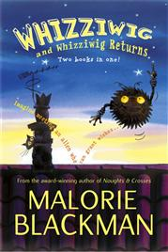 | Whizziwig is an alien who has crash-landed on Earth and ended up on top of Ben’s wardrobe. Ben is delighted to learn that Whizziwig is a ‘wish-giver’ able to turn wishes into reality but the wishes have to be made for someone else, and by accident, so it isn’t long before some very strange, and very funny, things start happening... | Whizziwig and Whizziwig Returns Omnibus  Malorie Blackman
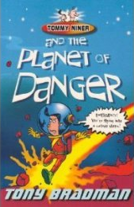 | Spaceships have been mysteriously going missing from Sector 13, so Tommy and his crew have been sent to investigate. Just as things are getting really boring, Grandad's mad machine makes Dad disappear and an alien gravity beam pulls Tommy's spaceship towards a sinister looking planet.  On a strange world fraught with danger, Tommy has to face fearsome robots and a bloodthirsty monster to try and save his family and escape the Planet of Danger. | Tommy Niner and the Planet of Danger  Tony Bradman
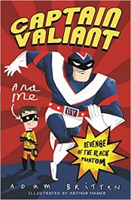 | Mark looks like an ordinary schoolboy, but the truth is he is really Dynamic Boy, one of a family of Astral Guardians sent to protect planet Earth. Dynamic Boy isn’t impressed with his superpowers – he can fly and create illusions – and his costume makes him look like an electric bee. His parents and sister seem much more powerful. And, as Mark, he still has to go to school. Then the Black Phantom unleashes the monstrous Abaddon and threatens all life on Earth... | Captain Valiant and Me: Revenge of the Black Phantom  Adam Britten
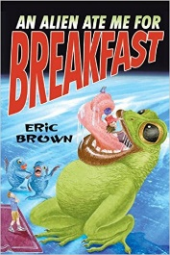 | One minute, Mouse's biggest problem is the local bully. The next, he's taken away by aliens! That's the start of Mouse and Millie's space adventure, starting with them on an alien ship and ending with them on an alien menu. | An Alien Ate Me For Breakfast  Eric Brown
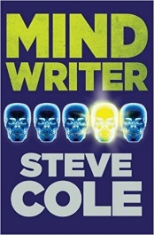 | Luke has a secret skill - he can read minds. When Luke meets Samira, he can't read her mind at all. Her powers are even stronger than his - she can write all over people's thoughts, making them do bad things. The Demon inside her wants to link her and Luke's minds to turn all good to evil. Can Luke persuade Samira to resist? | Mind Writer  Steve Cole
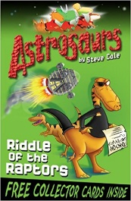 | Captain Teggs is an astrosaur! With the help of his crew he goes on dangerous space missions in his spaceship. 1. Riddle of the Raptors - Flesh-chomping raptors have kidnapped two top dino athletes. With the Great Dinosaur Games about to start, Teggs and his friends must race to the rescue. | Astrosaurus (series)  Steve Cole
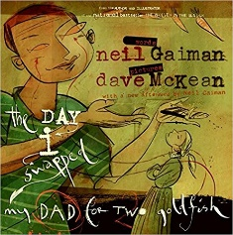 | When a boy swaps his dad for two goldfish he does not really think through the consequences! When the boy is told by his mother that he has to get his father back it is not so easily done. It seems that the father has a pretty high value as he has been traded by one child to the next leaving a trail that the son must follow. Where will it all end? | The Day I Swapped my Dad for Two Goldfish  Neil Gaiman and Dave McKean  (picture book)
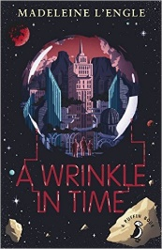 | When Charles goes searching through a 'wrinkle in time' for his lost father, he finds himself on an evil planet which is ruled by a pulsating brain known as 'It'. How Charles and his friends find and free his father is a mixture of fantasy and science fiction, which is dominated by a trio of guardian angels known as Mrs Whatsit, Mrs Who and Mrs Which. | A Wrinkle in Time  Madeleine L'Engle
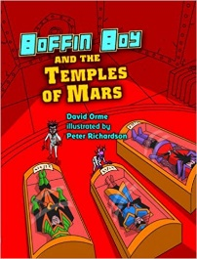 | Boffin Boy is actually Rick Shaw, a 14-year-old schoolboy who uses his scientific mind to fight evil. In Boffin Boy and the Temples of Mars, Boffin Boy discovers an ancient building on Mars containing mysterious creatures. | Boffin Boy and the Temple of Mars  David Orme
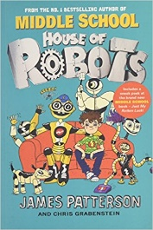 | When Sammy gets a new ‘brother’, it’s a super-clever robot, designed by his mum. Unlike the other robots in their home, E (Egghead, but to Sammy, Error) can do anything. Once E has been re-programmed Sammy becomes super cool amongst his friends, and eventually he realises just why his mum created that particular robot. | House of Robots  James Patterson and Chris Grabenstein
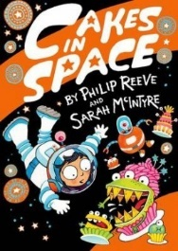 | Astra and her family are off on an exciting journey through space to start a wonderful new life on a new planet. Everyone sleeps through the journey to their new home. During the voyage, something goes wrong. The Nom-O-Tron machine in the spaceship canteen has malfunctioned, and ship is being taken over by monstrous cakes - cakes with a killer instinct! | Cakes in Space  Phillip Reeve
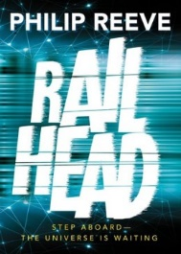 | Zen is a thief, hopping on and off the sentient trains speeding across the galaxy, hoping he won't get caught by a drone or one of the Guardians. When he is approached by Raven to infiltrate the Emperor's train, he jumps at the chance of adventure and dodging danger at every turn. But, does Zen really understand what he's getting into? | Rail Head  Phillip Reeve
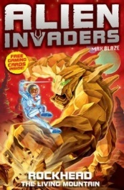 | Set in 2121, Cosmo is an earthboy on a mission to save the galaxy from the monster Kaos and his deadly alien invaders. There are three further adventures to come as Cosmo travels from planet to planet outwitting evil by transforming into many different alien forms using his Quantum Mutation Suit, among many other amazing inventions. | Alien Invaders: Rockhead - The Living Mountain  Max Silver
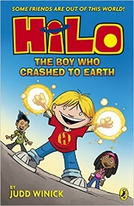 | Daniel Jackson Lim, or DJ, doesn’t think he’s good at anything – his brothers and sisters are all busy being high achievers. The only thing he’s good at is being friends with his best friend Gina. But when Gina moves away, DJ doesn’t have anything that will make him special anymore. That is, until, one day, HILO crashes down to earth next to DJ’s house wearing only a pair of pretty outstanding silver underpants. | HILO – The Boy Who Crashed to Earth  Judd Winick

