Here is a suggested reading list to help you find new books to read. Remember, if you find a book you enjoy, try another one from the list or try to find another book by the same author.
The school library might not have all the titles on the list; however, you should be able to find them in the local library.
If you would like to recommend a book for this list, give the details to your Reading Ambassador.
Cover | Synopsis | Title and Author
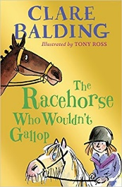 | Charlie's convinced that Noble Warrior is special and can win the Epsom Derby - even though Noble Warrior won't gallop without Percy the palomino pony. On top of that, Charlie's parents can't really afford to keep a horse, and she has no jockey (only Joe, an orphan whose father died in a horseracing accident). But the prize money could save her family's farm from bankruptcy | The Racehorse Who Wouldn’t Gallop  Clare Balding
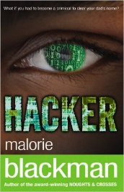 | When Vicky's father is arrested, accused of stealing over a million pounds from the bank where he works, she is determined to prove his innocence. But how? There's only one way - to attempt to break into the bank's computer files. Even if Vicky is the best hacker in the world, will she find the real thief before they find her? | Hacker  Malorie Blackman
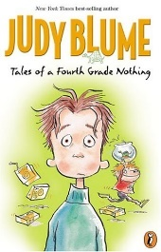 | Living with his little brother, Fudge, makes Peter Hatcher feel like a fourth grade nothing. Whether Fudge is throwing a temper tantrum or scribbling all over Peter’s homework, he’s never far from trouble; but gets away with everything. When Fudge walks off with Dribble, Peter’s pet turtle, it’s the last straw. How can Peter get his parents to pay attention to him for a change? | Tales of a Fourth Grade Nothing  Judy Bloom
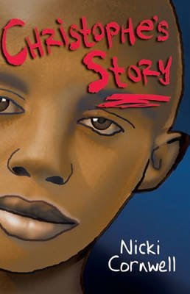 | Christophe is a young Rwandan refugee now living in the UK. Life has been very lonely for him. Most of all he misses his grandfather who they had to leave behind. His teacher persuades Christophe to share his story with his classmates - so he tells them of the terrifying day the soldiers came to his house and killed his baby brother. The spoken story fills the air and his classmates are spellbound. | Christophe's Story  Nicky Cornwell
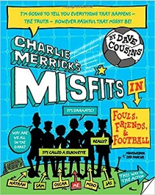 | Charlie Merrick and his football-mad friends on a Soccer Camp holiday, but the plan misfires when they discover that the booking got confused, and they end up at a Survival Camp instead. Intense rivalry with the other groups, especially the Wild Warriors and their leader Magpie lead them into all sorts of unpleasant situations before they prove that they are real survivors. | Charlie Merrick’s Misfits: I’m a Nobody, Get Me Out of Here!  Dave Cousins
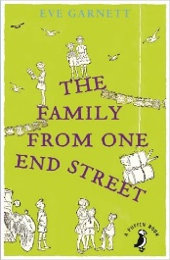 | The story of everyday life in the big, happy Ruggles family who live in the small town of Otwell. Father is a dustman and Mother a washerwoman. Then there's all the children - practical Lily Rose, clever Kate, mischievous twins James and John, followed by Jo, who loves films, little Peg and finally baby William. | The Family from One End Street  Eve Garnet
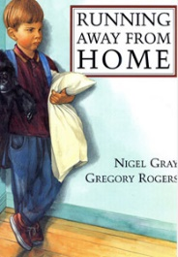 | This is the story of Sam, who decides to run away because his dad is being more bossy than usual. But when it starts to rain, Sam hides beneath his brother's skateboard ramp, and when the rain stops he decides to give his dad a second chance. | Running Away From Home  Nigel Gray
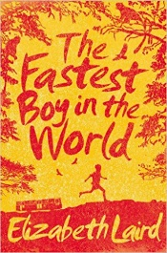 | Eleven-year-old Solomon loves to run! The great athletes of the Ethiopian national team are his heroes and he dreams that one day he will be a gold-medal-winning athlete like them, in spite of his ragged shorts and bare feet. When his grandfather announces that he's going to take Solomon to Addis Ababa, Solomon cannot believe his ears. | The Fastest Boy in the World  Elizabeth Laird
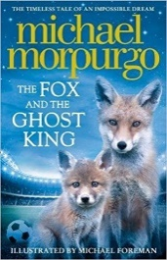 | A little fox cub in Leicester trawls the football ground for post-match leftovers with his dad. When they hear a hoity-toity voice claiming to be a long-lost king, the foxes promise to dig him out in exchange for a wish that will make the whole city proud. What wish does he make? Is it for Leicester City to win the Premiership title? | The Fox and the Ghost King  Michael Morpurgo
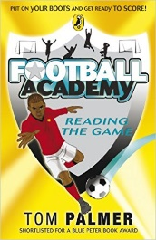 | One of six titles in the Football Academy series, each featuring two young players, this slim chapter book centres on Ben and Ryan, as Ben faces expulsion from United’s Under Twelve because he is behaving badly and missing practices. The team coach Steve discovers that Ben is failing at school, and disguising the fact that he cannot read, relying on Ryan to help him with his work. | Football Academy: Reading the Game (series)  Tom Palmer
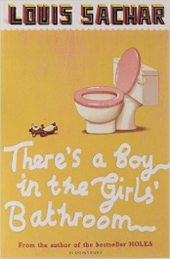 | "Give me a dollar or I'll spit on you." That's Bradley Chalke. He is the oldest child in the class - tells enormous lies; picks fights with girls, and the teachers say he has "serious behaviour problems." No one likes him - except Carla; she thinks Bradley is sensitive and generous. Carla knows that Bradley could change, if only he weren't afraid to try. The hardest thing in the world is believing in yourself. | There's a Boy in the Girls' Bathroom  Louis Sachar
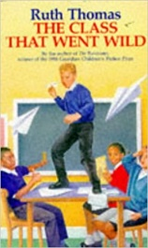 | When Mrs Lloyd leaves teaching to have her baby, it's the signal for Sean Adams and his gang to run riot. Class 4L build up the reputation for being the most unruly class in school. | The Class That Went Wild  Ruth Thomas
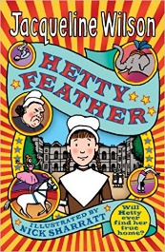 | Set in London's Foundling Hospital in the 1870s, the infant Hetty is left there by her distraught mother, then farmed out to a family in the country, before returning to the Hospital aged five. Removed from her beloved foster parents and siblings, the rebellious Hetty seeks desperately to uncover her birth mother’s identity, eventually reaching an unexpected and reassuring resolution. | Hetty Feather  Jacqueline Wilson

