Here is a suggested reading list to help you find new books to read. Remember, if you find a book you enjoy, try another one from the list or try to find another book by the same author.
The school library might not have all the titles on the list; however, you should be able to find them in the local library.
If you would like to recommend a book for this list, give the details to your Reading Ambassador.
Cover | Synopsis | Title and Author
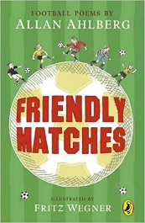 | Friendly Matches is an entertaining, and at times thought-provoking, collection of poetry about football. From The Song of the Referee to memories of the 1966 World Cup, many aspects of the game are explored using different styles of verse. | Friendly Matches  Allan Ahlberg
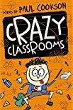 | Teachers, bullies, friends and school trips, not forgetting school dinners and the Dinner Lady Boot Camp Crew – all aspects of school life are here. Both funny and observant, this is a fabulous collection of poems by performance poet Paul Cookson. | Crazy Classrooms  Paul Cookson
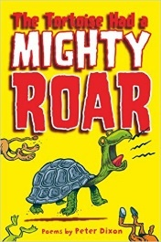 | A collection from Peter Dixon full of gentle humour and lovely thoughtful poems. In this book, we learn about the important things in life such as fairy picnics, what animals sounded like before they all swapped voices, a spider called Big Billy, what Stone-Age school was like and what goes on in the magic superstore. | The Tortoise had a Mighty Roar  Peter Dixon
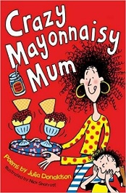 | An irresistible collection of poems including a sequence of poems about everyday life; number rhymes; action rhymes; noisy rhymes and more thoughtful pieces too. | Crazy Mayonnaisy Mum  Julia Donaldson
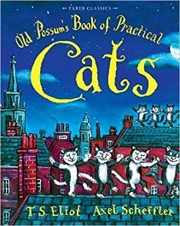 | Poems about Macavity, Old Deuteronomy, Mr Mistoffelees and many other cats, written by T.S. Eliot under the name of 'Old Possum'. | Old Possum's Book of Practical Cats  T.S. Eliot and Alex Scheffler
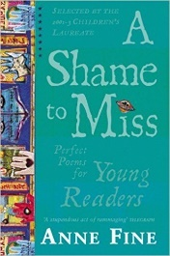 | selected some marvellous poems, both classic and contemporary, for inclusion in her trio of poetry anthologies, A Shame to Miss 1, and 2. She has added brief comments about what the poems mean to her and how we might understand them better. | A Shame to Miss  Anne Fine
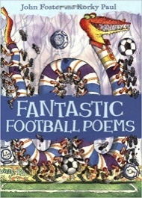 | There are poems by a range of authors about all kinds of football matches - including meteorite footballs, football on the moon, witches versus wizards football match, the goalie with expanding hands, and the Stone Age man who invented football. A perfect introduction to poetry either at home or at school. | Fantastic Football Poems  John Foster and Korky Paul
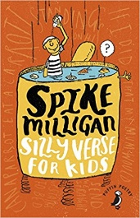 | A collection of the absurd, ridiculous, sublime and characteristically anarchic verse from the brilliant Spike Milligan. With his very own illustrations, this collection, which includes the famous On the Ning Nang Nong will make you laugh from the bottom of your belly - just like Spike did. | Silly Verse for Kids  Spike Milligan
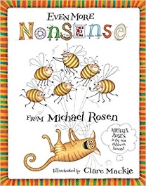 | Young and older readers alike will be greatly entertained by the wonderful poems, with titles which range from The Smeenge and Plonky Wonky Doodah to Windscreen Wipers and The Cat Went Out. | Even More Nonsense  Michael Rosen
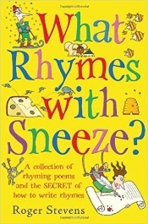 | Stuffed with brilliant rhyming poems and fascinating facts about how different kinds of rhymes work, and there's a section full of tips and tricks on how to write brilliant rhyming poems and takes the reader on a rhyming, rhythmic journey to discover just how fun messing about with rhymes can be. | What Rhymes with Sneeze?  Roger Stevens

