Here is a suggested reading list to help you find new books to read. Remember, if you find a book you enjoy, try another one from the list or try to find another book by the same author.
The school library might not have all the titles on the list; however, you should be able to find them in the local library.
If you would like to recommend a book for this list, give the details to your Reading Ambassador.
Cover | Synopsis | Title and Author
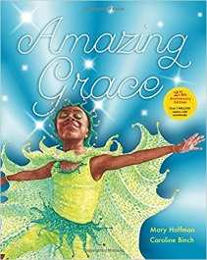 | Grace loves to act out stories. When her school decides to perform Peter Pan, Grace is longing to play Peter, but her classmates say that Peter was a boy, and besides, he wasn't black...But Grace's Ma and Nana tell her she can be anything she wants if she puts her mind to it... | Amazing Grace  Mary Hoffman and Caroline Binch  (picture book)
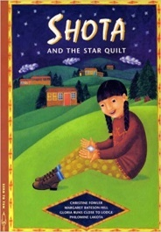 | Shota is a Lakota (Native American) girl who lives in a contemporary American city. When the street where she and her friends live on is threatened by development, they use Lakota traditions to save their homes. In working together, they create a beautiful quilt that resolves more than just their problem. | Shota and the Starquilt  Margaret Bateson-Hill and Christine Fowler  (picture book)
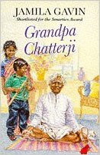 | When Neetu and Sanjay hear that Grandpa Chatterji is coming to stay with them, they try to imagine what he will be like. They could never have imagined the Grandpa who arrives. He wears a dhoti, stands on his head and makes the most delicious pakoras. And when they go to visit him in India, they meet more of their wonderful, vibrant family. | Grandpa Chatterji  Jamila Gain and Mei-Yim Low
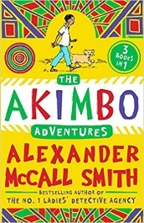 | Akimbo and his parents live on the edge of an African game reserve. It's his father's task to protect the thousands of amazing animals who make it their home, and wildlife-loving Akimbo dreams of helping him. In these three adventures, Akimbo protects elephants from poachers, saves a lion cub from a trap, and rescues a man from a crocodile! | The Akimbo Rescue  Alexander McCall Smith
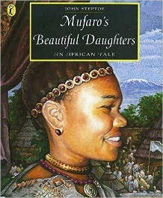 | The tale of Mufaro's two daughters, two beautiful girls who react in different ways to the king's search for a wife - one is aggressive and selfish, the other kind and dignified. The king takes on disguises to learn the true nature of both girls and of course chooses Nyasha, the kind and generous daughter, to be his queen. | Mufaro's Beautiful Daughter  John Steptoe  (picture book)
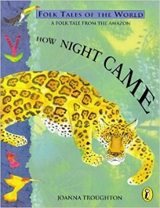 | This folk tale from Orissa, India, explains why tigers eat their food uncooked and why cats live with people. The tiger child is sent to fetch some more fire from the village, but on the way he gets distracted by his friends. By the time he gets to the village, he has forgotten what he has been sent to fetch. | How Night Came  Joanna Troughton  (picture book)
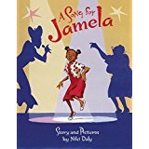 | Summer holidays are here and all Jamela can think about is the Afro-Idols TV final. At her job at Divine Braids hair salon, Afro-Idols celebrity, Miss Bambi Chaka Chaka comes into the salon. But while Jamela's idol dozes and Aunt Beauty designs her starry hairdo, a buzzy fly threatens to ruin everything. Can creative Jamela save the day and cover the bald patch? | A Song for Jamela  Niki Daly
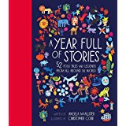 | Stories from around the world are collected in this nicely produced hardback, celebrating the wheel of the year across many cultures. It includes stories from Buddhist, Caribbean, Japanese, French, Inuit and Arabic traditions, among others. | A Year Full of Stories: 52 Folk Tales and Legends From Around the World  Angela McAllister
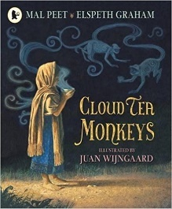 | Tashi's mother is an impoverished tea-picker, and when she becomes ill, the little girl tries to continue her mother's job. Ridiculed by the bad-tempered Overseer, Tashi seeks solace where the local monkeys regularly share her fruit, and her generosity is repaid as they pick the highest and best tea to fill her basket. | Cloud Tea Monkeys  Mal Peet and Elspeth Graham
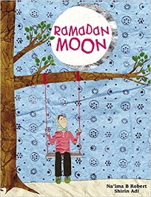 | During Ramadan, Muslim families visit their mosques to listen to verses from the Koran. They will eat before dawn and will not eat again until after sunset. Their hunger during the day reminds them of their good fortune and the needs of others; this is a time for generosity, goodwill and prayer. This book captures the excitement from a child’s perspective. | Ramadan Moon  Na'ima B Robert
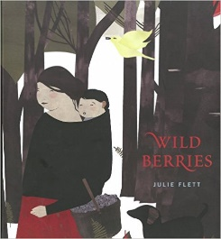 | As in Cree tradition, Clarence and his grandmother are going into the forest to pick blueberries. They sing as they go and Grandma checks the clearing for bears before they pick blueberries, when their buckets are full they leave and walk home together. On each page, there is one word written in both Cree (an aboriginal language from Canada) and English. | Wild Berries  Julie Flett
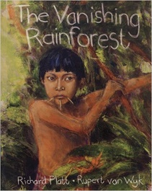 | This story, seen through the eyes of a child called Remaema, describes how the Yanomami tribe are battling against potential developers. Can a solution be found that will protect the forest and allow the tribe to continue living as they always have done, while benefiting from limited development? | The Vanishing Rainforest  Rupert Platt, Richard and van Wyk

