Here is a suggested reading list to help you find new books to read. Remember, if you find a book you enjoy, try another one from the list or try to find another book by the same author.
The school library might not have all the titles on the list; however, you should be able to find them in the local library.
If you would like to recommend a book for this list, give the details to your Reading Ambassador.
Cover | Synopsis | Title and Author
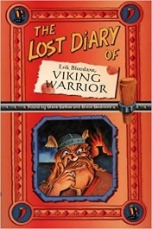 | Newly discovered diaries reveal that famous Viking king, Erik Bloodaxe, couldn't write. However, his court poet Gorblime could! This work talks about life in Viking times - battles and butchery; longships and love; births, marriages and plenty of deaths; Erik's victories and his wife's vengeance; Viking gods and Viking myths; travel and adventure; and much, much more! | The Lost Diary of Eric Bloodaxe, Viking Warrior  Steve Barlow and Steve Skidmore
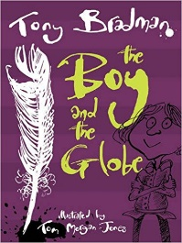 | It’s 17th-century London, a city of stink, rot and grot, but also new theatres, art and writing. Toby life is in chaos when he becomes an orphan and street child. He has to work for Moll Cut-Purse, Queen of the Pickpockets. When he goes to the Globe theatre to thieve, he meets a sad and despairing figure: William Shakespeare. Will needs Toby's help to keep the magic of theatre alive. | The Boy and the Globe  Tony Bradman
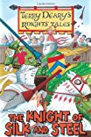 | The locals are all surprised when a strange figure arrives in the village. He says he is a knight, and he has a magnificent horse and a gleaming silver sword. But he is wearing a dress! Sir Ulrich has dedicated his life to fighting for Venus, the goddess of love, and he will fight any knight in the land for her honour. Unfortunately, fighting in a silk dress is not so easy. | The Knight of Silk and Steel  Terry Deary
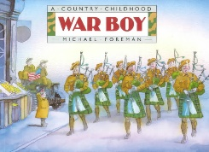 | I woke up when the bomb came through the roof. It came through at an angle, overflew my bed by inches, bounced up over my mother's bed, hit the mirror and exploded up the chimney.' World War II is an exciting time for a boy. A story of life from hiding in air-raid shelters to playing in bombed-out ruins and the arrival of American soldiers. | War Boy  Michael Foreman
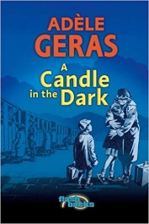 | A story set on the brink of the Second World War. Germany in 1938 is a dangerous place for Jews. Clara and her little brother, Maxi, are leaving behind everything they know and going to England to live with a family they have never met. Will Clara and Maxi adapt to life in an English village, and will they ever see their parents again? | A Candle in the Dark  Adele Geras
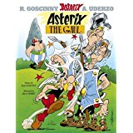 | In a tiny corner of Brittany, one small village of indomitable Gauls hold out against the almighty, all-conquering Romans. The Gauls are mighty fighters, but none more so than Asterix, a dauntless and cunning warrior who gets his tremendous strength from drinking a magic potion supplied to him by Druid Getafix. | Asterix the Gaul  Rene Goscinny
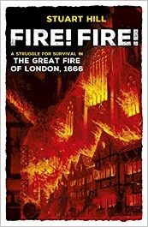 | Fire! Fire! tells the story of a young boy trapped in London as the Great Fire takes hold. 350 years since fire swept through the city in 1666, this gripping first-hand account is perfect for children studying the Great Fire at school. | Fire! Fire!  Stuart Hill
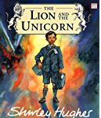 | Evacuated during the Second World War, Lenny takes with him a badge given to him by his father, depicting a lion and a unicorn fighting. Lenny is bullied by the children at his new school, but draws courage from his father’s badge, and comes to terms with his fear and loneliness when he befriends Mick. | The Lion and the Unicorn  Shirley Hughes
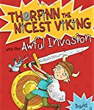 | Thorfinn is possibly the nicest and politest Viking that ever lived, which is absolutely no good at all from the point of view of his dad, Chief Harald the Skull-Splitter, who wants him to Viking-up a bit more. So Harald decides to send Thorfinn to Scotland on a boat full of nasty smelly Vikings to toughen him up - but will Thorfinn survive? Or is being nice the most heroic deed of all? | Thorfinn and the Awful Invasion  David MacPhail
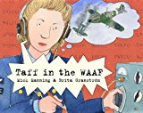 | An account of the secret work carried out during WWII at Bletchley Park, based on the experience of Manning's own mother, Taff. The book spotlights the ground-breaking work done by women at that time, and provide an exciting slant on a different aspect of life on the Home Front. | Taff in the WAAF  Mick and Granstrom, Brita Manning
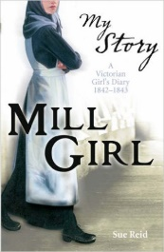 | In spring 1842, Eliza is shocked when she is sent to work in the Manchester cotton mills - the noisy, suffocating mills. The work is backbreaking and dangerous - and when she sees her friends' lives wrecked by poverty, sickness and unrest, Eliza realizes she must fight to escape the fate of a mill girl. | Mill Girl: A Victorian Girl's Diary, 1842-1843 (My Story)  Sue Reid
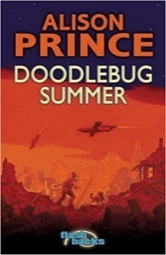 | It is summer and there have been no air raids for quite a while, and war may be coming to an end. It’s a relief for Katie and her family to be back in the comfort of proper beds. One night, she wakes to hear a noise like a loud motorbike, coming closer. It stops abruptly, and there are a few seconds of silence – then an explosion that rocks the house. The Doodlebugs have arrived… | Doodlebug Summer  Alison Prince
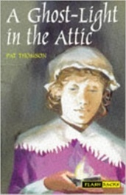 | While helping to sort out old toys and other artefacts in the attic of a historic house, two youngsters are summoned back to the 17th century by Elinor, a young girl whose family lived in the house at that time. Thrust into the midst of the English Civil War, the children must try and foil a plot to betray Elinor’s injured brother before the Parliamentarians discover him. | Ghost light in the Attic  Pat Thomson
 | "I am King Henry the Eighth of England!" roared the an..."Fetch me my shoes!" When Catherine finds a golden box in the maze at Hampton Court, little does she realise that it contains a shoe belonging to King Henry the Eighth of England. The search for this shoe leads a larger-than-life monarch from Tudor times to twentieth-century England, and to Catherine's house! | King Henry VIII’s Shoes  Karen Wallace
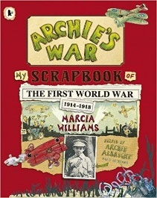 | In 1914, ten-year-old Archie is sent a scrapbook in the post by his Uncle Colin, and through the years that follow, we see the world through Archie's eyes, as documented in a collage of strip comics, doodles, drawings, mementos, photographs and hand-written comments. | Archie's War  Marcia Williams

