Here is a suggested reading list to help you find new books to read. Remember, if you find a book you enjoy, try another one from the list or try to find another book by the same author.
The school library might not have all the titles on the list; however, you should be able to find them in the local library.
If you would like to recommend a book for this list, give the details to your Reading Ambassador.
Cover | Synopsis | Title and Author
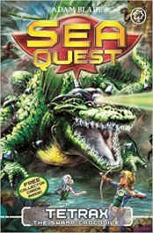 | Dare you dive in to Sea Quest? Discover a new series of adventures involving underwater beasts and baddies. | Sea Quest Series  Adam Blade
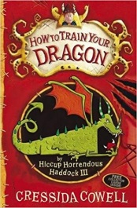 | Hiccup Horrendous Haddock is the most put upon Viking you've ever seen and not seen as brave or loud enough to be a Viking, by his father, Stoick the Vast; until he meets Toothless the dragon … | How To Train Your Dragon  Cressida Cowell
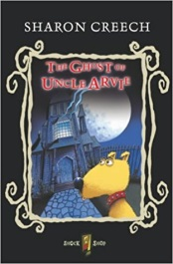 | This is the tale of a very unusual ghost, Uncle Arvie, who needs some help from his nephew, Danny, to find three precious possessions at his old home. | The Ghost of Uncle Arvie  Sharon Creech
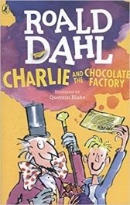 | Willy Wonka's famous chocolate factory is opening at last! But only five lucky children will be allowed inside to be given a tour of the weird and wonderful factory. Charlie Bucket, is a boy who is honest and kind, brave and true, and good and ready for the wildest time of his life! | Charlie and the Chocolate Factory  Roald Dahl
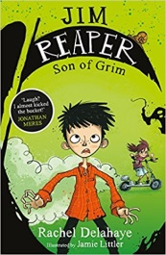 | Disaster! Jim Wimple needs a Bazoom! scooter, and fast. So he and his best friend Will break into Will's dad's workplace. But they find the walls are lined with ancient portraits, the staff are highly secretive, and Jim's dad's office bears the sign 'G Reaper'...And then all hell really breaks loose. What would YOU do if you thought your dad might be ...Death? | Jim Reaper: Son of Grim  Rachel Delahaye
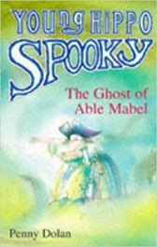 | Able Mabel is huge and horrible. She's a thief and a pirate...and she's a ghost! Many years ago she stole a box of gold from Sam's old grandad-and now Sam wants it back. No matter that Mabel won't let it go without a fight… | The Ghost of Able Mabel  Penny Dolan
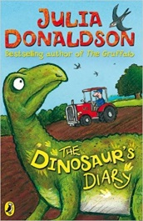 | Surviving and finding a safe place to lay her eggs is difficult for Hypsilophodon with dinosaurs like Tyrannosaurus Rex around. When she falls into a mysterious pool and finds herself on a modern farm, Finally she finds a safe place to hatch her babies, but how can she keep her baby dinosaurs safe and secret? | The Dinosaur Diary  Julia Donaldson
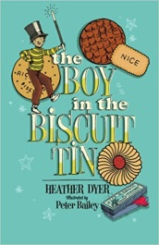 | When Ibby is sent to stay with her aunt, she discovers her two troublesome boy cousins playing with an old box of magic tricks they found in the attic. Ibby is sure that magic isn't real until she sees Francis sitting at the bottom of the biscuit tin, magically miniaturised by Alex. After that, nothing is what it seems. | The Boy in the Biscuit Tin  Heather Dyer
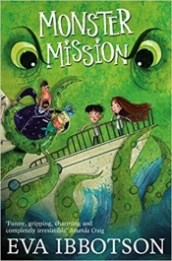 | We must kidnap some young, strong children,' announced Aunt Etta. Three children are stolen and taken to a bizarre island, which is home to some extraordinary beasts, including the legendary kraken. The island is the base for a very mysterious mission which is cut short when the island is suddenly under siege. Can the children save themselves? | Monster Mission  Eva Ibbotson
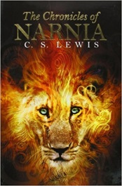 | The series is set in Narnia, a fantasy world of magic, mythical beasts, and talking animals, following the adventures of different children in the worlds. | The Chronicles of Narnia (series)  C.S Lewis
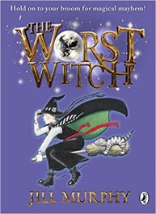 | The Worst Witch is the story of life at a magical boarding school. Mildred Hubble is a trainee at Miss Cackle's Academy for Witches, but she's making an awful mess of it. She keeps getting her spells wrong and crashing her broomstick. And when she turns Ethel, the teacher's pet into her worst enemy, chaos ensues... | The Worst Witch stories  Jill Murphy
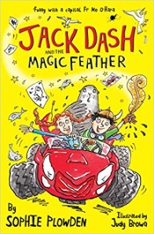 | On the day that Jack’s family moves to a new house, he finds a magic feather in the attic that makes whatever he  draws real. Problem is, he accidentally draws a sea lion, which is pretty hard to keep secret, not least from Coco, the annoying girl next door. Surreal humour and a pageturning plot will keep you hooked. | Jack Dash and the Magic Feather  Sophie Plowden
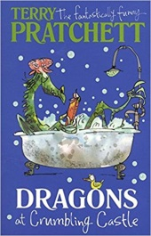 | A collection of short stories covering a variety of imaginary settings, including several about the Carpet People, and events in Gritshire, and also feature time-travel, Hercules the Tortoise and Father Christmas. All stories are boisterous and and hilarious, and many have rather unexpected conclusions. | Dragons at Crumbling Castle (and Other Stories)  Terry Pratchett
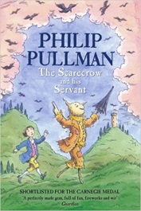 | One night there was a thunderstorm. A tattered scarecrow stood in the wind when a bolt of lightning struck his head. The scarecrow blinked with surprise and came to life; he meets a boy, Jack, who becomes his faithful servant, and they set out to journey and along the way there's no end of excitement… | The Scarecrow and his Servant  Phillip Pullman
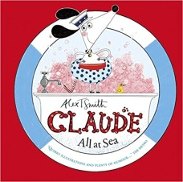 | When his owners, are out at work, Claude the dog and his best friend Sir Bobblysock have amazing adventures. One day, Claude leaves the taps running and floods the house, and they are swept out to sea. Luckily Claude’s beret has all sorts of items that are useful for emergencies and scrapes. | Claude All at Sea  Alex T Smith
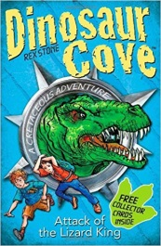 | Fast-paced adventure stories, starring two boys and a whole host of very real dinosaurs and adventures throughout the Cretaceous, Jurassic, Triassic, and Permian periods. | Dinosaur Cove  Rex Stone
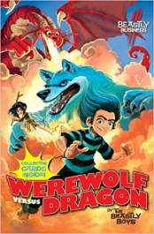 | Ulf is an orphaned werewolf who has lived all his life at the home of the RSPCB and a sanctuary for rare and endangered beasts. When a dead dragon arrives and a ghost reveals a dark secret, Ulf sets out to investigate, uncovering a plot by the world's most villainous beast hunter to resurrect the cruel sport of dragon fighting. | Werewolf Versus Rescue  The Beastly Boys
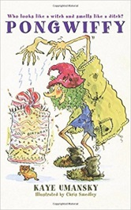 | Pongwiffy lives in hovel with her friend named Sharkadder, and an odour only a witch could love. Everything is almost perfect -- until a gaggle of Goblins move in next door. It's time to move - but where? How can Pongwiffy cope with a gang of Goblins, a sassy rodent assistant, and the Witches' Coven, who are waiting for an explanation? | Pongwiffy  Kaye Umansky
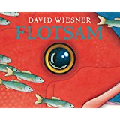 | The story of a boy finding a vintage camera washed up on a beach unspools like a silent film. The camera and its secrets take the boy on an extraordinary visual journey into an undersea otherworld where he makes unexpected connections across continents and through time. | Flotsam  David Wiesner

