Here is a suggested reading list to help you find new books to read. Remember, if you find a book you enjoy, try another one from the list or try to find another book by the same author.
The school library might not have all the titles on the list; however, you should be able to find them in the local library.
If you would like to recommend a book for this list, give the details to your Reading Ambassador.
Cover | Synopsis | Title and author
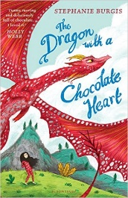 | Aventurine, a young dragon, lives with her family in the mountains. She is too young to go out hunting alone, but sneaks out of her cave and attempts to capture a human. He tricks her by adding a magical ingredient to his pot, so when she drinks it, she turns into a human girl. Without wings, claws or fire, she cannot return home so heads to the city. | The Dragon with a Chocolate Heart  Stephanie Burgis
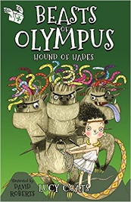 | Hades, Lord of the Underworld, summons Demon to cure his three-headed dog Cerberus whose earth-shattering sneezes are threatening to liberate the hundred-armed monsters of Tartarus …To cure Cerberus, Demon must find ingredients ranging from a hero's toenail to a Cauldron of Healing. And he only has one day… | Beasts of Olympus: Hound of Hades  Lucy Coats
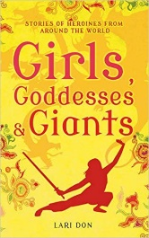 | This book contains twelve short heroine stories from different cultures. The villains include the Baba Yaga, who eats children for supper, a shape-shifting demon who can't be killed by any man or god, and a giant sea serpent who requires a human sacrifice. These stories come from a range of countries including India, China, Cameroon and Venezuela. | Girls, Goddesses & Giants  Lari Don
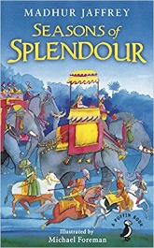 | India is particularly rich in colourful folkore, these stories, make a rich and dazzling collection of mythological tales drawn from a great heritage of Hindu epics - from the life of the great god Krishna to how the monkey god Hanuman helped defeat the Demon King Ravan and a host of other magical and spectacular creatures. | Seasons of Splendour: Tales, Myths & Legends of India  Madhur Jaffrey
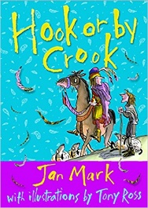 | Mayhem in the Middle Ages! The Abbot of Canterbury has been set three very tricky puzzles by mean King John. The Abbot decides to visit the cleverest people in the land to get some help answering the questions but nobody there can help him. He returns home to find the shepherd who lives in the field next to the castle has some interesting answers. | Hook or by Crook  Jan Mark
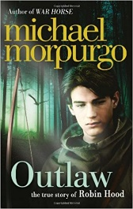 | After a storm, a boy discovers a human skull with a legendary story… “Tell the sheriff, tell Sir Guy of Gisbourne, tell everyone in Nottingham, that the Outlaws rule here in Sherwood, that we rule in the king’s name… I am Robin Hood.” Homeless and lost in a dark forest, young Robin is rescued by a motley crew of misfits and sets about defeating the Sheriff of Nottingham. | Outlaw: The story of Robin Hood  Michael Morpurgo
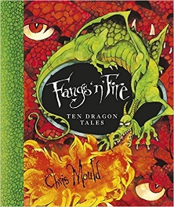 | Traditional dragon myth and legends as well as some new and original tales. Stories include: 'George and the Dragon' (traditional), 'The Dragon's Teeth' (Greek myth), 'The Eyeless Dragons' (Chinese myth), 'The Dragon Swarms' (Edith Nesbit) and many more. | Fangs 'n' Fire  Chris Mould
 | A black dog appears outside the Hope family's home. As each member of the household sees it and hides, the dog grows bigger and bigger. Only the youngest child has the courage to face the Black Dog. When it chases her through the forest she shows no fear, so it grows smaller and smaller. What happens next? | Black Dog  Levi Pinfold
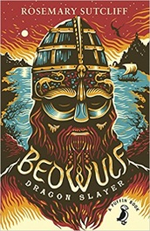 | This thrilling re-telling of the Anglo-Saxon legend, Beowulf, recounts its most terrifying quests: against Grendel the man-wolf, against the hideous sea-hag and, most courageous of all - his fight to the death with the monstrous fire-drake. | Beowulf Dragonslayer  Rosemary Sutcliff
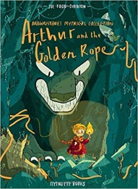 | Arthur, a small boy fascinated by the magical tales of the town's wise woman, is out exploring one day when he's startled by a terrible howl. Too late, he watches as a huge wolf, Fenrir, puts out the village's great fire, meaning that the village faces being frozen solid in a week - unless a Viking god relights the fire. | Arthur and the Golden Rope  Stanton, Joe Todd
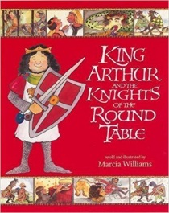 | Aided by the magician Merlin, Arthur draws the sword from the stone to become King of Britain, and Lord of the Knights of the Round Table. Read of their valiant deeds as King Arthur, Sir Lancelot, Sir Galahad and other heroic knights rescue maidens, defend Excalibur and search for the Grail. | King Arthur and the Knights of the Round Table  Marcia Williams
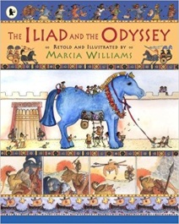 | This comic-strip book tells the story of the Iliad (war) between Greeks and Trojans; the love between Helena and Paris; Achilles and Hector's deadly combat; the Trojan Horse...The Odyssey depicts the perilous voyage home of the Greek warrior Odysseus; his struggles against the one-eyed Cyclops; the terrible Sirens; the dreadful, six-headed Scylla.... | The Iliad and the Odyssey  Marcia Williams
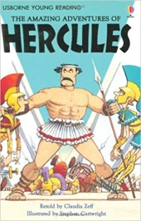 | Hercules is set 12 impossible tasks to earn the forgiveness of the Gods, but will he succeed? | The Amazing Adventures of Hercules  Claudia Zeff

