Here is a suggested reading list to help you find new books to read. Remember, if you find a book you enjoy, try another one from the list or try to find another book by the same author.
The school library might not have all the titles on the list; however, you should be able to find them in the local library.
If you would like to recommend a book for this list, give the details to your Reading Ambassador.
Cover | Synopsis | Title and Author
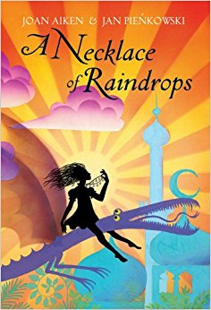 | Beginning and ending with a birthday, this collection of eight stories is filled with magic, where wishes can come true. A necklace of raindrops that keeps its owner dry in the heaviest rainstorm; a tiger that runs faster than the wind; a huge floating apple pie with a piece of sky in it - these are just some of the objects and characters that figure in these delightful stories. | A Necklace of Raindrops  Joan Aiken
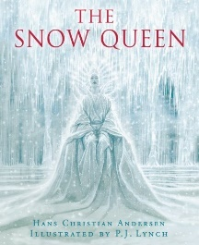 | The Snow Queen puts Kay under her spell and takes him to her palace of snow and ice. It is up to Gerda to find him and bring him home to the love that awaits him. | The Snow Queen  Hans-Christian Anderson
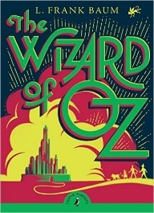 | Dorothy and her friends know there's only one person who can help make their wishes come true and that's the Wizard. But as they set off to find him, the Wicked Witch is never far behind . . . | Wonderful Wizard of Oz (graphic novel)  Frank Baum
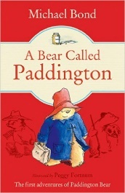 | The story of the bear from Darkest Peru who arrived at Paddington Station with nothing but a suitcase, a half-empty jar of marmalade and a label that read, ‘Please look after this bear. Thank you.’ Mr and Mrs Brown discovered him, named him Paddington and welcomed him to their home, where he has lived ever since. | Paddington Bear Stories  Michael Bond
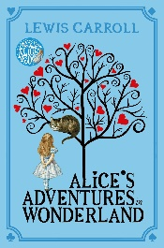 | When Alice falls down a rabbit hole into a strange land inhabited by talking rabbits, smoking caterpillars and grinning cats, she finds herself undergoing several challenges both physically, intellectually and emotionally, as she tries to find her way back home. | Alice's Adventures in Wonderland  Lewis Carroll
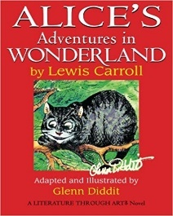 | When Alice falls down a rabbit hole into a strange land inhabited by talking rabbits, smoking caterpillars and grinning cats, she finds herself undergoing several challenges both physically, intellectually and emotionally, as she tries to find her way back home. | Alice in Wonderland (graphic novel) Lewis Carroll and Glen Diddit
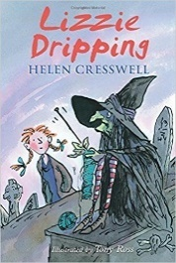 | Everyone in the village where Lizzie lives thinks that she's a dreamer - so it's no wonder that they don't believe her when she says she's seen a witch. But Lizzie doesn't care because she knows it's true and having a witch for a friend makes life much more exciting. | Lizzie Dripping  Helen Cresswell
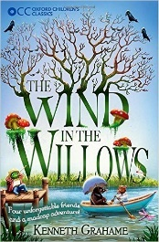 | Leaving his spring-cleaning behind him, timid Mole ventures beyond the familiar comfort of his burrow and makes a new friend in Ratty, who lives by the riverbank. When they meet the reckless Mr Toad, they find themselves caught up in a series of strange adventures. | The Wind in the Willows  Kenneth Grahame
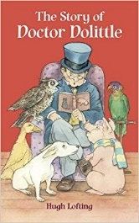 | Mice in the piano, rabbits in the pantry, hedgehogs in the cellar: welcome to the home of Dr Dolittle, the greatest animal doctor ever known. | The Story of Dr Dolittle  Hugh Hofting
 | Mankind must put a stop to the dreadful destruction by the Iron Man and set a trap for him, but he cannot be kept down. Then, when a terrible monster from outer space threatens to lay waste to the planet, it is the Iron Man who finds a way to save the world. | The Iron Man  Ted Hughes
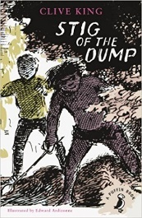 | Exploring an old chalk pit, Barney meets a strange boy who wears a rabbit skin and speaks in grunts. | Stig of the dump  Clive King
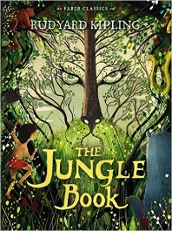 | The Jungle Book is a collection of stories featuring Mowgli (the "man cub", who is raised in the jungle by wolves. Other characters include Shere Khan the tiger and Baloo the bear. | The Jungle Book  Rudyard Kipling
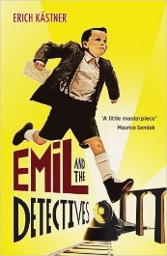 | Unfortunately, when his seven pounds goes missing on the train, Emil is determined to get it back - and when he teams up with the detectives he meets in Berlin, it's just the start of a marvellous money-retrieving adventure. | Emil the Detective stories  Astrid Lindgren
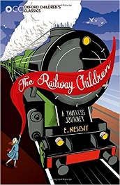 | When Father goes away with two strangers one evening, the lives of his children are shattered. They and their mother must move from their comfortable London home to go and live in a simple country cottage. A railway runs near their cottage and when they save a train from disaster, they are helped an old gentleman to solve the mystery of their father's disappearance. | The Railway Children  E. Nesbitt
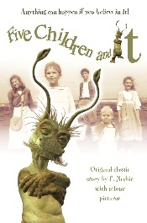 | What you would do if you were granted three wishes? Five children - Cyril, Anthea, Robert, Jane and their baby brother - had often talked about it but when they are faced with the grumpy sand-fairy they find it difficult to make up their minds. As they discover, there is nothing quite like a wish for getting you into terrible trouble. | Five Children and It (1st in series)  E. Nesbitt
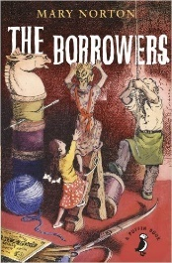 | The Borrowers live in the secret places of quiet old houses; behind the mantelpiece, inside the harpsichord, under the kitchen clock. They own nothing, borrow everything, and think that human beings were invented just to do the dirty work. Girls weren't supposed to go borrowing but Arrietty did and then she made friends with the human boy living in the house… | The Borrowers  Mary Norton
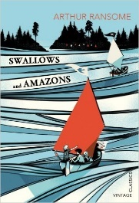 | The Walker children set sail on the Swallow and head for Wild Cat Island. There they camp under open skies, swim in clear water and go fishing for their dinner. But their days are disturbed by the Blackett sisters, the fierce Amazon pirates. The Swallows and Amazons decide to battle it out, and so begins a summer of unforgettable discoveries and incredible adventures. | Swallows and Amazons  Arthur Ransome
 | Black Beauty tells the story of the horse's own long and varied life, from a well-born colt in a pleasant meadow to an elegant carriage horse for a gentleman to a painfully overworked cab horse. Readers will follow Black Beauty's fortunes, good and bad, with gentle masters as well as cruel. | Black Beauty  Anne Sewell
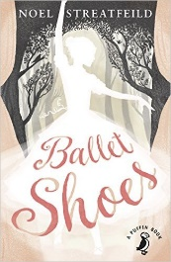 | The Fossil sisters were adopted as babies by Great Uncle Matthew, who then disappeared, leaving them in the care of his niece Sylvia. The girls grow up in comfort until their money begins to run out and nobody can find Great Uncle Matthew. They take to the stage but it's not long before the Fossils learn that being a star isn't as easy as they first thought... | Ballet Shoes  Noel Streatfield
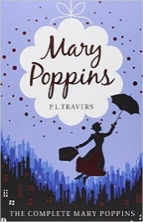 | When the Banks family advertise for a nanny, Mary Poppins and her talking umbrella appear out of the sky, ready to take the children on extraordinary adventures. Mary Poppins is strict but fair, and soon Michael and Jane are whisked off to a funfair inside a pavement picture and on many more outings with their wonderful new nanny! | Mary Poppins  P. L. Travers
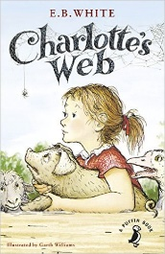 | This is the story of a little girl named Fern who loved a little pig named Wilbur and of Wilbur's dear friend, Charlotte A. Cavatica, a beautiful large grey spider. With the unlikely help of Templeton the rat, and a wonderfully clever plan of her own, Charlotte saves the life of Wilbur, who by this time has grown up to be quite a pig | Charlotte's Web  E.B. White

