Here is a suggested reading list to help you find new books to read. Remember, if you find a book you enjoy, try another one from the list or try to find another book by the same author.
The school library might not have all the titles on the list; however, you should be able to find them in the local library.
If you would like to recommend a book for this list, give the details to your Reading Ambassador.
Cover | Synopsis | Title and Author
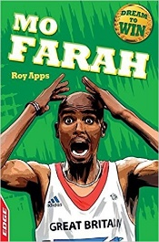 | Mo Farah is the UK's most successful distance runner. This book goes from his childhood in Somalia to when he crossed the finish line at London 2012. It takes blood, sweat and tears to get to the top of any sport, and this short biography shows just how tough it can be. | Mo Farah  Roy Apps
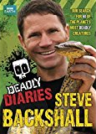 | Steve Backshall shares what it means to him to film the world's top predators. Learn how it feels to have a blue whale silently power past you in crystal clear Indian Ocean waters or to dangle beneath a helicopter in order to be dropped onto a crocodile nest while the mother crocodile is still there! | Deadly Diaries  Steve Backshall
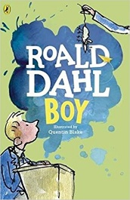 | In Boy, Roald Dahl recounts his days as a child growing up in England. From his years as a prankster at boarding school to his envious position as a chocolate tester for Cadbury's, Roald Dahl's boyhood was as full of excitement and the unexpected as are his world-famous, best-selling books. | Boy: Childhood Tales  Roald Dahl
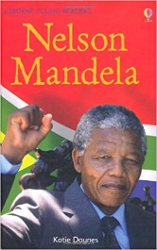 | This book follows Mandela's life from his rural childhood through to his time with the ANC; his fight against apartheid; his 27 years in prison; and his world-changing appointment as South Africa's first black president. | Nelson Mandela  Katie Daynes
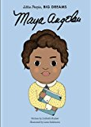 | Maya grew up in the American South during the 1930s, at a time of racial tension and segregation. The hardships she endured are described as Maya was treated unfairly because of the colour of her skin and because she was a girl. | Little People, Big Dreams: Maya Angelou  Lisbeth Kaiser
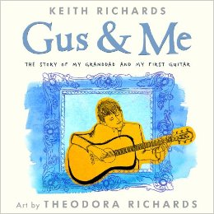 | Keith Richards, a legendary musician, had a real life and a fairly standard childhood before being catapulted into global stardom. He also had a granddad, Gus, who inspired his lifelong love of music and with whom he shared a very special bond. Richards tells the story of his granddad and his first guitar. | Gus and Me  Keith Richards

