Here is a suggested reading list to help you find new books to read. Remember, if you find a book you enjoy, try another one from the list or try to find another book by the same author.
The school library might not have all the titles on the list; however, you should be able to find them in the local library.
If you would like to recommend a book for this list, give the details to your class Reading Ambassador.
Cover | Synopsis | Title/Author
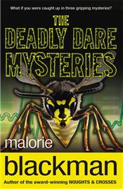 | Three books - Deadly Dare, Computer Ghost and Lie Detectives, featuring best friends Theo and Ricky. The friends get involved in a game of dare which gets seriously out of hand; form a detective agency, to investigate a series of desperate emails sent to their friend. Then they make a lie detector and try to solve the near-death of a top inventor. | The Deadly Dare Mysteries  Malorie Blackman
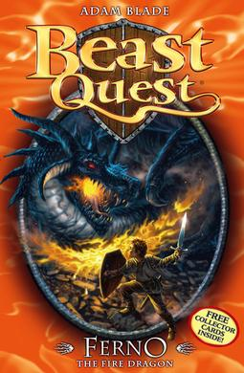 | Tom, a 12-year old boy with dreams of excitement and adventure, has his life turned upside-down when terrible things happen to his village and he's chosen to get help from the King. In each book, Tom is involved in an incredible adventure against a legendary beast. | Beast Quest Stories  Adam Blade
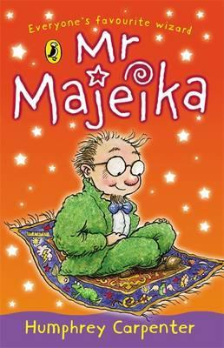 | As a rule, magic carpets don't turn up in schools, but this is exactly what happens when Class Three’s new teacher flies in through the classroom window and lands on the floor with a bump. Mr Majeika is an extraordinary teacher with magical powers. | Mr Majeika Stories  Humphrey Carpenter
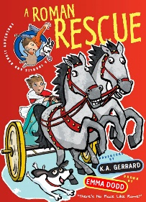 | This is the first in a new time-travel series featuring Charlie and his dog, Bandit. In this first adventure, they accidentally fall into a 'sinkhole' that transports them back to ancient Rome where their adventures begin as Charlie searches for his dog. | A Roman Rescue  K A Gerrard
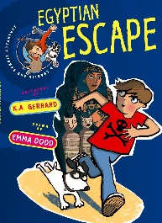 | Charlie Bandit has already had a narrow escape from the perils of Ancient Rome, but this time he travels back in time to an archaeological dig in 1906 and then back to Ancient Egypt. | An Egyptian Rescue  K A Gerrard
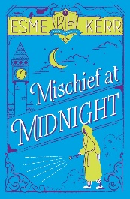 | Edie and Anastasia are excited to be back for a new term at Knight's Haddon Academy. But unfortunately, things quickly start to go wrong when they meet the unusual new girl, Janet Stone. | Mischief at Midnight  Esme Kerr
 | When Tom sees a lion strolling through the orchard with a string of sausages, only Clare, the cleverest girl in the class, believes him. Why? She knows something about Tom's story that no-one else does. Together, they devise a plan to prove that Tom is telling the truth, but somehow things don't go according to plan… | Tom's Sausage Lion  Michael Morpurgo
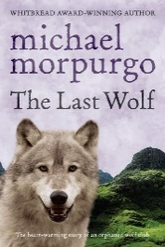 | Robbie McLeod and a wolf cub, both orphaned, venture far from their birthplace in Scotland. The wolf is Robbie's constant companion but when at last Robbie finds a place where he can peacefully make his home, he knows in his heart that the wolf must find his own natural home too… | The Last Wolf  Michael Morpurgo
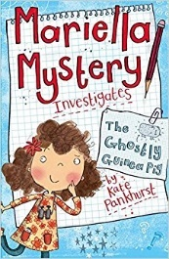 | Mariella Mystery is a totally amazing girl detective, aged nine and a bit - and this is her top-secret detective journal. | Mariella Mystery: The Ghostly Guinea Pig  Kate Pankhurst
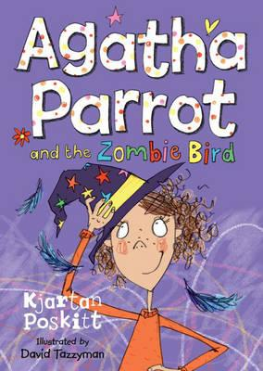 | When Misto the Mysterious announces that his Pen of Destiny has randomly picked Old Street School for the spectacular Zombie Bird’s re-appearance, Agatha Parrot knows he is up to no good. She soon discovers a secret trapdoor leading from the caretaker’s den up to the school, and then the mystical sparks start to fly. | Agatha Parrot and the Zombie Bird  Kjartan Poskitt
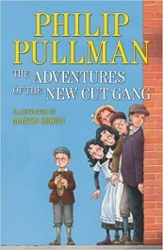 | The New Cut Gang are a rag-tag group of resourceful young rascals who get up to all manner of adventures on the streets of Victorian Lambeth. | The Adventures of the New Cut Gang  Philip Pullman
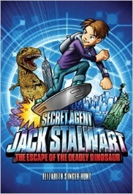 | Nine-year-old Secret Agent Jack Stalwart defeats pirates, rescues fine art and tracks down the crown jewels as he travels around the world in action-packed adventures. Each book is set in a different country that is highlighted on a world map. | Jack Stalwart Series  Elizabeth Singer Hunt
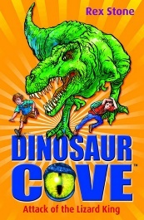 | Jamie and Tom are both obsessed with dinosaurs and love finding fossils in Dinosaur Cove. They find more than they bargained for when they discover a secret cave that takes them back to the time of the real dinosaurs, including an angry T Rex | Dinosaur Cove: Attack of the Lizard King  Rex Stone
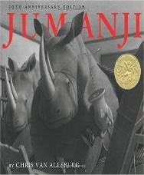 | Judy and Peter are bored and alone - until they discover a mysterious board game, Jumanji, that comes to life as soon as they start to play; it must be finished or it will go on forever. | Jumanji  Chris Van Allsburg
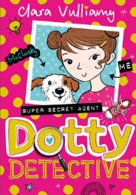 | Dot loves super-sour apple sherberts, running fast and puzzles – especially if they’re fiendishly tricky. And with the help of trusty sidekick, Beans and TOP DOG, McClusky, she is always ready to sniff out a mystery. So, when meangirl Laura seems set on sabotaging the school talent show, Dot is determined to find out how, and save the day… | Dotty Detective  Clara Vulliamy
 | The eruption of Mount Vesuvius in AD 79 meant death for most of the Roman citizens living in Pompeii. The book tells of Tranio, an actor's son, and his friend Livia, the baker's daughter, who witness the destruction of their beloved city. | Escape from Pompeii  Christina Balit

