Fantasy and Science Fiction: Suggested Reading List Years 5 and 6

Here is a suggested reading list to help you find new books to read. Remember, if you find a book you enjoy, try another one from the list or try to find another book by the same author.

The school library might not have all the titles on the list; however, you should be able to find them in the local library.

If you would like to recommend a book for this list, give the details to your class Reading Ambassador.

Cover | Synopsis | Title/Author
 | There are wolves outside the walls of Willoughby Chase, | The Wolves of
 | but for cousins Bonnie and Sylvia, the real danger lies | Willoughby Chase
 | inside. Their wicked governess Miss Slighcarp is working | Joan Aiken
 | with a network of criminals, forgers and snitches to carry
 | out a terrible plan. Bonnie and Sylvia must use all their wits
 | if they are to escape their cruel governess - and the wolves.
 | Twelve-year-old criminal mastermind, Artemis Fowl, | Artemis Fowl
 | hatches an ingenious plot to steal all the gold in fairy land. | Eoin Colfer
 | Although a little dubious about the plan - indeed not even
 | quite believing in the existence of fairies - his trusty
 | bodyguard and companion, Butler, is on hand to help.
 | However, they have not reckoned on Captain Holly Short,
 | who as first female officer in the Lower Elements Police
 | Reconnaissance unit, or LEPrecon, has much to prove.
 | When she is kidnapped by Artemis, she is determined to
 | stand her ground and protect the fairy secrets.
 | When the Pevensie children - Peter, Susan, Edmund and | The Lion the Witch and
 | Lucy - step through a wardrobe door in the strange country | the Wardrobe
 | house where they are staying, they find themselves in the | C.S.Lewis
 | land of Narnia. Frozen in eternal winter, Narnia is a land of
 | snow and pine forests, and its creatures are enslaved by the
 | terrible White Witch.
 | To the thousands of the tiny nomes who live under the | Truckers
 | floorboards of a large department store, there is no | Terry Pratchett
 | Outside. Things like Day and Night, Sun and Rain are just
 | daft old legends. Then a devastating piece of news shatters
 | their existence: the Store - their whole world - is to be
 | demolished. And it's up to Maskin, one of the last nomes to
 | come into the Store, to mastermind an unbelievable escape
 | plan that will take all the nomes into the dangers of the
 | great Outside...
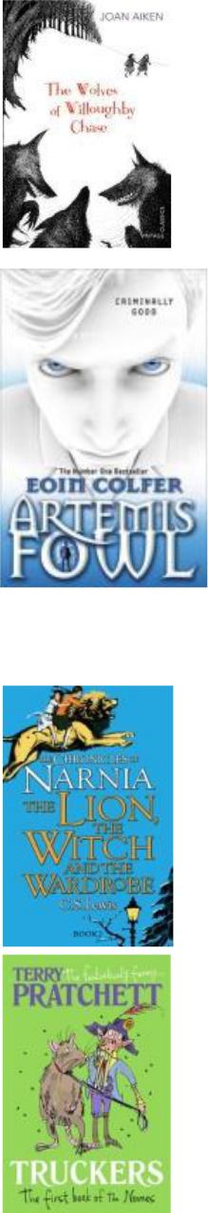
Fantasy and Science Fiction: Suggested Reading List Years 5 and 6

 | After the misery of life with his ghastly aunt and uncle, | Harry Potter and the
 | Harry Potter is delighted to have the chance to embark on | Philosophers Stone
 | an exciting new life at the Hogwart's School of Wizardry and | JK Rowling
 | Witchcraft. Learning about magic and making new friends,
 | he has the chance to use his new-found wizarding skills to
 | unravel some of the mysteries of his own past - and to
 | uncover some shocking secrets about his teachers.
 | This is the classic story of Bilbo Baggins - a home-loving | The Hobbit
 | hobbit who enjoys a quiet and contented life in his cosy | JRR Tolkein
 | hobbit hole and has no desire to travel afar. But then the
 | wizard Gandalf and a band of dwarves arrive unexpectedly
 | and enlist his services, and soon Bilbo finds himself part of
 | an extraordinary expedition to raid the treasure-hoard of
 | Smaug the Dragon - and on the way becomes the possessor
 | of a very unusual ring.
 | The quaint (and aptly named) German village of | Clockwork
 | Glockenheim sets great store in its clockmaking tradition: | Philip Pullman
 | each time an apprentice becomes master of his craft, he
 | commemorates the occasion by adding a new figure to the
 | town's great clock. On the eve of one of these celebrations,
 | a delectably spooky train of events is set in motion when
 | the novelist Fritz sets out to entertain the villagers with his
 | most recent work: the tale of Prince Florian, the deceased
 | local ruler's son, whose fate is linked to a brilliant
 | clockmaker.
 | Twelve-year-old Percy Jackson is on the most dangerous | Percy Jackson and the
 | quest of his life. With the help of a satyr and a daughter of | Lightning Thief
 | Athena, Percy must journey across the United States to | Rick Riordan
 | catch a thief who has stolen the original weapon of mass
 | destruction — Zeus’ master bolt. Along the way, he must
 | face a host of mythological enemies determined to stop
 | him. Most of all, he must come to terms with a father he
 | has never known, and an Oracle that has warned him of
 | betrayal by a friend.
 | When Coraline steps through a door to find another house | Coraline
 | strangely similar to her own (only better), things seem | Neil Gaiman
 | marvelous.
 | But there's another mother there, and another father, and
 | they want her to stay and be their little girl. They want to
 | change her and never let her go.
 | Coraline will have to fight with all her wits and courage if
 | she is to save herself and return to her ordinary life.
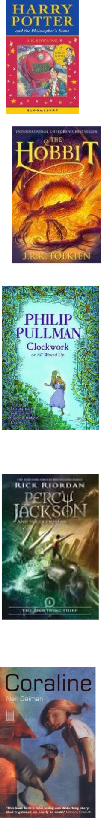
Fantasy and Science Fiction: Suggested Reading List Years 5 and 6

 | Fifteen-year-old Eragon believes that he is merely a poor | Eragon
 | farm boy- until his destiny as a Dragon Rider is revealed. | Christopher Paolini
 | Gifted with only an ancient sword, a loyal dragon, and sage
 | advice from an old storyteller, Eragon is soon swept into a
 | dangerous tapestry of magic, glory, and power. Now his
 | choices could save - or destroy- the Empire..
 | For Milo, everything’s a bore. When a tollbooth | The Phantom
 | mysteriously appears in his room, he drives through only | Tollbooth
 | because he’s got nothing better to do. But on the other | Norton Juster
 | side, things seem different. Milo visits the Island of
 | Conclusions (you get there by jumping), learns about time
 | from a ticking watchdog named Tock, and even embarks on
 | a quest to rescue Rhyme and Reason! Somewhere along the
 | way, Milo realizes something astonishing. Life is far from
 | dull. In fact, it’s exciting beyond his wildest dreams. . . .
 | Skulduggery Pleasant; wise cracking detective, powerful | Skulduggery Pleasant
 | magician, master of dirty tricks and burglary (in the name of | Derek Landy
 | the greater good, of course), oh yeah, and dead!
 | If you can’t wait to find out what happens next, here’s a
 | brief synopsis…
 | Buffy meets Dr Who meets Ghostbusters in this thrilling
 | new book you won’t want to put down!
 | Stephanie’s uncle Gordon is a writer of horror fiction. But
 | when he dies and leaves her his estate, Stephanie learns
 | that while he may have written horror, it certainly wasn’t
 | fiction.
 | Pursued by evil forces intent on recovering a mysterious
 | key, Stephanie finds help from an unusual source – the
 | wisecracking skeleton of a dead wizard.
 | When all hell breaks loose, it’s lucky for Skulduggery that
 | he’s already dead. Though he’s about to discover that being
 | a skeleton doesn’t stop you from being tortured, if the
 | torturer is determined enough. And if there’s anything
 | Skulduggery hates, it’s torture…


