[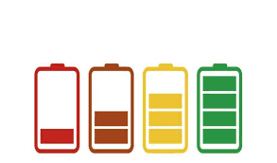](https://www.google.co.uk/url?sa=i&rct=j&q=&esrc=s&source=images&cd=&cad=rja&uact=8&ved=2ahUKEwi0gZvAitjZAhXJWhQKHQTyAYEQjRx6BAgAEAU&url=https://www.tribunasalamanca.com/noticias/cinco-mitos-sobre-como-hay-que-cargar-el-telefono-movil&psig=AOvVaw17uAM0FQU9_pkBVp-6MrXb&ust=1520438887571919)

My target grade is:

**My Target Wall**

**GCSE**

Each skill is a power bar as you get more comfortable with each skill fill in a further bar ☺

I can use evidence in some of my responses

Ideas, examples, scholars

I can explain using my own knowledge while also supporting my ideas with key examples, scholars and ideas

I can explain using my own knowledge

I can state by suggesting ideas

I can state by giving examples from the topic

I can easily define key words and use them clearly in my answers

I can use key words to help define what a question is asking

**Key:** Choose a colour for each skill. Colour in the bricks where you have met that target.

|  |  |
| --- | --- |
| Evaluate |  |
| Analyse |  |
| Explain |  |
| Evidence |  |
| State |  |
| Define |  |

I can evaluate clearly by using a wide range of scholars

I can analyse by offering my opinion on the topic

I can analyse by offering my opinion while also being able to illustrate the opposing view

I can evaluate clearly weighing up evidence in my conclusion