Year 3 Egyptian Dress Up Day – Tuesday 18th July
As the children have not gone on an Egyptian related trip this term we felt that it would be lovely to end our topic by having an Ancient Egyptian Day. This will bring to life the learning we have done during the summer term and to have an educational and fun experience at the same time. Costumes can be anything related to Ancient Egyptian times, slaves, pharaohs, queens, mummies (as long as they can walk), any of the gods, and goddess, cats, Howard Carter or an archaeologist etc. If you are unable to provide a costume please let us know in advance so we can sort something out for your child. Below are some ideas for costumes:
Girls: White adult t-shirt or White sheet with arms and head hole, necklace and bangles can be made from gold card or any gold colourful jewellery, gold ribbon tied around the waste/head. Amazon outfits start at £12
Boys: Same as girls or black t-shirt, black shorts, gold jewellery. Amazon outfits start at £10
You can also find simple ideas and inspiration on Pinterest etc. for outfits and make up ideas if you wish.
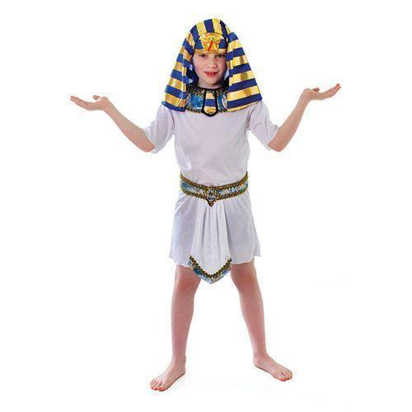
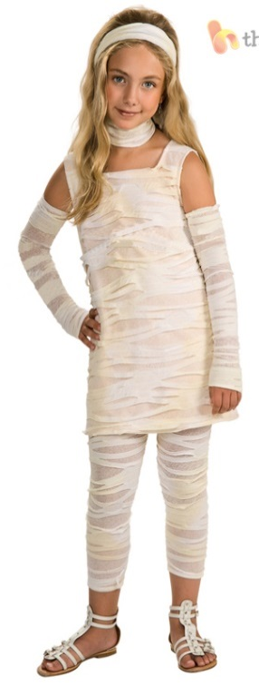

Thank you in advance.
Mrs Edwards and Mrs Pickard

