WALT: Describe and show understanding of why the Jews celebrate the Passover. February 2017
Imagine you are a radio presenter. You have invited Moses for an interview. You want to find out about the tradition of Passover.

With your partner write a radio interview with Moses. You need to write both the presenter's questions and the answers Moses would give. Do not forget to welcome and introduce Moses to your audience (and to thank him at the end). Remember it must be a joint effort. We will then act out the interviews.
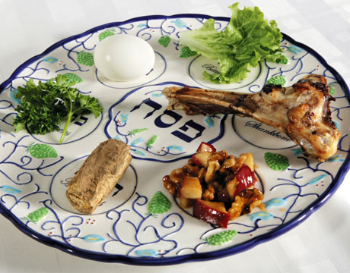
These are the questions you need to find answers to:
What is Passover? Why do Jews celebrate it every year?
Why is it such a special occasion?
How did it start?
Why is it called Passover or Pesach?
What does it involve? How is it celebrated?

WALT: Describe and show understanding of why the Jews celebrate the Passover. February 2017
Imagine you are a radio presenter. You have invited Moses for an interview. You want to find out about the tradition of Passover.

With your partner write a radio interview with Moses. You need to write both the presenter's questions and the answers Moses would give. Do not forget to welcome and introduce Moses to your audience (and to thank him at the end). Remember it must be a joint effort. We will then act out the interviews.
These are the questions you need to find answers to:
What is Passover? Why do Jews celebrate it every year?
Why is it such a special occasion?
How did it start?
Why is it called Passover or Pesach?
What does it involve? How is it celebrated?

